Sunrise UMC



**June 2025**

***Pastor Rob’s Message***

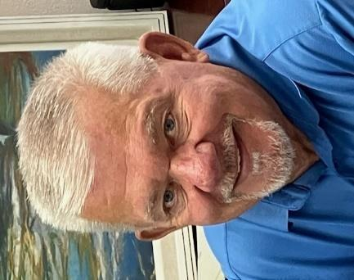

"Loving God, we give thanks for the fathers in our lives, for the men who have modeled your love and grace. We thank you for their kindness, courage, and generosity, and for the ways they've shown us truth, compassion, and faith. We pray for them today, that you would guide and protect them, and give them the strength to continue loving and serving us, their families, and the world. May they find comfort in your presence and strength in your love, as they strive to live lives that honor you. Amen."

This prayer acknowledges both the earthly fathers and God as the ultimate Father, asking for blessings and strength for all fathers. It also highlights qualities like kindness, courage, and generosity, reflecting the values often associated with good fathers.



**Worship times!**

As promised, it will soon be time to make a decision about our worship times beginning in July.  On Sunday, June 8th and 15th, everyone who signs the attendance pad, may record their preference under their name.  You may choose the current time of 11:00 or a different one you would prefer.  If you are not able to be in church those two Sundays, simply call the church office and leave your name and preference.  One vote per person should allow us to look at everyone's preference.  An all church email will be sent out after all the choices are tallied.

**UMOM**

As you know, our monetary gifts help various projects in the United Methodist ministry. Here is an update.

Construction continues on UMOM campus with the renovation of our main lobby! The new lobby will feature a variety of improvements, focused on the safety and dignity of our clients and staff. It also includes enhancements to vital services such as our onsite clinic in partnership with Phoenix Children's Hospital.

**Farewell to Rev. Javier Olivares**

Join Clergy and Laity from the West District on June 7, 2025, at Shepherd of the Hills UMC as we celebrate Superintendent Javier Olivares' four years of ministry with us, and wish him well as he transitions to ministry in the South District. We'll have refreshments and a brief program beginning at 4:30 pm. No reservations required. All are welcome!

**Special Sharing time**

Sunrise will be adding a special sharing time beginning in May during the offertory. If you or someone you know (neighbor, child, grandchild, friend) would like to share a song, an instrumental number, a meaningful story, a dance, a poem, or any other creative way to enhance our worship, please let the office know. This is an opportunity to share a gift with our wonderful Sunrise community!

**Wednesday Mornings With the Pastor**

Pastor Rob leads a group that meets every Wednesday morning from 10:00-11:00. It offers an opportunity to build relationships, have fun, pray, and study scripture. Consider making this group a part of your weekly routine. See you there!

**WAYS YOU CAN HELP**

*Many Hands Make the Work Go Lightly*

**﻿Helping Hands:**

Families help each other in many ways. One way you can help your church family is on Communion Sunday. That is the one day we put out a special offering basket called Helping Hands. This money is used to help members in need when times are tough.

**Easy Ways to Give:**

Shop at Fry’s and join the Fry’s Community Rewards program.

We collect cans (please make sure they are empty) & plastic bottles (no other plastics please), and used plastic grocery bags.

**NEWS FROM OUR MINISTRIES**

**Recovery Worship Service:**

Everyone is welcome to join us on Wednesdays at 7:00 p.m.

**Worship times:**

Several people have asked if Sunrise could revisit our current 11:00 worship time now that Pastor Rob is only serving one church. It was decided at the March SBG meeting to wait on that discussion until July, when we are sure that Sunrise will be his only assignment.

**Prayer Shawl Ministry**   
Prayer Shawl continues to meet the first Saturday of every month at 9:00 a.m. in the conference room. Join us for chatting, knitting, crocheting, and more chatting.

**Justa Center**

Our summer collection for the Justa Center is here! Their needs for the summer months are: sunscreen, baseball caps or hats, cool wraps, propel powder (electrolytes), coffee, sugar and creamer packages, canned tuna and chicken, shoes and socks.

You may place items in the Narthex for collection. A pallet of water costs $200. If you would like to contribute toward purchasing a pallet, please mark your check or

envelope for Missions. The Missions Team Leader, Carl Richeson, is out of town for the next few months so Duane Keeling has volunteered to transport all items to the center.

**Sunrise's Prayer Plan**

The Prayer Team has begun praying before the worship service in the Prayer Room. They are asking God’s guidance for the leaders and all participants. Feel free to use this time and place for your own quiet prayers.

**WELCOME VISITORS!**

Please be sure to greet anyone you don’t know and share a smile and a kind word. And if you see someone without a smile…give them yours!

**POTLUCK**

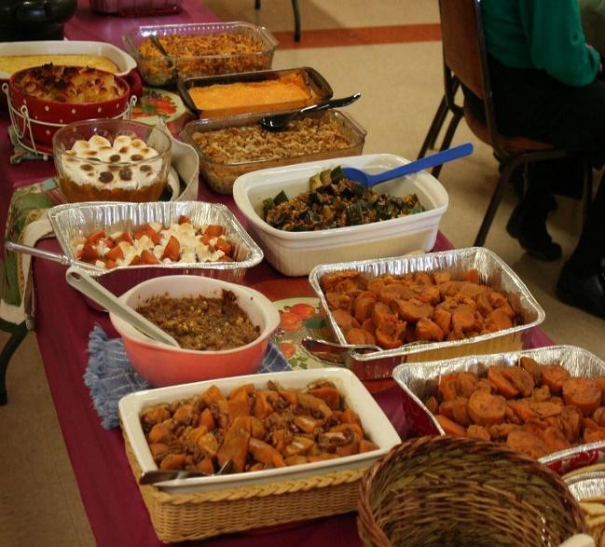June 22, 2025

**Pot Luck** to celebrate the June

Birthdays and Anniversaries

12:00 noon

If possible, bring your own place settings to save on

paper/plastic products and help us go green!

**June**

|  |  |
| --- | --- |
| **Birthdays**  16-Dana Fischer  17-Linda DeYoung | **Anniversaries**  3-Bill & Lynn Wesp  14-Bob & Kim Nunez |

**BIBLE STUDY**

Please join us on Sundays at 10:00 am to study and discuss The Bible. It’s a great opportunity to learn and to immerse yourself in God’s Word on a regular basis. We are currently reading the Book of Acts. Now is the perfect time to begin your study along with us!

**RESOURCES**

**Daily Prayer:**

[prayer.forwardmovement.org](http://prayer.forwardmovement.org/) [dailyofficeexpress.org](http://dailyofficeexpress.org/)

[lectionary.library.vanderbilt.edu/daily.php?year=B](http://lectionary.library.vanderbilt.edu/daily.php?year=B)

[Upperroombooks.com/neweverymorning/](http://upperroombooks.com/neweverymorning/)

**Building Use:**

We have about 9 outside groups that meet in the building each month. If you would like more information about these groups, please contact the church office. Groups include: NA (Narcotics Anonymous), AA (Alcoholics Anonymous), OA (Overeaters Anonymous).

**Office Hours**

Office Open 9:00-1:00 p.m. Tuesday, Wednesday

Pastor Rob in office Wednesday approximately 7:00-2:00 p.m.

Pastoral Emergencies – please contact Pastor Rob at 480-450-7445

