Sunrise UMC

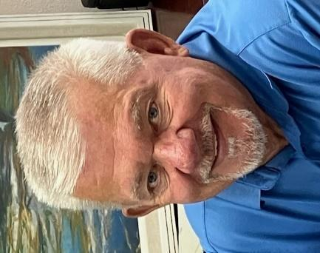

**July 2025**

***Pastor Rob’s Message***

The new pastor once told his congregation, “I’m a recovering perfectionist. So, if I stumble over my words or accidentally misquote a Bible verse, know it’s all part of my journey toward embracing imperfection – and hopefully, you’ll join me!” Of course, you can understand why this quote spoke to me. Sometimes my “imperfections” are a bit embarrassing, but together we live by grace and can enjoy the humor in them as well. You know, it’s okay to laugh, even in worship. In my mind, you can only truly laugh if you love. I am genuinely thankful for the grace and love you share with me.

However, it reminds me of a question we should often ask ourselves: “*Why do I come to worship?”* Have you ever really thought about it? We have many things at church that we can find to be thankful for. Maybe it is the blessing we receive from the fellowship with our family in Christ. Maybe it’s the joy you receive from listening to and singing along with our wonderful music. How often does the liturgy speak to you like it was written just for you? (It was!). And hopefully, the message is meaningful, assuming the pastor is not too long-winded.

I see worship like baking a cake. The goal is to combine all the necessary ingredients to create a beautiful, flavorful cake. The same goes for our church, we have but one goal. We have many gifts in worship to be thankful for.  When we recognize and appreciate the blessings we have been given, only then can we reach our goal of praising God. Because, even with our mistakes, God smiles when we lift up our risen Savior.

Thank you for allowing me to serve as your pastor at Sunrise UMC. See you in church Sunday, where our God will be praised!  


**Worship Times**

The Worship time has changed beginning the first Sunday in July to starting at 10 a.m. Thank you all for your input!

**Special Sharing time**

We love having special music! If you or someone you know (neighbor, child, grandchild, friend) would like to share a song, an instrumental number, a meaningful story, a dance, a poem, or any other creative way to enhance our worship, please let the office know. This is an opportunity to share a gift with our wonderful Sunrise family!

**Wednesday Mornings With the Pastor**

Pastor Rob leads a group that meets every Wednesday morning before our Sunday service. It is on hold for right now until cooler temperatures prevail.

**WAYS YOU CAN HELP**

*Many Hands Make the Work Go Lightly*

**﻿Helping Hands:**

Families help each other in many ways. One way you can help your church family is on Communion Sunday. That is the one day we put out a special offering basket called Helping Hands. This money is used to help members in need when times are tough.

**Easy Ways to Give:**

Shop at Fry’s and join the Fry’s Community Rewards program.

**Recycle:**

We collect cans (please make sure they are empty) & clear plastic bottles (no other plastics please), and used plastic grocery bags.

**NEWS FROM OUR MINISTRIES**

**Recovery Worship Service:**

Everyone is welcome to join us on Wednesdays at 7:00 p.m.

**Prayer Shawl Ministry**   
Prayer Shawl continues to meet the first Saturday of every month at 9:00 a.m. in the conference room. Join us for chatting, knitting, crocheting, and more chatting.

**Justa Center**

Our summer collection for the Justa Center is here! Their needs for the summer months are: sunscreen, baseball caps or hats, cool wraps, propel powder (electrolytes), coffee, sugar and creamer packages, canned tuna and chicken, shoes and socks.

You may place items in the Narthex for collection. A pallet of water costs $200. If you would like to contribute toward purchasing a pallet, please mark your check or

envelope for Missions. The Missions Team Leader, Carl Richeson, is out of town for the next few months so Duane Keeling has volunteered to transport all items to the center.

**Sunrise's Prayer Plan**

The Prayer Team has begun praying before the worship service in the Prayer Room. They are asking God’s guidance for the leaders and all participants. Feel free to use this time and place for your own quiet prayers.

**WELCOME VISITORS!**

Please be sure to greet anyone you don’t know and share a smile and a kind word. And if you see someone without a smile…give them yours!

**POTLUCK**

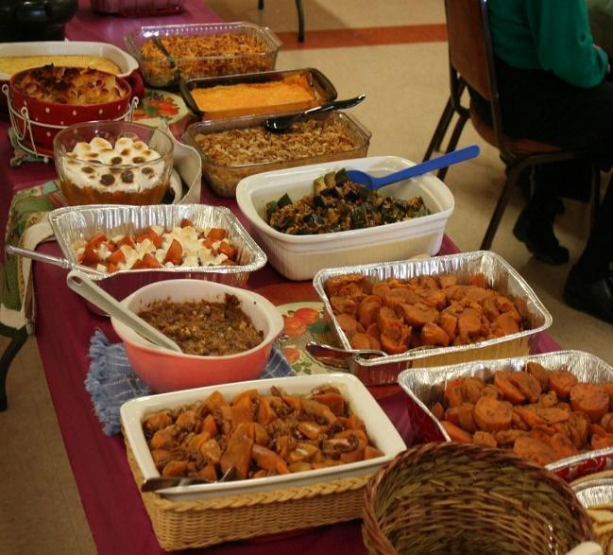

**Pot Luck** July 27, 11:15 a.m.

Birthdays and Anniversaries get head of the line privileges!

If possible, bring your own place settings to save on

paper/plastic products and help us go green!

**BIBLE STUDY**

Please join us on Sundays at 10:00 am to study and discuss The Bible. It’s a great opportunity to learn and to immerse yourself in God’s Word on a regular basis. We are currently reading the Book of Acts. Now is the perfect time to begin your study along with us!

**RESOURCES**

**Daily Prayer:**

[prayer.forwardmovement.org](http://prayer.forwardmovement.org/) [dailyofficeexpress.org](http://dailyofficeexpress.org/)

[lectionary.library.vanderbilt.edu/daily.php?year=B](http://lectionary.library.vanderbilt.edu/daily.php?year=B)

[Upperroombooks.com/neweverymorning/](http://upperroombooks.com/neweverymorning/)

**Building Use:**

We have about 9 outside groups that meet in the building each month. If you would like more information about these groups, please contact the church office. Groups include: NA (Narcotics Anonymous), AA (Alcoholics Anonymous), OA (Overeaters Anonymous).

**Office Hours**

Office Open 9:00-1:00 p.m. Tuesday, Wednesday

Pastor Rob in office Wednesday approximately 7:00-2:00 p.m.

Pastoral Emergencies – please contact Pastor Rob at 480-450-7445

July Birthdays: 8-Cassidy Erb, 18-July Moody, 21-Julie Erb, 23-Frank Simchak & Margery Simchak

July Anniversaries: None this month

