Sunrise UMC



**May 2025**

***Pastor Rob’s Message***

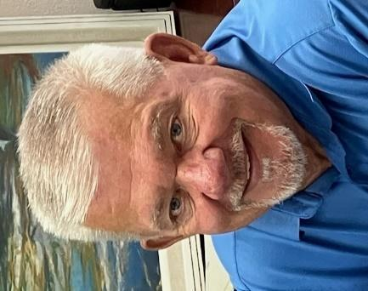

Well, winter is over and Easter has passed, which only means “warmer” weather (not using the H_t word) is coming soon to our beautiful state.

As most of you know, my primary focus the past few years has been caring for my wife Patty. As painful as it was to lose her, it brings me peace knowing that she is in the arms of Jesus, celebrating with Him and family who have gone on before.

I mentioned Easter because we can never forget that Jesus defeated death through His resurrection, and because of Jesus Christ, death has been defeated for us as believers. Losing a loved one leaves a large void in our lives. However, our faith tells us it is only a short period of separation. One day, we will celebrate for eternity with the ones we have always loved.

Jesus teaches us that death is not the end, but a transition to eternal life. In John 11:25, Jesus says*, “I am the resurrection and the life. He who believes in Me, though he may die, he shall live.*”

Thank you for allowing me to take this opportunity to express my gratitude to all my brothers and sisters at Sunrise UMC. I cherished the support you provided me and my family through the many cards, encouraging words, gifts, and more importantly, prayer.

Have a blessed summer and bring a friend to church next Sunday!



**Special Sharing time**

Sunrise will be adding a special sharing time beginning in May during the offertory. If you or someone you know (neighbor, child, grandchild, friend) would like to share a song, an instrumental number, a meaningful story, a dance, a poem, or any other creative way to enhance our worship, please let the office know. This is an opportunity to share a gift with our wonderful Sunrise community!

**Wednesday Mornings With the Pastor**

Pastor Rob leads a group that meets every Wednesday morning from 10:00-11:00. It offers an opportunity to build relationships, have fun, pray, and study scripture. Consider making this group a part of your weekly routine. See you there!

**WAYS YOU CAN HELP**

*Many Hands Make the Work Go Lightly*

**﻿Helping Hands:**

Families help each other in many ways. One way you can help your church family is on Communion Sunday. That is the one day we put out a special offering basket called Helping Hands. This money is used to help members in need when times are tough.

**Easy Ways to Give:**

Shop at Fry’s and join the Fry’s Community Rewards program.

We collect cans (please make sure they are empty) & plastic bottles (no other plastics please), and used plastic grocery bags.

**NEWS FROM OUR MINISTRIES**

**Recovery Worship Service:**

Everyone is welcome to join us on Wednesdays at 7:00 p.m.

**Worship times:**

Several people have asked if Sunrise could revisit our current 11:00 worship time now that Pastor Rob is only serving one church. It was decided at the March SBG meeting to wait on that discussion until July, when we are sure that Sunrise will be his only assignment.

**Prayer Shawl Ministry**   
Prayer Shawl continues to meet the first Saturday of every month at 9:00 a.m. in the conference room. Join us for chatting, knitting, crocheting, and more chatting.

**Justa Center** has asked for donations of the following items: knit caps, beanies, gloves, socks, shoes, hand warmers, coffee, creamer, detergent, and canned goods.

Thank you for your continued support of these mission projects.

**Sunrise's Prayer Plan**

The Prayer Team has begun praying before the worship service in the Prayer Room. They are asking God’s guidance for the leaders and all participants. Feel free to use this time and place for your own quiet prayers.

**WELCOME VISITORS!**

Please be sure to greet anyone you don’t know and share a smile and a kind word. And if you see someone without a smile…give them yours!

**POTLUCK**

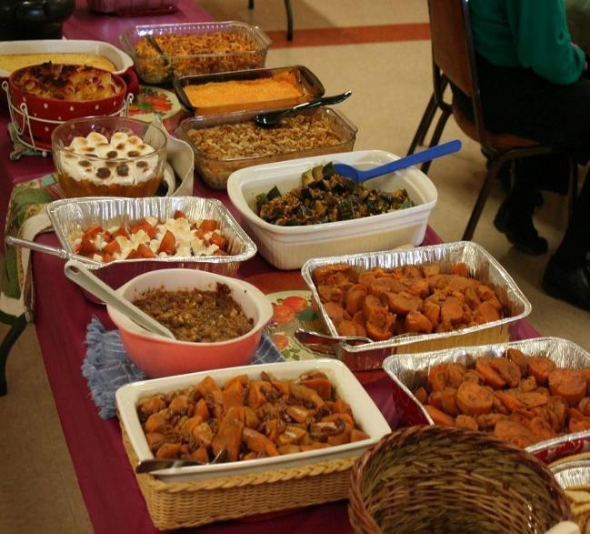May 25, 2025

**Pot Luck** to celebrate the April

Birthdays and Anniversaries

12:00 noon

If possible, bring your own place settings to save on

paper/plastic products and help us go green!

**BIBLE STUDY**

Meets every Sunday in the conference room an hour before worship on Sunday and lasts about 45 minutes and everyone is welcome! Join Duane Keeling during this time

We are studying the book of Acts. Currently on Acts 5:27-42 and Acts 6-7.

**RESOURCES**

**Daily Prayer:**

[prayer.forwardmovement.org](http://prayer.forwardmovement.org/) [dailyofficeexpress.org](http://dailyofficeexpress.org/)

[lectionary.library.vanderbilt.edu/daily.php?year=B](http://lectionary.library.vanderbilt.edu/daily.php?year=B)

[Upperroombooks.com/neweverymorning/](http://upperroombooks.com/neweverymorning/)

**Building Use:**

We have about 9 outside groups that meet in the building each month. If you would like more information about these groups, please contact the church office. Groups include: NA (Narcotics Anonymous), AA (Alcoholics Anonymous), OA (Overeaters Anonymous).

**Office Hours**

Office Open 9:00-1:00 p.m. Tuesday, Wednesday

Pastor Rob in office Wednesday approximately 7:00-2:00 p.m.

Pastoral Emergencies – please contact Pastor Rob at 480-450-7445

