Sunrise UMC 



**March 2025**

***Pastor Rob’s Message***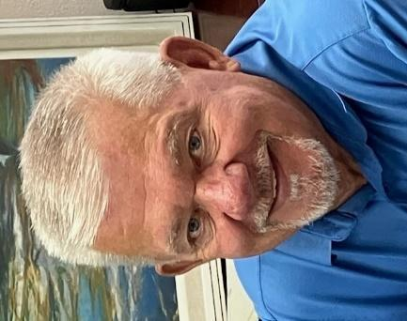

The first Sunday of March is known as Transfiguration Sunday. What does that mean exactly? It's a pivotal moment in Jesus' life, and a manifestation of his divine nature. The revelation of Jesus being the son of God and the foreshadowing of his suffering, death, and resurrection told us that Jesus is the bridge between heaven and earth.

This holy day is also known as the Feast of Transfiguration and is immediately followed by Ash Wednesday. (You may receive ashes on Wednesday, March 5th at 4 p.m. and 6 p.m.) This transition in the liturgical year shifts the focus from Jesus Transfiguration to the beginning of Lent. Lent being a time of reflection and penitence leading up to Easter. A lot going on this time of the year. Transfiguration Sunday is also the last Sunday of the Epiphany season.

The Transfiguration can be read in the Gospels of Matthew, Mark, and Luke. Several things happened in these books: Jesus takes Peter, James, and John up a Mountain, Moses and Elijah appear, Jesus’ face and clothes become dazzlingly bright and a voice is heard from a cloud, “This is my beloved son: hear ye Him.”

And may God shine the light of glory into your hearts. May Christ be with you and never leave you. And may the Spirit renew the image of God within you.

Blessings unto you,

Pastor Rob

**﻿Wednesday Mornings With the Pastor**

Pastor Rob leads a group that meets every Wednesday morning from 10:00-11:00. It offers an opportunity to build relationships, have fun, pray, and study scripture. Consider making this group a part of your weekly routine. See you there!

**WAYS YOU CAN HELP**

*Many Hands Make the Work Go Lightly*

**﻿House of Refuge**

Our next meal is scheduled for April 29th. If you are interested in being a part of this ministry, please talk to Alice Mildenberger.

Thank you for signing up to be a Greeter or Liturgist. We still need more! Please sign up by the office. Also, if you would like to help out with the audio visual, please see Dave Pierce.

**Easy Ways to Give:**

Shop at Fry’s and join the Fry’s Community Rewards program.

We collect cans (please make sure they are empty) & plastic bottles (no other plastics please), and used plastic grocery bags.

**NEWS FROM OUR MINISTRIES**

**Trustees:**

Trustees meet the first Wednesday of the month at 6:00 p.m.

**Recovery Worship Service:**

Everyone is welcome to join us on Wednesdays at 7:00 p.m.

**Men’s Fellowship:**

All men are invited to breakfast on Saturday, March 1st, at 8:00 a.m.

**Missions Committee:**

The Missions Committee meets the 2nd Wednesday of the Month at 11:00am. The next meeting will be March 12th.

**Prayer Shawl Ministry**   
Prayer Shawl participants meet the first Saturday of every month at 9:00 a.m..

**Constitution Elementary School started**   
THANK YOU FOR ALL YOUR DONATIONS FOR THE LOVE OF TEACHERS!

**Justa Center** has asked for donations of the following items: knit caps, beanies, gloves, socks, shoes, hand warmers, coffee, creamer, detergent, and canned goods.

Thank you for your continued support of these mission projects.

**Sunrise's prayer plan**

Now that our prayer team is in place, the team will begin praying for Sunday morning prayer concerns. Place your blue prayer card in the offering plate to be added to that Sunday’s prayer requests. More information will be added to our plan in the following months.

March 23rd 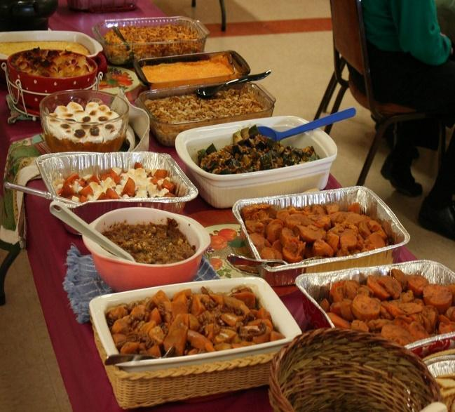

**Pot Luck** to celebrate the March

Birthdays and Anniversaries

12:00 noon

If possible, bring your own place settings to save on

paper/plastic products and help us go green!

**WELCOME VISITORS!**

Please be sure to greet anyone you don’t know and share a smile and a kind word. And if you see someone without a smile…give them yours!

|  |  |
| --- | --- |
| **BIBLE STUDY**  Meets every Sunday in the conference room an hour before worship on Sunday and lasts about 45 minutes and everyone is welcome! Join Dave Newcomer as he leads this animated discussion. Please join them in the church Library to delve more deeply into God's Word and to discuss biblical history, customs and scripture meanings. It is a fun and interesting way to read your Bible on a regular basis. The Book of John is considered highly significant in the Bible because it explicitly presents Jesus as the divine Son of God. It is often seen as the most theological of the Gospels, clearly stating Jesus’ identity as “the Word” who was with God in the beginning.  **RESOURCES**  **Daily Prayer:**  [prayer.forwardmovement.org](http://prayer.forwardmovement.org/) [dailyofficeexpress.org](http://dailyofficeexpress.org/)  [lectionary.library.vanderbilt.edu/daily.php?year=B](http://lectionary.library.vanderbilt.edu/daily.php?year=B)  Upperroombooks.com/neweverymorning/  **Building Use:**  We have about 9 outside groups that meet in the building each month. If you would like more information about these groups, please contact the church office. Groups include: NA (Narcotics Anonymous), AA (Alcoholics Anonymous), OA (Overeaters Anonymous).  **Office Hours**  Office Open 9:00-1:00 p.m. Tuesday, Wednesday, Thursday  Pastor Rob in office Wednesday approximately 7:00-2:00 p.m.    Pastoral Emergencies – please contact Pastor Rob at 480-450-7445 |  |
|  |  |