Sunrise UMC 



**February 2025**

***Pastor Rob’s Message***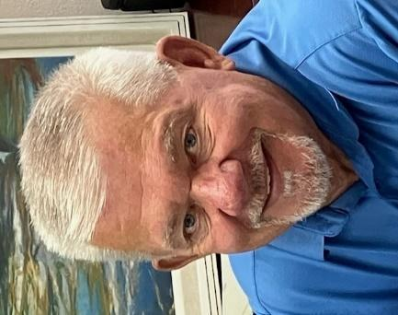

*For I was hungry and you gave me something to eat, I was thirsty and you gave me something to drink, I was a stranger and you invited me in,…* Matthew 25:35 NIV

Allow me to just say “Thank You”! I cannot believe we have been together for seven months now. You have gone out of your way to make me feel so welcome as your pastor.

January was busy as usual but now it is time to put our feet flat on the floor and focus on our plans for the coming months. I have a good feeling about the future of our church and I hope you do as well. Just look around after service on Sundays at the many small friendly conversations that transpire. And if you are new or visiting, you are likely to be in one of those chats. People will come up to you, smiling, to let you know how glad we are that you came to visit with us.

When I arrived at Sunrise UMC, I heard several people say that we are a “friendly church.” You have proven that to me many times over. In conversations, worship, and even in meetings, there is a real passion for our church that shows through. It is a kind of appetite that demonstrates who we are as a church. It just comes alive in the way that shows how much you care for each other, as Christ tells us to do.

Before I go, let me share with you how I plan to be more visible to you. We will be introducing a new fun, educational, and friendly event beginning in February. We will be having a 1-hour Wednesday morning session with the pastor. Our goal will be to invite everyone to participate as we dig into the upcoming Sunday’s scripture and message. By discussing these things in advance it may prove to make a difference on Sunday mornings, for both you and I.

Of course, we will have prayer, good conversations and “Donuts”. So, let’s call it ***“Donuts with the Pastor.”*** Our first meeting will be on Wednesday, February 5, at 10:00 A.M.

I’ll bring the donuts! Only by Grace!

**﻿Wednesday Mornings With the Pastor**

Pastor Rob is beginning a new group that will meet every Wednesday morning from 10:00-11:00 beginning February 5th. It will offer an opportunity to build relationships, have fun, pray, and study scripture. Consider making this group a part of your weekly routine. See you there!

**WAYS YOU CAN HELP**

*Many Hands Make the Work Go Lightly*

**﻿House of Refuge**

Our next meal is scheduled for April 29th. If you are interested in being a part of this ministry, please talk to Alice Mildenberger.

Our biggest need is for Greeters and Liturgists. Please sign up by the office.

**Easy Ways to Give:**

Shop at Fry’s and help Sunrise UMC. Fry’s Community Rewards program.

We collect cans (please make sure they are empty) & plastic bottles (no other plastics please). And we collect used plastic grocery bags.

**NEWS FROM OUR MINISTRIES**

**Trustees:**

Trustees meet the first Wednesday of the month at 6:00 p.m.

**Recovery Worship Service:**

The Wednesday Recovery Service is growing. We have great speakers, devotions, prayer and even a baptism. Everyone is welcome to join us on Wednesdays at 7:00 p.m. To sign up to do devotions or for more information contact Art Erb or Charles Taylor.

**Men’s Fellowship:**

All men are invited to breakfast on Saturday January 4th at 8:00 a.m.

**Missions Committee:**

The Missions Committee meets the 2nd Wednesday of the Month at 11:00am. The next meeting will be February 12th.

**Prayer Shawl Ministry**   
Prayer Shawl participants meet the first Saturday of the every month at 9:00 a.m..  Join us for the fellowship and blessings that come from sharing these shawls and squares with others.  We are always ready to help someone get started.

Our support of **Constitution Elementary School started** in 2015 due to their high percentage of low-income children.   We have 4 mission events each year.   
Coming soon…*Love for Teachers in February

**Justa Center** has asked for donations of the following items: knit caps, beanies, gloves, socks, shoes, hand warmers, coffee, creamer, detergent, and canned goods.

Thank you for your continued support of these mission projects.

Mission Committee Members are:

Linda DeYoung Pat Hepperle Alice Mildenberger Rich Mildenberger Dana Fischer Frank Fischer Carl Richeson (chairperson)

**Prayer Team:** Art Erb, Roy Trevolt, Christine Powell, Ralph Pittman, Dana Fischer and Cathy Bennett.

**﻿Sunrise's Prayer Plan**

Sunrise believes that lifting each other up in prayer is an essential part of a Christian community. The original prayer team is being revised to broaden its scope and responsibilities. More information will be coming as the plan comes together. Please consider being a part of the prayer team. If you have questions or ideas, please talk to Alice or Pastor Rob.

February 23rd 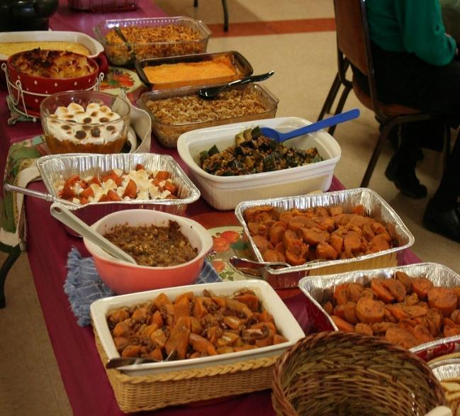

**Pot Luck** to celebrate the February

Birthdays and Anniversaries

12:00 noon

Bring your best potluck dish.

Come and enjoy good food and fellowship.

**WELCOME VISITORS!**

Please be sure to greet anyone you don’t know and share a smile and a kind word. And if you see someone without a smile…give them yours!

|  |  |
| --- | --- |
| **BIBLE STUDY**  Meets every Sunday in the conference room an hour before worship on Sunday and lasts about 45 minutes. Join Dave Newcomer as he leads this animated discussion. Only a few chapters at a time are addressed to make it easy to follow along and keep up. Please join them in the church Library to delve more deeply into God's Word and to discuss biblical history, customs and scripture meanings. It is a fun and interesting way to read your Bible on a regular basis. Everyone is welcome! The Book of John is considered highly significant in the Bible because it explicitly presents Jesus as the divine Son of God. It is often seen as the most theological of the Gospels, clearly stating Jesus’ identity as “the Word” who was with God in the beginning.  **RESOURCES**  **Daily Prayer:**  [prayer.forwardmovement.org](http://prayer.forwardmovement.org/)  [dailyofficeexpress.org](http://dailyofficeexpress.org/)  [lectionary.library.vanderbilt.edu/daily.php?year=B](http://lectionary.library.vanderbilt.edu/daily.php?year=B)  Upperroombooks.com/neweverymorning/  **Building Use:**  We have about 9 outside groups that meet in the building each month. If you would like more information about these groups, please contact the church office. Groups include: NA (Narcotics Anonymous), AA (Alcoholics Anonymous), OA (Overeaters Anonymous).  **Office Hours**  Office Open 9:00-1:00 p.m. Tuesday, Wednesday, Thursday  Pastor Rob in office Wednesday approximately 7:00-2:00 p.m.    Pastoral Emergencies – please contact Pastor Rob at 480-450-7445 |  |
| If there have been any changes to your information; address, phone number, email address, please email the office at hello@sunrisephx.org and let them know of the changes. Thank you! |  |