Sunrise UMC 



**April 2025**

***Pastor Rob’s Message***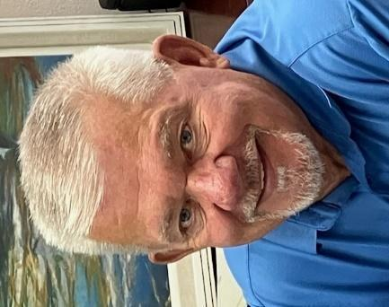

Easter symbolizes new life and rebirth. And it is only natural to celebrate the resurrection of Jesus at this time.

On this earthly plane we look at different situations we encounter and call them a new chapter in our lives. Jesus went from life to death to everlasting life. Our transitions in life may or may not be as black and white, but they are equated to leaving our past life behind to begin a new one. Those could include: births, marriage, death, leaving a job or retiring, beginning a new career, moving to another place.

We have heard people say “Jesus is the reason for the season.” And perhaps we have been through many seasons in our lifetimes. Just as Jesus died on the cross, perhaps we die also when one of our seasons comes to an end. We die a little, find our strength in the Lord, and move into a new life. We are renewed with energy and strength to begin anew.

During this period of Lent we have been in for some time, it has been a time of reflection and self-examination, renewal and preparing our hearts for Easter and a deeper connection with God. Take a moment to see where you have been and how your life has changed throughout the different seasons of your life. And perhaps you are just now entering a time of change, a time of rebirth. Trust that God already had this new life planned for you and walk boldly into the future.



**﻿Wednesday Mornings With the Pastor**

Pastor Rob leads a group that meets every Wednesday morning from 10:00-11:00. It offers an opportunity to build relationships, have fun, pray, and study scripture. Consider making this group a part of your weekly routine. See you there!

**WAYS YOU CAN HELP**

*Many Hands Make the Work Go Lightly*

**﻿House of Refuge**

Our next meal is scheduled for April 29th. If you are interested in being a part of this ministry, please talk to Alice Mildenberger.

Thank you for signing up to be a Greeter or Liturgist. We still need more! Please sign up by the office. Also, if you would like to help out with the audio visual, please see Dave Pierce.

**Easy Ways to Give:**

Shop at Fry’s and join the Fry’s Community Rewards program.

We collect cans (please make sure they are empty) & plastic bottles (no other plastics please), and used plastic grocery bags.

**NEWS FROM OUR MINISTRIES**

**Trustees:**

Trustees meet the first Wednesday of the month at 6:00 p.m.

**Recovery Worship Service:**

Everyone is welcome to join us on Wednesdays at 7:00 p.m.

**Men’s Fellowship:**

All men are invited to breakfast on Saturday, April 5, at 8:00 a.m.

**Missions Committee:**

The Missions Committee meets the 2nd Wednesday of the Month at 11:00am. The next meeting will be April 9th.

**SPECIAL MEETING:**

Women’s Christmas event planning meeting is scheduled for April 5th at 10:30 AM for all interested in planning and being a part of the event. Any questions contact Jean Danielson 602- 882-4449.

**Worship times:**

Several people have asked if Sunrise could revisit our current 11:00 worship time now that Pastor Rob is only serving one church. It was decided at the March SBG meeting to wait on that discussion until July, when we are sure that Sunrise will be his only assignment.

**Prayer Shawl Ministry**   
Prayer Shawl participants meet the first Saturday of every month at 9:00 a.m..

**Constitution Elementary School started**   
THANK YOU FOR ALL YOUR DONATIONS FOR THE LOVE OF TEACHERS!

**Justa Center** has asked for donations of the following items: knit caps, beanies, gloves, socks, shoes, hand warmers, coffee, creamer, detergent, and canned goods.

Thank you for your continued support of these mission projects.

**Sunrise's Prayer Plan**

Now that our prayer team is in place, the team will begin praying for Sunday morning prayer concerns. Place your blue prayer card in the offering plate to be added to that Sunday’s prayer requests. More information will be added to our plan in the following months.

**WELCOME VISITORS!**

Please be sure to greet anyone you don’t know and share a smile and a kind word. And if you see someone without a smile…give them yours!

**POTLUCK**

April 27, 2025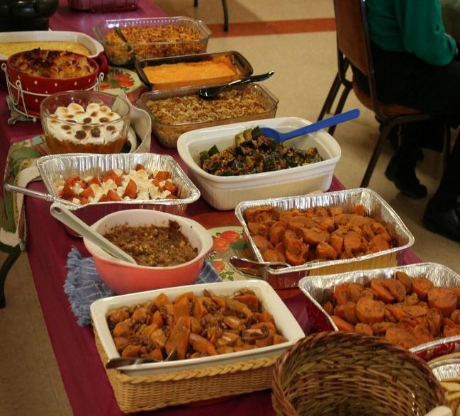

**Pot Luck** to celebrate the April

Birthdays and Anniversaries

12:00 noon

If possible, bring your own place settings to save on

paper/plastic products and help us go green!

**BIBLE STUDY**

Meets every Sunday in the conference room an hour before worship on Sunday and lasts about 45 minutes and everyone is welcome! Join Dave Newcomer as he leads this animated discussion. Please join them in the church Library to delve more deeply into God's Word and to discuss biblical history, customs and scripture meanings. It is a fun and interesting way to read your Bible on a regular basis. The Book of John is considered highly significant in the Bible because it explicitly presents Jesus as the divine Son of God. It is often seen as the most theological of the Gospels, clearly stating Jesus’ identity as “the Word” who was with God in the beginning.

**RESOURCES**

**Daily Prayer:**

[prayer.forwardmovement.org](http://prayer.forwardmovement.org/) [dailyofficeexpress.org](http://dailyofficeexpress.org/)

[lectionary.library.vanderbilt.edu/daily.php?year=B](http://lectionary.library.vanderbilt.edu/daily.php?year=B)

[Upperroombooks.com/neweverymorning/](http://upperroombooks.com/neweverymorning/)

**Building Use:**

We have about 9 outside groups that meet in the building each month. If you would like more information about these groups, please contact the church office. Groups include: NA (Narcotics Anonymous), AA (Alcoholics Anonymous), OA (Overeaters Anonymous).

**Office Hours**

Office Open 9:00-1:00 p.m. Tuesday, Wednesday

Pastor Rob in office Wednesday approximately 7:00-2:00 p.m.

Pastoral Emergencies – please contact Pastor Rob at 480-450-7445



    
    
    
    