 Sunrise UMC

**March**

**2024**



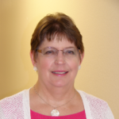

From the desk of your Pastor

**Broken Hearted**

“I didn’t do it!” Crying. “No, I didn’t!” More crying. Continued crying. “It’s not fair! I didn’t do it!” Ongoing crying. On and on it went, breaking my heart, because, perhaps the child was telling the truth, even if caught in the act.

One of my churches has a Montessori School located on campus – in fact, in the same building as the church offices. Children crying and screaming has become part of my work life. There are many reasons why children cry, but as a parent, I know there is a difference between cries of anger, of physical pain, of frustration, and even of injustice. I can hear screams of terror, and the sobbing of a child sorry for what they have done. But for the most part, any of it makes me want to cry along with them – or maybe get earplugs.

Children’s minds do not work like ours. They live a truth we don’t understand, until we remember when…., and most of us don’t remember that far back. But, if we are lucky, we have had at least one child in our lives that we are close to, and have witnessed the pain and injustice children experience.

My oldest son was often punished for others bullying him. He was taught in daycare to not strike back, but tell a teacher if there was a problem. But grade school was different. If one child complained, both got punished automatically. There was no justice on the playground.

My middle son held his breath when he was in pain, the screams and tears horribly delayed. As he got older, the quivering chin of held-in tears broke my heart.

My youngest son didn’t want to be potty-trained, even after being held back in daycare. When we tried to force him, he screamed and cried. I finally realized he was terrified. But of what? Eventually I remembered he had surgery to repair a hernia just before he turned two. I realized he must in some way remember it, and wanted a diaper for protection. Once Alan and I spent time reassuring him no one would hurt him “down there”, he finally began to respond to potty training.

As I say, a child crying breaks my heart. When they say they didn’t do it, either they really didn’t or they wish they didn’t. Are we any different? How many times have we cried out to God proclaiming it wasn’t my fault or I didn’t do it? Don’t you imagine our tears and denials break God’s heart and Jesus’ too? Maybe they want to cry along with us.

The end of this month is Holy Week. Let us bring our tears, our screams, our honest confusion and honest desire to not be the one to blame and lay them at the foot of the cross. I believe someone is waiting to heal our tears, to reassure us, to give us a hug and welcome us back into loving relationship. Whether it feels like it or not, Easter is coming, and our tears will give way to joy.

Pastor Galene



February Planning Meeting Update

On Sunday, February 18th, everyone at Sunrise was invited to a planning meeting with Rev. Rachel Gilmore, Director of New and Vital Faith Communities for the Desert Southwest Conference. Rev. Javier Olivares, our District Superintendent, was also there.

Fifteen members and friends came to the meeting, along with Rachel, Javier, and Galene, for a total of 18 people. Rachel and Javier asked various questions and presented some information obtained from Insite Reports (based on the most recent census).

Generally people like best that Sunrise has a family feel to it, with friendly welcoming people. Also, they are happy to find Sunrise doing mission work, as many consider that very important as well. But there was frustration over things they couldn’t control, like the high number of pastors Sunrise has had. One person estimated Sunrise has had 20 pastors in 40 years. Given there were six pastors in the first 16 years, the estimate is very reasonable. But it is not good for the congregation, or even for the pastors who are moving around so much. Rachel explained that the appointment system can be difficult, especially considering if a pastor at a large church retires or leaves, it can start a chain of moves that affects four or more pastors and congregations as pastors get sent to larger churches.

But perhaps the most difficult thing considered at the meeting was that, based on current finances, it is estimated Sunrise will only last about three more years before we can no longer pay our bills.

Rachel and Javier presented three different paths Sunrise might take.

1. Legacy Path: close the church, consider merging with a like-minded congregation, consider the Elijah-Elisha path – where Sunrise closes but then relaunches a new congregation in the same space
2. Clear Vision Path: Sunrise reevaluates our mission and focus in order to set new goals and reach new people
3. Clear Process Path: Sunrise has a clear and focused vision but doesn’t know how to implement it in order to reach new people.

Of course, there is always an option of doing nothing.

Members decided to study the book “Choosing the Faithful Path”. The books should be available the beginning of this month. Get a copy of the book and look for discussion opportunities so Sunrise can determine its way forward!



**LENTEN ACTIVITIES**

**$5,000 Lenten Challenge**

In the Christian calendar, Lent is a time of reflection, denial and sacrifice. Therefore, we will be launching, with suggestions from the Annual Conference, a Lenten challenge to raise money for our budget, and therefore for ministry needs. We can accept offerings, do fund raiser, apply for grants, whatever we can think of to raise the $5,000, or at least get as close to it as possible. Remember, this is to help US.

There is a Fat Tuesday Pancake Supper on February 13th, which we can count toward our goal. There is already an offer of $500 towards our goal. See, we already have a good start! There will be some Lenten offering coin holders as well as special Lenten offering envelopes available for pick up for those who want to participate in the challenge through their gifts.

Please prayerfully reflect on what you might do to help us reach our goal. Pray for this challenge and for our church. If you have a good fundraising idea, please share it. Invite a friend to join you at the Fat Tuesday Pancake Supper. Let’s prove to ourselves and others that the Spirit lives here at Sunrise and God is doing great things among us.

Donuts and Devotions  Wednesday, March 6 at 9:30 am, Pastor Galene will host a time of coffee and donuts as well as Bible Study and prayer in the Library. We will discuss scripture at 9:30 am, move into prayer time at 10:15 am., and then people can hang around for fellowship afterwards. So, come at 9:30, or 10:15, or 10:30 and enjoy some time with fellow members and friends of Sunrise.



[This Photo](https://www.flickr.com/photos/97546644@N02/14972384709/) by Unknown Author is licensed under [CC BY-NC-ND](https://creativecommons.org/licenses/by-nc-nd/3.0/)



**March 24 – Palm Sunday**

**March 28 – Maundy Thursday**

**March 29 – Good Friday**

**March 31 – Easter Sunday**

**GROWTH OPPORTUNITY**

The West District of the Desert Southwest Conference of the United Methodist Church is pleased to announce it will be offering: The Advanced Lay Servant Ministries course:

Come to the Waters

**WHEN:** Friday, **March 15, 2024**, from **6:00 pm – 9:00 pm**

Saturday, **March 16, 2024**, from **9:00 am – 4:30 pm**

**WHERE:** Dove of the Desert United Methodist Church

7201 Beardsley Rd, Glendale, AZ

This course will deepen your experience of baptism, confirmation, and reaffirmation of baptism through this wide-ranging study of By Water and the Spirit, Scripture, church history, and United Methodist theology and practice of the sacrament.

There is no text required for this course.

The cost for this course is **$15** and is payable upon registration. You can register and pay online. If paying by cash or check, bring it to the class and give it to the instructor.

Once you register for this course, you will receive a confirmation email with a link to the book and other information.

If you have further questions, you may contact Jill Cristina-Krebs, the West District LSM Director, at [westlayservants@dscumc.org](mailto:westlayservants@dscumc.org).

The West District of the Southwest Desert Conference of the United Methodist Church is pleased to announce it will be offering: The Advanced Lay Servant Ministries course:

Discover Your Spiritual Gifts

**WHEN:** Friday, March 15, 2024 from 6:00 pm – 9:00 pm

Saturday, March 16 from 9:00 am – 4:30 pm

**WHERE:** Dove of the Desert United Methodist Church

7201 Beardsley Rd, Glendale, AZ

This course helps participants understand spiritual gifts and how the church can use them to fulfill its mission and ministry. Participants will also learn what it means to be a spiritual leader and will be equipped to lead others in exploring and using their spiritual gifts.

The participants text *Each One a Minister* by William J. Carter is required reading for this program. You are required to have read the text prior to the course starting.

The cost for this course is **$15** and is payable upon registration. You can register and pay online. If paying by cash or check, bring it to the class and give it to the instructor.

Once you register for this course, you will receive a confirmation email with a link to the book and other information.

If you have further questions, you may contact Jill Cristina-Krebs, the West District LSM Director, at email [westlayservants@dscumc.org](mailto:westlayservants@dscumc.org).



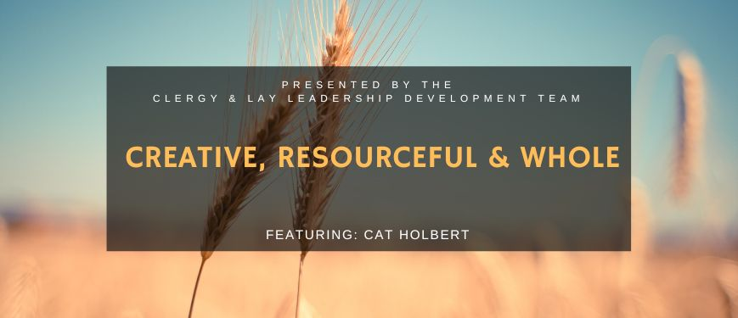The Desert Southwest Conference Clergy and Lay Leadership Development team invites you to join us for another Leadership Talk on March 11, 2024 at 7:00 PM Arizona Time (6:00 PM Nevada Time) via Zoom with featured presenter Cat Holbert, Director of Camp and Retreat Ministries for the Desert Southwest Conference.

**Desert southwest conference**



Update from Ukraine

by [Billie K. Fidlin](https://dscumc.org/author/bfidlin/) | Jan 11, 2024 | [Conference Newsletter](https://dscumc.org/blog/category/news/newsletter-mailchimp2020/), [East District Newsletter](https://dscumc.org/blog/category/news/east-mailchimp/), [Global Ministries](https://dscumc.org/blog/category/global-ministries/), [North District Newsletter](https://dscumc.org/blog/category/news/north-mailchimp/), [South District Newsletter](https://dscumc.org/blog/category/news/south-mailchimp/), [West District Newsletter](https://dscumc.org/blog/category/news/west-mailchimp/)

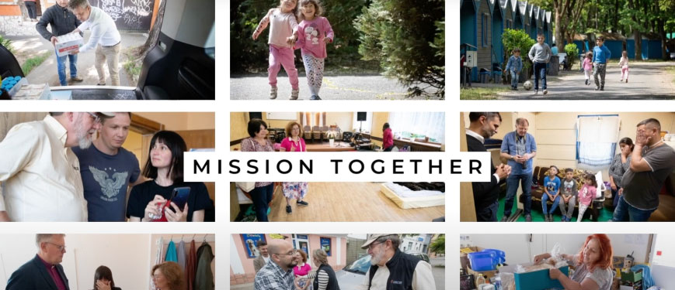

Recently those of us in our denomination who meet with ***Bishop Alsted*** and the United Methodists in Ukraine received an update from **District Superintendent *Oleg Starodubets***. After receiving permission to share this update, I wanted to communicate what **DS *Oleg*** had to say. Our Conference was generous in their support of Ukraine through our Annual Conference Mission Project 2023, and I know you would like to hear more. Each time I meet via Zoom with our Ukrainian colleagues, I am moved by their courage and commitment to our Lord and Savior. Their mission continues under the most difficult of circumstances. As you know from the news, Putin has increased the frequency of attacks on ALL of Ukraine. It is no longer simply the cities on the eastern front. Please continue to hold our United Methodist clergy, churches and the people of Ukraine in your prayers.

The following is the update from **DS *Oleg***. Keep in mind these ministries and events are occurring in the backdrop of war – its bombs, its destruction, and personal loss for so many.

1. The Ukraine UMC had a discipleship seminar from Dec 6-9, in Transcarpathia. Forty members from various local churches took part in it, with missionary *Hernando Montana* providing the teaching.
2. **Kharkiv UMC** is our most heroic church. The city is under the constant shelling since the first days of the war. In spite of this the church continues ministry, and Pastor Igor has committed to not leave the city even if one member remains.
3. Kyiv’s two United Methodist Churches are experiencing difficult times. Russian attacks have become more severe, with drone strikes almost daily in recent weeks. The church family there asks for prayers to persevere.
4. Lviv UMC continues to have regular services and engage the student ministry. In warmer months that had several retreats with youth.
5. Chernivsty UMC is able to lead their ministry in a relatively stable environment. Members are active in humanitarian ministry.
6. Our new church plant in Germany (near Hamburg) for Ukrainian refugees is growing fast. More new families have joined. It proves to be a vital ministry for those adjusting to a new environment.
7. Our UMC center for displaced persons in Uzhgorod, continues to be able to host more than 60 people at a time that come from the most difficult parts of Ukraine. All of them have tragic stories of loss.
8. Uzhgorod UMC continues regular services and an ongoing construction project that will provide more space for youth ministry and hospitality as they welcome displaced persons from the shelter each Sunday.
9. Kamyanitsa UMC heads up the district children and youth camps. Youth from the church take on more responsibilities as the actively serve.
10. Finally, Sredne UMC is a unique ministry among Roma people located in the village. More have joined since the start of the war.

Please keep praying for Ukraine and the Ukraine United Methodist Church. Pray that God will help us move forward in our vision to start ministries in new cities, towns, and villages throughout Ukraine.

***Rev. Oleg Starodubets***  
**District Superintendent**



For more than 80 years, United Methodists have ensured that resources from the United Methodist Committee on Relief are available in times of crisis. UMCOR Sunday donations cover UMCOR’s operation costs, so that 100% of donations received in response to emergency appeals go directly to communities in need. **March 10th** **is UMCOR Sunday.** Please consider giving.



**Church News**

***Office Hours***

Monday & Wednesday 10:30AM Rev. Galene in office

Tuesday-Thursday 9:00-1:00PM Office Open

Pastoral Emergencies – 623.236.3969

If you would like to meet with Rev. Galene,

please contact the office at 623-780-1008

**Help with Worship:**

We are still looking for greeters, liturgist and AV persons to assist with our Sunday worship services. Being a greeter is a great way to get to know all who attend Sunrise UMC. Please let Rev. Galene or Joyce know if interested.

**Building Use:**

We have about 9 outside groups that meet in the building each month. If you would like more information about these groups, please contact the church office.

**Daily Prayer:**

[prayer.forwardmovement.org](http://prayer.forwardmovement.org/)

[dailyofficeexpress.org](http://dailyofficeexpress.org/)

[lectionary.library.vanderbilt.edu/daily.php?year=B](http://lectionary.library.vanderbilt.edu/daily.php?year=B)

Upperroombooks.com/neweverymorning/

If there have been any changes to your information; address, phone number, email address, please email the office at hello@sunrisephx.org and let them know of the changes. Thank you!

**Find Sunrise UMC on Social Media,**

**[sunriseumcphx](https://www.facebook.com/sunriseumcphx/)** [**#sunriseumcphx**](https://www.instagram.com/sunriseumcphx/)



[This Photo](http://commons.wikimedia.org/wiki/File:Facebook_Shiny_Icon.svg) by Unknown Author is licensed under [CC BY-SA](https://creativecommons.org/licenses/by-sa/3.0/)



[This Photo](https://radiouniversidad.uca.edu.ni/instagram-agrega-stickers-animados-historias/) by Unknown Author is licensed under [CC BY-SA](https://creativecommons.org/licenses/by-sa/3.0/)

**Easy Ways to Give:**

**Shop at Fry’s and help Sunrise UMC.** **Fry’s Community Rewards program**. This program makes fundraising easy by donating to local organizations based on the shopping you do every day. Once you link your Card to an organization, all you have to do is shop at Fry’s and swipe your Shopper’s Card. Need help signing up, please, let the office know.

** We also collect cans; plastic bottles**

**Movie CD’s and TV Programs:**

Sunrise UMC has been given movie CD’s and have started a library. The CD’s are in room #4 in the fellowship hall. You may check out the movie to view and then return when you have watched it. Anyone who has movies they wish to donate can place on the shelf. Enjoy!



**NEWS FROM OUR MINISTRIES**

**Trustees:**



[This Photo](http://www.picserver.org/t/trustee.html) by Unknown Author is licensed under [CC BY-SA](https://creativecommons.org/licenses/by-sa/3.0/)

Greetings Sunrise from your trustees!

Trustees meet the first Wednesday of the month at 6:00pm.

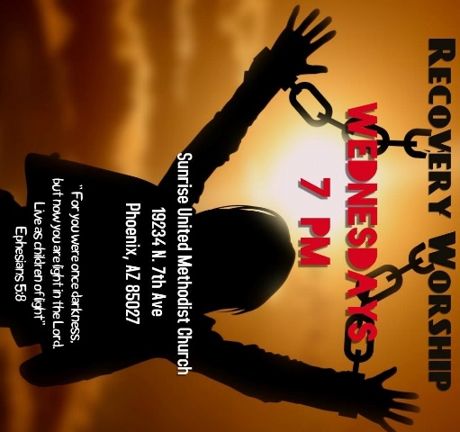

**Recovery Worship Service:**

The Wednesday Recovery Services is growing. We have great speakers, devotions, prayer and even a baptism. Everyone is welcome to join us on Wednesdays at 7:00PM.

To sign up to do devotions or for more information contact Art Erb or Charles Taylor.



[This Photo](http://justinsomnia.org/2009/09/breakfast-in-heathrow/) by Unknown Author is licensed under [CC BY](https://creativecommons.org/licenses/by/3.0/)

**Men’s Fellowship will have a breakfast on Saturday March 2nd at 8:00am.**

**NEWS FROM OUR MINISTRIES**

**Missions ~ Mission Committee**

**Ongoing Mission Projects**

The Justa Center is still in need of the following items: **Can tuna, can chicken, can beans and can veggies; boxes or bags of pasta; laundry pods; and large bottles of shampoo.** They are also in need of: **warm clothing, coats, sweaters, hoodies, socks,** please bring to church and it will be taken to Justa Center



They are always in need of shoes, sunscreen, toothpaste (2.30z or larger) shampoo and water. Donations of money is always welcome. Place in envelope and write Missions- Justa Center.

Mission Committee meets the 2nd Wednesday of the Month at 11:00am.

Mission Committee Members are:

Linda DeYoung Pat Heppele Alice Mildenberger Rich Mildenberger

Dana Fischer Frank Fischer

Donna and Carl Richeson

**Prayer Shawl Ministry**



[This Photo](http://sweetbeebuzzings.blogspot.com/2014/08/nordic-shawl.html) by Unknown Author is licensed under [CC BY-SA-NC](https://creativecommons.org/licenses/by-nc-sa/3.0/)

Prayer Squares are here!  Check out the basket at the back of the sanctuary.

These are great visual reminders to pray.

Placed in a pocket, purse, beside your bed, or in the car, the prayer square serves as a reminder: a reminder to pause and pray and also a reminder that someone cares about you.  Take one for yourself or someone you know.   
Prayer Shawls continue to be available to give to someone with a specific need.

**We will gather on the first Saturday of the month, March 2 at 9:00am. There will be yarn, knitting needles, crochet hooks, and people to assist as needed.  Join us as for this ministry.**

Contact Alice Mildenberger for more information.

**Love For Teachers:**  Thank you for your support.

   
  
Sign-up sheets for April 7-14 Family Promise week are on the table at the back of the sanctuary. Please check your calendars, pray about and plan on joining us for this mission.  The benefits are so rewarding. If you have questions, contact Richard and Alice Mildenberger



[This Photo](https://www.pngall.com/easter-png/download/64281) by Unknown Author is licensed under [CC BY-NC](https://creativecommons.org/licenses/by-nc/3.0/)



Larry D March 3

Joel B March 11

Matt B March 13

Jana G March 13

Janice F March 21

Patti T March 28



Please let us know if we have missed your special day.



Pot Luck to celebrate the March Birthdays and Anniversaries

March 24th 12:00 noon

Bring your best potluck dish.

Come and enjoy good food and fellowship.

**NEWS FROM OUR MINISTRIEs**

**Prayer Ministry**



***What we do today is more important than what we plan to do in the future.***

*-* ***Jack Hyles***

**Prayer Team**

|  |
| --- |
| Rev. Galene |
| Art E |
| Susan R |
| Roy T |
| Mary S |
| Katy O |
| Christine P |
| Susan A |
| Ralph P |
| Dana F |

**NEWS FROM oUR MINIST****ry**

**Finance Ministry**



**FACEBOOK** – are you a participant on Facebook? If so, please LIKE Sunrise. It is a new page and we need people to LIKE us @

**[sunriseumcphx](https://www.facebook.com/sunriseumcphx/)** [**#sunriseumcphx**](https://www.instagram.com/sunriseumcphx/)



[This Photo](http://commons.wikimedia.org/wiki/File:Facebook_Shiny_Icon.svg) by Unknown Author is licensed under [CC BY-SA](https://creativecommons.org/licenses/by-sa/3.0/)



[This Photo](https://radiouniversidad.uca.edu.ni/instagram-agrega-stickers-animados-historias/) by Unknown Author is licensed under [CC BY-SA](https://creativecommons.org/licenses/by-sa/3.0/)