 Sunrise UMC

**February**

**2024**



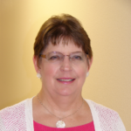

From the desk of your Pastor

Calendar Musings from the Pastor

Once again, Valentine’s Day and Ash Wednesday are one and the same day. A day for indulging in love and celebrating love with chocolates, flowers, time together and other gifts is grafted together with a day for self-denial, sparseness, and the color gray. The two do not mix. Or, at least, that is the appearance.

But let me tell you what I have learned about love since being in the ministry.

Since the early days of my career, I have stood helplessly by, feeling inadequate, as members or their loved ones slowly slipped away from this mortal place. Prayer just doesn’t seem to be enough. Presence doesn’t seem to be enough. And yet, it has to be enough, because I am no doctor or miracle worker.

But over time, I accepted my shortcomings, because I discovered something amazing: the things people do for those they love. The journey of caregiver and care receiver is the strongest, hardest journey I have seen anyone undertake.

Holding the head of the vomiting, brushing gel on cracked lips, cleaning up blood or bodily functions and needs, injecting pain medications – the things care givers do is amazing. Also amazing are the people who allow themselves to be cared for. Most of us want to be givers, not receivers.

I know of no greater love than watching while someone you love leaves you. The only worse pain, I imagine, is the emptiness when your time as caregiver is over. All the hearts and flowers, fancy dinners and gifts, cannot compare to the love demonstrated by millions of people caring for parents, children, and others for days, weeks, months and years while knowing they can do nothing to change the result. Where do these people find the strength?

As we begin this year’s journey towards the cross, let us remember ashes, suffering and death are part of love too. The greatest love we can offer Jesus is to be willing to stand by and watch as he struggles to love us and eventually dies for us. What a privilege to be able to be there for him.

Pastor Galene



**LENTEN ACTIVITIES**

Fat Tuesday Pancake Meal  
February 13th



[This Photo](https://www.creationsbykara.com/2011/03/buttermilk-pancakes.html/) by Unknown Author is licensed under [CC BY-NC-ND](https://creativecommons.org/licenses/by-nc-nd/3.0/)

6:00-7:30pm  
Donations going to general budget  
Sponsored by Men's Group

ASH WEDNESDAY SERVICE

FEBRUARY 14th

IMPOSITION OF ASHES 6:00pm

**$5,000 Lenten Challenge**

In the Christian calendar, Lent is a time of reflection, denial and sacrifice. Therefore, we will be launching, with suggestions from the Annual Conference, a Lenten challenge to raise money for our budget, and therefore for ministry needs. We can accept offerings, do fund raiser, apply for grants, whatever we can think of to raise the $5,000, or at least get as close to it as possible. Remember, this is to help US.

There is a Fat Tuesday Pancake Supper on February 13th, which we can count toward our goal. There is already an offer of $500 towards our goal. See, we already have a good start! There will be some Lenten offering coin holders as well as special Lenten offering envelopes available for pick up for those who want to participate in the challenge through their gifts.

Please prayerfully reflect on what you might do to help us reach our goal. Pray for this challenge and for our church. If you have a good fundraising idea, please share it. Invite a friend to join you at the Fat Tuesday Pancake Supper. Let’s prove to ourselves and others that the Spirit lives here at Sunrise and God is doing great things among us.



**All Church Planning Meeting**

All members and friends of Sunrise are invited to attend an all church strategic planning meeting on **Sunday, February 18th** following worship. Rev. Rachel Gilmore, Director of New Faith and Vital Faith Communities, will be leading us in a time of assessing where we are and where we would like to be. Rev. Gilmore can help us find ways to grow our church and make our ministries more vital. Come join us for this important discussion.

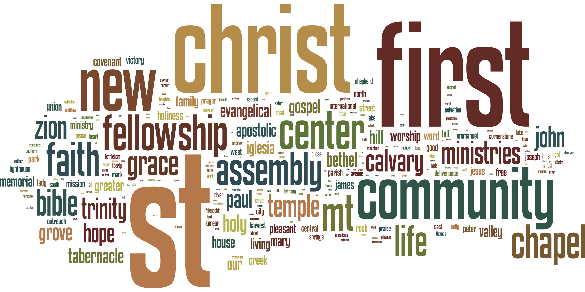

[This Photo](https://www.openbible.info/blog/2010/) by Unknown Author is licensed under [CC BY](https://creativecommons.org/licenses/by/3.0/)

Donuts and Devotions Starting on Wednesday, February 14th at 9:30 am, Pastor Galene will host a time of coffee and donuts as well as Bible Study and prayer in the Library. We will discuss scripture at 9:30 am, move into prayer time at 10:15 am., and then people can hang around for fellowship afterwards. So come at 9:30, or 10:15, or 10:30 and enjoy some time with fellow members and friends of Sunrise.



[This Photo](https://www.flickr.com/photos/97546644@N02/14972384709/) by Unknown Author is licensed under [CC BY-NC-ND](https://creativecommons.org/licenses/by-nc-nd/3.0/)

**NEWS FROM the conference**



Greetings Faithful,

The 2024 District Leadership Conference is rapidly approaching. The topic of the workshop is conflict management, featuring Rev. April Casperson, Director of Enrollment Management Methodist Theological School in Ohio. In the workshop we will explore the five conflict management styles, take an informal conflict management style assessment, and explore ways to manage conflict. Then we will explore the role of trust, credibility, and power in organizational culture, and consider what individuals and organizations can do when trust breaks down.

For more information and to register, please click the hyperlink below which will take you directly to the District Leadership Conference registration information page. Please disseminate this information to those who may be interested in attending. Please note, space is limited, and registration is filling up fast.

<https://dscumc.org/blog/2023/12/01/dont-miss-the-2024-district-leadership-conference/>

Each leadership conference will occur on Saturday mornings through early afternoons in person with lunch provided. Registration is required. Click on the links below to register for the event near you.

East & West Districts Leadership Conference

**When:**February 3, 2024 – 8:30 a.m. – 12:30 p.m.

**Where:**[Cross in the Desert UMC](https://crossinthedesert.org/), Phoenix, AZ.

[East & West Registration](https://dscumc.org/event/east-west-districts-leadership-conference-2024/)

Please contact Jeannine Marinoni at the District Office with any questions at[jmarinoni@dscumc.org](mailto:jmarinoni@dscumc.org).

If you are interested in having a table at a District Leadership Conference, please contact the appropriate District Superintendent for further information.





The Desert Southwest Conference of the United Methodist Church is pleased to announce it will be offering the Advanced Lay Servant Ministries Course – Lay Servants Lead in Intercultural Competency on Saturdays,**February 10, 17, and 24** from **9 a.m.** to **12:30 p.m**. via **Zoom**. All three classes must be attended for credit. This course will teach Lay Servants the Biblical basis for diversity, to understand Culture and Bias, to recognize Implicit Bias, and will focus on the joys, challenges, and opportunities of embracing diversity and counteracting bias. The text “Unconscious Bias” by **Pamela Fuller** is required reading for this program. PDF materials will also be provided.

The cost for this course is **$15.00** and is payable upon registration. Either register and pay online or call the Conference LSM Director at **317-730-0162** to complete the registration and send the payment to the DSCUMC Treasurer, PO Box 32830, Phoenix, AZ 85064 with instructions to deposit into the LSM account.

Update from Ukraine

by [Billie K. Fidlin](https://dscumc.org/author/bfidlin/) | Jan 11, 2024 | [Conference Newsletter](https://dscumc.org/blog/category/news/newsletter-mailchimp2020/), [East District Newsletter](https://dscumc.org/blog/category/news/east-mailchimp/), [Global Ministries](https://dscumc.org/blog/category/global-ministries/), [North District Newsletter](https://dscumc.org/blog/category/news/north-mailchimp/), [South District Newsletter](https://dscumc.org/blog/category/news/south-mailchimp/), [West District Newsletter](https://dscumc.org/blog/category/news/west-mailchimp/)

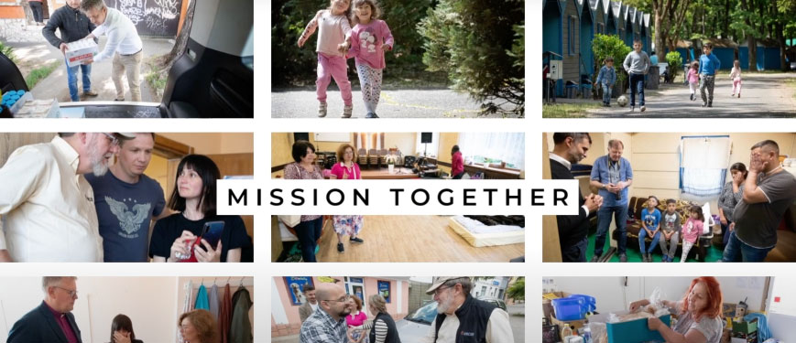

Recently those of us in our denomination who meet with ***Bishop Alsted*** and the United Methodists in Ukraine received an update from **District Superintendent *Oleg Starodubets***. After receiving permission to share this update, I wanted to communicate what **DS *Oleg*** had to say. Our Conference was generous in their support of Ukraine through our Annual Conference Mission Project 2023, and I know you would like to hear more. Each time I meet via Zoom with our Ukrainian colleagues, I am moved by their courage and commitment to our Lord and Savior. Their mission continues under the most difficult of circumstances. As you know from the news, Putin has increased the frequency of attacks on ALL of Ukraine. It is no longer simply the cities on the eastern front. Please continue to hold our United Methodist clergy, churches and the people of Ukraine in your prayers.

The following is the update from **DS *Oleg***. Keep in mind these ministries and events are occurring in the backdrop of war – its bombs, its destruction, and personal loss for so many.

1. The Ukraine UMC had a discipleship seminar from Dec 6-9, in Transcarpathia. Forty members from various local churches took part in it, with missionary *Hernando Montana* providing the teaching.
2. **Kharkiv UMC** is our most heroic church. The city is under the constant shelling since the first days of the war. In spite of this the church continues ministry, and Pastor Igor has committed to not leave the city even if one member remains.
3. Kyiv’s two United Methodist Churches are experiencing difficult times. Russian attacks have become more severe, with drone strikes almost daily in recent weeks. The church family there asks for prayers to persevere.
4. Lviv UMC continues to have regular services and engage the student ministry. In warmer months that had several retreats with youth.
5. Chernivsty UMC is able to lead their ministry in a relatively stable environment. Members are active in humanitarian ministry.
6. Our new church plant in Germany (near Hamburg) for Ukrainian refugees is growing fast. More new families have joined. It proves to be a vital ministry for those adjusting to a new environment.
7. Our UMC center for displaced persons in Uzhgorod, continues to be able to host more than 60 people at a time that come from the most difficult parts of Ukraine. All of them have tragic stories of loss.
8. Uzhgorod UMC continues regular services and an ongoing construction project that will provide more space for youth ministry and hospitality as they welcome displaced persons from the shelter each Sunday.
9. Kamyanitsa UMC heads up the district children and youth camps. Youth from the church take on more responsibilities as the actively serve.
10. Finally, Sredne UMC is a unique ministry among Roma people located in the village. More have joined since the start of the war.

Please keep praying for Ukraine and the Ukraine United Methodist Church. Pray that God will help us move forward in our vision to start ministries in new cities, towns, and villages throughout Ukraine.

***Rev. Oleg Starodubets***  
**District Superintendent**



**Growth opportunity**

Creation Care  
The Creation care team is in the process of receiving information and ideas for us as individuals, for our neighbors, and for God's creation.  The monthly 90 minute sessions are attended by people from various denominations from all over the country.  Our first suggestion was to use reusable plates and silverware for our church gatherings either from home or Sunrise.  We will continue to collect ideas to share.  There is still room for interested individuals to join us.   
Your Green Team,  
Stephanie Newcomer, Alice Mildenberger



**Church News**

***Office Hours***

Monday & Wednesday 10:30AM Rev. Galene in office

Tuesday-Thursday 9:00-1:00PM Office Open

Pastoral Emergencies – 623.236.3969

If you would like to meet with Rev. Galene,

please contact the office at 623-780-1008

**Help with Worship:**

We are still looking for greeters, liturgist and AV persons to assist with our Sunday worship services. Being a greeter is a great way to get to know all who attend Sunrise UMC. Please let Rev. Galene or Joyce know if interested.

**Building Use:**

We have about 9 outside groups that meet in the building each month. If you would like more information about these groups, please contact the church office.

**Daily Prayer:**

[prayer.forwardmovement.org](http://prayer.forwardmovement.org/)

[dailyofficeexpress.org](http://dailyofficeexpress.org/)

[lectionary.library.vanderbilt.edu/daily.php?year=B](http://lectionary.library.vanderbilt.edu/daily.php?year=B)

Upperroombooks.com/neweverymorning/

If there have been any changes to your information; address, phone number, email address, please email the office at hello@sunrisephx.org and let them know of the changes. Thank you!

**I Want To Pray**

Sign-up sheet is on the back table. Please consider joining this ministry. You need to come 15 minutes early on Sunday morning and pray in the prayer room.

**Find Sunrise UMC on Social Media,**

**[sunriseumcphx](https://www.facebook.com/sunriseumcphx/)** [**#sunriseumcphx**](https://www.instagram.com/sunriseumcphx/)



[This Photo](http://commons.wikimedia.org/wiki/File:Facebook_Shiny_Icon.svg) by Unknown Author is licensed under [CC BY-SA](https://creativecommons.org/licenses/by-sa/3.0/)



[This Photo](https://radiouniversidad.uca.edu.ni/instagram-agrega-stickers-animados-historias/) by Unknown Author is licensed under [CC BY-SA](https://creativecommons.org/licenses/by-sa/3.0/)

**Easy Ways to Give:**

**Shop at Fry’s and help Sunrise UMC. 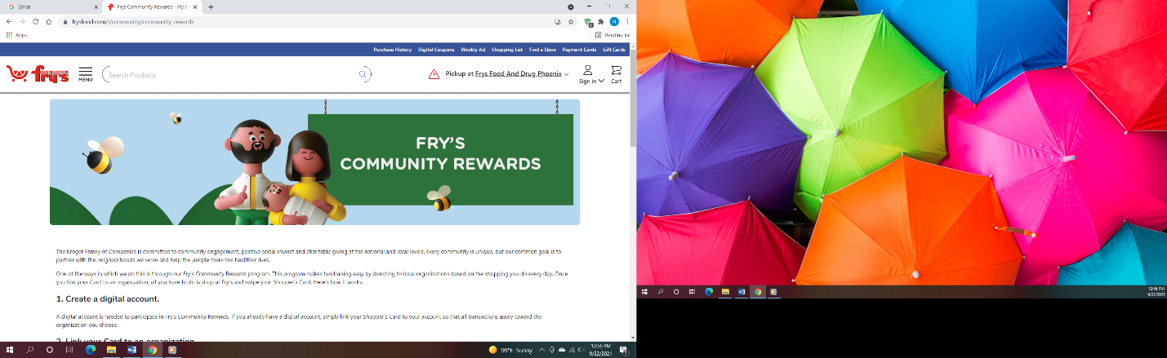Fry’s Community Rewards program**. This program makes fundraising easy by donating to local organizations based on the shopping you do every day. Once you link your Card to an organization, all you have to do is shop at Fry’s and swipe your Shopper’s Card. Need help signing up, please, let the office know.

** We also collect cans; plastic bottles**

**Movie CD’s and TV Programs:**

Sunrise UMC has been given movie CD’s and have started a library. The CD’s are in room #4 in the fellowship hall. You may check out the movie to view and then return when you have watched it. Anyone who has movies they wish to donate can place on the shelf. Enjoy!



**NEWS FROM OUR MINISTRIES**

**Trustees:**



[This Photo](http://www.picserver.org/t/trustee.html) by Unknown Author is licensed under [CC BY-SA](https://creativecommons.org/licenses/by-sa/3.0/)

Greetings Sunrise from your trustees!

Trustees meet the first Wednesday of the month at 6:00pm.

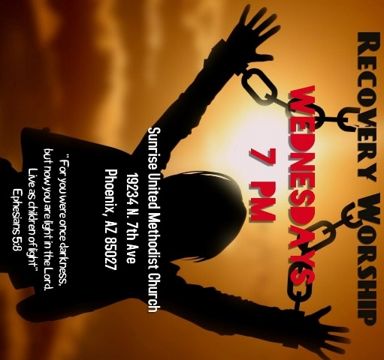

**Recovery Worship Service:**

The Wednesday Recovery Services is growing. We have great speakers, devotions, prayer and even a baptism. Everyone is welcome to join us on Wednesdays at 7:00PM.

To sign up to do devotions or for more information contact Art Erb or Charles Taylor.



[This Photo](http://justinsomnia.org/2009/09/breakfast-in-heathrow/) by Unknown Author is licensed under [CC BY](https://creativecommons.org/licenses/by/3.0/)

**Men’s Fellowship will have a breakfast on Saturday February 3rd at 8:00am.**

**NEWS FROM OUR MINISTRIES**

**Missions ~ Mission Committee**

**Ongoing Mission Projects**

The Justa Center is still in need of the following items: **Can tuna, can chicken, can beans and can veggies; boxes or bags of pasta; laundry pods; and large bottles of shampoo.** They are also in need of: **warm clothing, coats, sweaters, hoodies, socks,** please bring to church and it will be taken to Justa Center



They are always in need of shoes, sunscreen, toothpaste (2.30z or larger) shampoo and water. Donations of money is always welcome. Place in envelope and write Missions- Justa Center.

Mission Committee meets the 2nd Wednesday of the Month at 11:00am.

Mission Committee Members are:

Linda DeYoung Pat Heppele Alice Mildenberger Rich Mildenberger

Dana Fischer Frank Fischer

Donna and Carl Richeson

**Prayer Shawl Ministry**



[This Photo](http://sweetbeebuzzings.blogspot.com/2014/08/nordic-shawl.html) by Unknown Author is licensed under [CC BY-SA-NC](https://creativecommons.org/licenses/by-nc-sa/3.0/)

Prayer Squares are here!  Check out the basket at the back of the sanctuary.

These are great visual reminders to pray.

Placed in a pocket, purse, beside your bed, or in the car, the prayer square serves as a reminder: a reminder to pause and pray and also a reminder that someone cares about you.  Take one for yourself or someone you know.   
Prayer Shawls continue to be available to give to someone with a specific need.

**We will gather on the first Saturday of the month, February 3 at 9:00am. There will be yarn, knitting needles, crochet hooks, and people to assist as needed.  Join us as for this ministry.**

Contact Alice Mildenberger for more information.

**Love For Teachers:**  Missions will be collecting items for teachers at Constitution Elementary School February 4th-25th.  The items will be used in the classroom and as rewards for students.  School items such as:  Kleenex, hand sanitizer, note pads, stickers, pencils, etc. or wrapped candy may be left on the table in the narthex.  Thank you for your support.

   
  
The 2024 weeks are April 7-14 and October 13-20. Please mark your calendars and plan on joining us for this mission.  If you have questions, contact Richard and Alice Mildenberger



Karen G. February 5



Allan & Janice F. February 14

Please let us know if we have missed your special day.

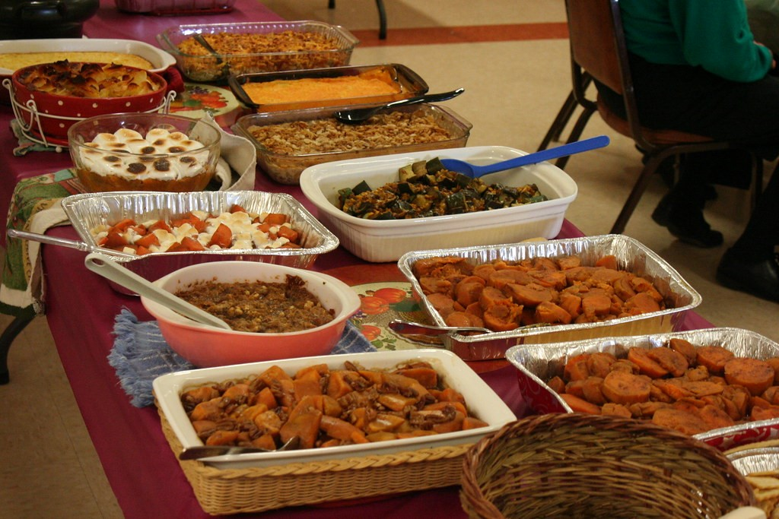

Pot Luck to celebrate the February Birthdays and Anniversaries

February 25th 12:00 noon

Bring your best potluck dish.

Come and enjoy good food and fellowship.

**NEWS FROM OUR MINISTRIEs**

**Prayer Ministry**

***What we do today is more important than what we plan to do in the future.***

*-* ***Jack Hyles***

**

**Prayer Team**

|  |
| --- |
| Rev. Galene |
| Art Erb |
| Susan Rowland |
| Roy Trevolt |
| Mary Stein |
| Katy Moore-Odoud |
| Christine Powell |
| Susan Allen |
| Ralph Pittman |
| Dana Fischer |

**NEWS FROM oUR MINIST****ry**

**Finance Ministry**



**FACEBOOK** – are you a participant on Facebook? If so, please LIKE Sunrise. It is a new page and we need people to LIKE us @

**[sunriseumcphx](https://www.facebook.com/sunriseumcphx/)** [**#sunriseumcphx**](https://www.instagram.com/sunriseumcphx/)



[This Photo](http://commons.wikimedia.org/wiki/File:Facebook_Shiny_Icon.svg) by Unknown Author is licensed under [CC BY-SA](https://creativecommons.org/licenses/by-sa/3.0/)



[This Photo](https://radiouniversidad.uca.edu.ni/instagram-agrega-stickers-animados-historias/) by Unknown Author is licensed under [CC BY-SA](https://creativecommons.org/licenses/by-sa/3.0/)