 Sunrise UMC

**January**

**2024**



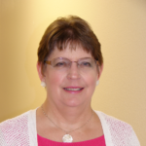

From the desk of your Pastor

Calendar Musings from the Pastor

I think January was my favorite month when I lived in New Jersey. Yes, it could be bitterly cold and shoveling snow (some years absent, some years very prevalent) is no fun. But January was a surprise, and that part, I liked. January reminded me that people of faith live according to a different calendar than the rest of the world. January was truly, in the darkest, coldest time of the year, a season of light.

We live in a well-regulated world that has no knowledge or interest in our faith lives. This creates interesting and competing seasons, as well as a distraction for we who want to follow God With Us. Consider some of these seasons:

For Retailers: Halloween, Christmas (often including the 12 Days of Savings season), then after-Christmas sales.

For TV: Halloween, Hallmark and Children’s Thanksgiving, Christmas, College Bowls, NFL Playoffs.

For Cities and Counties: Christmas decorations and festivities followed by Tree recycling.

For HOAs: Holiday decorations beginning in October and finished by January 2nd.

But for me, the seasons are:

All Saints, a time to study eschatology/the end times, and finally the reign of Christ celebrated on Christ the King Sunday, all in November.

The great Trivium of Light: Advent (with the great Antiphons beginning December 18) – Christmas – Epiphany (end of November to January 6), leading into a lesser season of light running between the Baptism of the Lord and Ash Wednesday (January to February).

But then there was New Jersey, state of many faith traditions, where Christmas lights shine well into the dark winter nights of January. It was such a joy to be driving down some dark country road in the middle of January and see Christmas lights in the distance. You see, New Jersey has many members of the Eastern Christian traditions: Greek Orthodox, Russian Orthodox, etc., and they follow a different calendar. For instance, the Nativity of the Lord is celebrated on January 7th, with their Christmas season running through January 19th. Just as we in the Western Church tradition are taking our decorations down, those in the Eastern Tradition are finally getting to celebrate.

What a blessed surprise of light January held! What a great way to start a new year! May you, too, be blessed with good surprises – in January and throughout the year!

Pastor Galene



**Preaching Schedule January 2024**

January 7 – Feast of Epiphany – Waiting No More – Seeking & Finding, Matthew

2:1-12, Isaiah 60:1-6

**NEWS FROM the conference**



Greetings Faithful,

The 2024 District Leadership Conference is rapidly approaching. The topic of the workshop is conflict management, featuring Rev. April Casperson, Director of Enrollment Management Methodist Theological School in Ohio. In the workshop we will explore the five conflict management styles, take an informal conflict management style assessment, and explore ways to manage conflict. Then we will explore the role of trust, credibility, and power in organizational culture, and consider what individuals and organizations can do when trust breaks down.

For more information and to register, please click the hyperlink below which will take you directly to the District Leadership Conference registration information page. Please disseminate this information to those who may be interested in attending. Please note, space is limited, and registration is filling up fast.

<https://dscumc.org/blog/2023/12/01/dont-miss-the-2024-district-leadership-conference/>

Each leadership conference will occur on Saturday mornings through early afternoons in person with lunch provided. Registration is required. Click on the links below to register for the event near you.

East & West Districts Leadership Conference

**When:**February 3, 2024 – 8:30 a.m. – 12:30 p.m.

**Where:**[Cross in the Desert UMC](https://crossinthedesert.org/), Phoenix, AZ.

[East & West Registration](https://dscumc.org/event/east-west-districts-leadership-conference-2024/)

Please contact Jeannine Marinoni at the District Office with any questions at[jmarinoni@dscumc.org](mailto:jmarinoni@dscumc.org).

If you are interested in having a table at a District Leadership Conference, please contact the appropriate District Superintendent for further information.

Next Leadership Talk with Rev. Dr. Kristin Hansen

by [Jeannie Ward](https://dscumc.org/author/jward/) | Dec 8, 2023 | [Clergy and Lay Leadership Development](https://dscumc.org/blog/category/clld/), [Conference Newsletter](https://dscumc.org/blog/category/news/newsletter-mailchimp2020/)

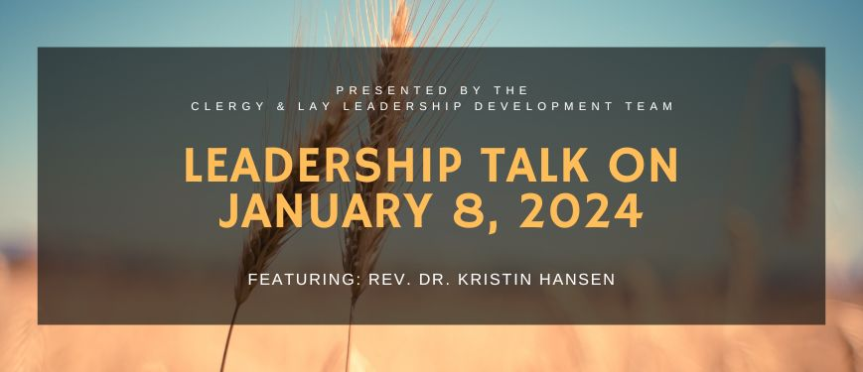

On January 8, 2024, at 7:00 PM Arizona Time (6:00 PM Nevada Time), the Clergy and Lay Leadership Development team from the Desert Southwest Conference is hosting a Leadership Talk on Zoom featuring presenter Rev. Dr. Kristin Hansen. Her presentation from ‘Friedman’s Fables’ in February 2023 was very interesting and thought-provoking, so we look forward to this next presentation.

About the Presenter

Rev. Dr. Kristin Hansen has served God in the Church for 24 years locally, nationally, and internationally with all ages in churches, choirs, conventions, curriculum, publishing, radio, and internet ministry. But, finds the most fulfilling and challenging ministry has always been between two people. She served and was ordained in the Church of God (Anderson, Indiana) before serving and transferring to the United Methodist Church in the Desert Southwest. She is currently serving as the Pastor appointed to Desert Foothills UMC in the Ahwatukee area of Phoenix, AZ.



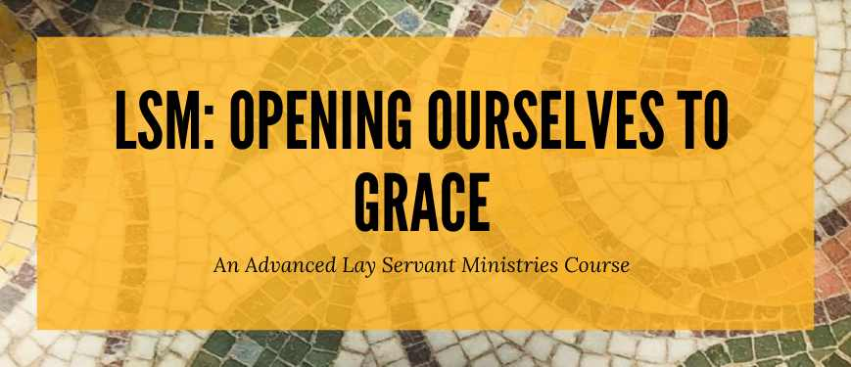The West District of the Southwest Desert Conference of the United Methodist Church is pleased to announce it will be offering: The Advanced Lay Servant Ministries course:

**Opening Ourselves to Grace Basic Christian Practices**

**WHEN:**Saturday, January 13, 2024 from 9:00 am – 3:00 pm

Saturday, January 20, 2024 from 9:00 am – 3:00 pm

**WHERE:**Dove of the Desert United Methodist Church

7201 Beardsley Rd, Glendale, AZ

This course helps lay servant leaders embrace and communicate a Wesleyan understanding of basic Christian practices (works of piety and mercy) as means of grace.

The participants’ text *Opening Ourselves to Grace: The Means of Grace and Discipleship* by Steven W. Manskar is required reading for this program. You are required to have read the text prior to the course starting.

The cost for this course is **$15** and is payable upon registration. You can register and pay online. If paying by cash or check, bring it to the class and give it to the instructor.

Once you register for this course, you will receive a confirmation email with a link to the book and other information.

If you have further questions, you may contact Jill Cristina-Krebs, the West District LSM Director, at email [WestLayServants@dscumc.org](mailto:WestLayServants@dscumc.org).

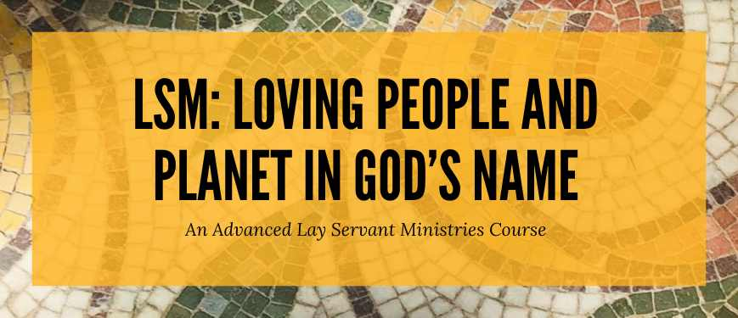

The Desert Southwest Conference of the United Methodist Church is pleased to announce it will be offering the Advanced Lay Servant Ministries course “LSM Loving People and Planet in God’s Name” on three consecutive Mondays, **January 15, 22, and 29, 2024,**at **5:30-9:00 pm**via **Zoom**. All sessions must be attended to receive credit for completion.

This course empowers lay participants to engage local churches in creation care and environmental justice. Lay participants will see this work as the appropriate response of disciples of Jesus Christ to the realities of climate change. This course helps communities grow deeper in their faith through the caring creation of practical and context-specific spiritual practices that mitigate the effects of reckless human consumption.

The text *“Climate Justice: A Call to Hope and Action”,* Second Edition, Edited by Pat Watkins, is required reading for this program.

The cost for this course is**$15.00** and is payable upon registration. Either register and pay online or call the Conference LSM Director at 317-730-0162 to complete the registration and send the payment by check to DSCUMC Treasurer, PO Box 32830, Phoenix, AZ 85064 with instructions to deposit into the LSM account.

Once you register for this course, you will receive a confirmation with a link to the book, the Zoom link, and other information.

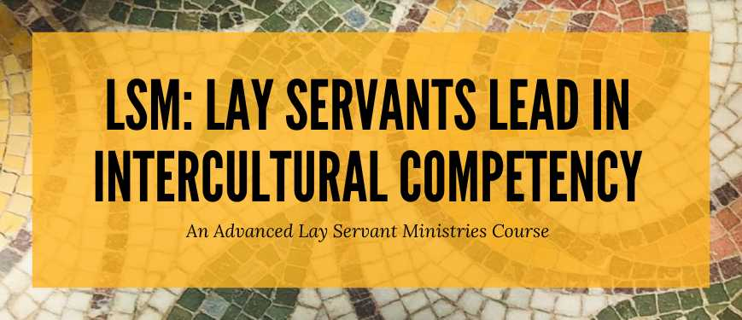

The Desert Southwest Conference of the United Methodist Church is pleased to announce it will be offering the Advanced Lay Servant Ministries Course – Lay Servants Lead in Intercultural Competency on Saturdays,**February 10, 17, and 24** from **9 a.m.** to **12:30 p.m**. via **Zoom**. All three classes must be attended for credit. This course will teach Lay Servants the Biblical basis for diversity, to understand Culture and Bias, to recognize Implicit Bias, and will focus on the joys, challenges, and opportunities of embracing diversity and counteracting bias. The text “Unconscious Bias” by **Pamela Fuller** is required reading for this program. PDF materials will also be provided.

The cost for this course is **$15.00** and is payable upon registration. Either register and pay online or call the Conference LSM Director at **317-730-0162** to complete the registration and send the payment to the DSCUMC Treasurer, PO Box 32830, Phoenix, AZ 85064 with instructions to deposit into the LSM account.

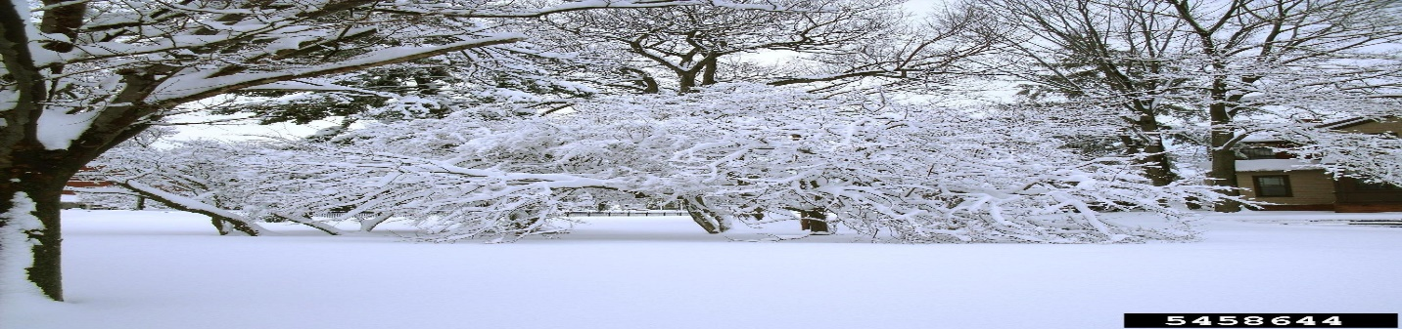

**Growth opportunity**

Creation Care  
The Creation care team is in the process of receiving information and ideas for us as individuals, for our neighbors, and for God's creation.  The monthly 90 minute sessions are attended by people from various denominations from all over the country.  Our first suggestion was to use reusable plates and silverware for our church gatherings either from home or Sunrise.  We will continue to collect ideas to share.  There is still room for interested individuals to join us.   
Your Green Team,  
Stephanie Newcomer, Alice Mildenberger



**Church News**

***Office Hours***

Monday & Wednesday 10:30AM Rev. Galene in office

Tuesday-Thursday 9:00-1:00PM Office Open

Pastoral Emergencies – 623.236.3969

If you would like to meet with Rev. Galene,

please contact the office at 623-780-1008

**Help with Worship:**

We are still looking for greeters, liturgist and AV persons to assist with our Sunday worship services. Being a greeter is a great way to get to know all who attend Sunrise UMC. Please let Rev. Galene or Joyce know if interested.

**Building Use:**

We have about 9 outside groups that meet in the building each month. If you would like more information about these groups, please contact the church office.

**Daily Prayer:**

[prayer.forwardmovement.org](http://prayer.forwardmovement.org/)

[dailyofficeexpress.org](http://dailyofficeexpress.org/)

[lectionary.library.vanderbilt.edu/daily.php?year=B](http://lectionary.library.vanderbilt.edu/daily.php?year=B)

Upperroombooks.com/neweverymorning/

If there have been any changes to your information; address, phone number, email address, please email the office at hello@sunrisephx.org and let them know of the changes. Thank you!

**I Want To Pray**

Sign-up sheet is on the back table. Please consider joining this ministry. You need to come 15 minutes early on Sunday morning and pray in the prayer room.

**Find Sunrise UMC on Social Media,**

**[sunriseumcphx](https://www.facebook.com/sunriseumcphx/)** [**#sunriseumcphx**](https://www.instagram.com/sunriseumcphx/)



[This Photo](http://commons.wikimedia.org/wiki/File:Facebook_Shiny_Icon.svg) by Unknown Author is licensed under [CC BY-SA](https://creativecommons.org/licenses/by-sa/3.0/)



[This Photo](https://radiouniversidad.uca.edu.ni/instagram-agrega-stickers-animados-historias/) by Unknown Author is licensed under [CC BY-SA](https://creativecommons.org/licenses/by-sa/3.0/)

**Easy Ways to Give:**

**Shop at Fry’s and help Sunrise UMC. 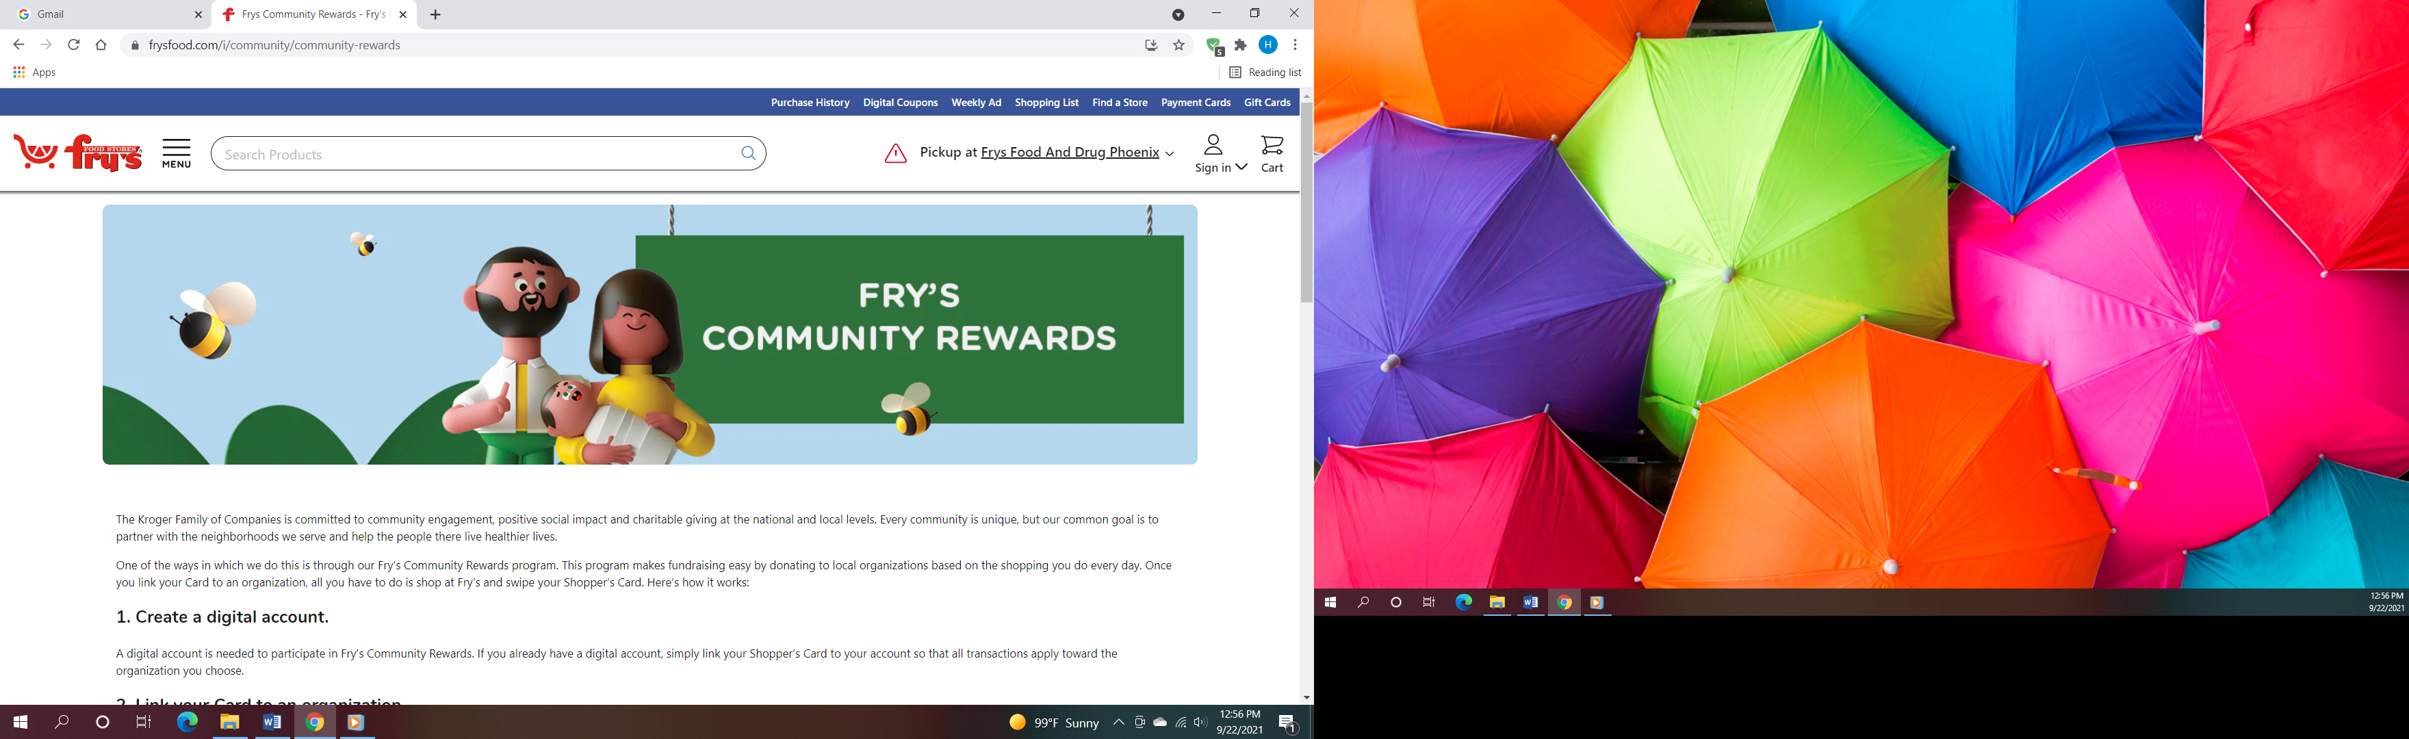Fry’s Community Rewards**

**program**. This program makes fundraising easy by donating to local organizations based on the shopping you do every day. Once you link your Card to an organization, all you have to do is shop at Fry’s and swipe your Shopper’s Card. Need help signing up, please, let the office know.

** We also collect cans; plastic bottles**

**Movie CD’s and TV Programs:**

Sunrise UMC has been given movie CD’s and have started a library. The CD’s are in room #4 in the fellowship hall. You may check out the movie to view and then return when you have watched it. Anyone who has movies they wish to donate can place on the shelf. Enjoy!



**NEWS FROM OUR MINISTRIES**

**Trustees:**



[This Photo](http://www.picserver.org/t/trustee.html) by Unknown Author is licensed under [CC BY-SA](https://creativecommons.org/licenses/by-sa/3.0/)

Greetings Sunrise from your trustees!

Trustees will meet Dec. 2nd after the breakfast. They will be placing flags for the plants to be delivered on Dec. 5th.

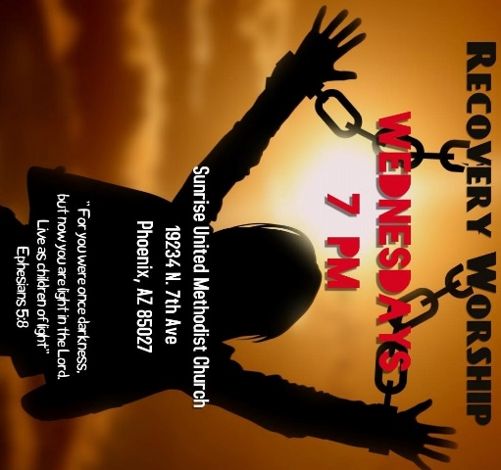

**Recovery Worship Service:**

The Wednesday Recovery Services is growing. We have great speakers, devotions, prayer and even a baptism. Everyone is welcome to join us on Wednesdays at 7:00PM.

To sign up to do devotions or for more information contact Art Erb or Charles Taylor.



[This Photo](http://justinsomnia.org/2009/09/breakfast-in-heathrow/) by Unknown Author is licensed under [CC BY](https://creativecommons.org/licenses/by/3.0/)

**Men’s Fellowship will have a breakfast on Saturday January 6th at 8:00am at Sunrise UMC.**

**NEWS FROM OUR MINISTRIES**

**Missions ~ Mission Committee**

**A big THANK YOU for your outreach to Constitution Elementary school by being a Christmas angel. It was greatly appreciated.**

**Ongoing Mission Projects**

The Justa Center is still in need of the following items: **Can tuna, can chicken, can beans and can veggies; boxes or bags of pasta; laundry pods; and large bottles of shampoo.** They are also in need of: **warm clothing, coats, sweaters, hoodies, socks,** please bring to church and it will be taken to Justa Center



They are always in need of shoes, sunscreen, toothpaste (2.30z or larger) shampoo and water. Donations of money is always welcome. Place in envelope and write Missions- Justa Center.

Mission Committee meets the 2nd Wednesday of the Month at 11:00am.

Mission Committee Members are:

Linda DeYoung Pat Heppele Alice Mildenberger Rich Mildenberger

Dana Fischer Frank Fischer

Donna and Carl Richeson

**Prayer Shawl Ministry**



[This Photo](http://sweetbeebuzzings.blogspot.com/2014/08/nordic-shawl.html) by Unknown Author is licensed under [CC BY-SA-NC](https://creativecommons.org/licenses/by-nc-sa/3.0/)

Prayer Squares are here!  Check out the basket at the back of the sanctuary.

These are great visual reminders to pray.

Placed in a pocket, purse, beside your bed, or in the car, the prayer square serves as a reminder: a reminder to pause and pray and also a reminder that someone cares about you.  Take one for yourself or someone you know.   
Prayer Shawls continue to be available to give to someone with a specific need.

**We will gather on the first Saturday of the month, January 6th at 9:00am. There will be yarn, knitting needles, crochet hooks, and people to assist as needed.  Join us as for this ministry.**

Contact Alice Mildenberger for more information.

House of Refuge  
The next meal served at House of Refuge will be Thursday, January 18th.  All are welcome to participate.  
Contact Richard and Alice Mildenberger for information

   
  
The 2024 weeks are April 7-14th and one in October. Date to be confirmed. Please mark your calendars and plan on joining us for this mission.  If you have questions, contact Richard and Alice Mildenberger



Patricia H. Jan. 3

Taylor A. Jan. 7

Angie E. Jan. 15

Teresa C. Jan. 24

Donna R. Jan. 25

Jean D. Jan. 30



Jack & Julie M. January 2

Please let us know if we have missed your special day.

**NEWS FROM OUR MINISTRIEs**

**Prayer Ministry**

***What we do today is more important than what we plan to do in the future.***

*-* ***Jack Hyles***

**

**NEWS FROM oUR MINIST****ry**

**Finance Ministry**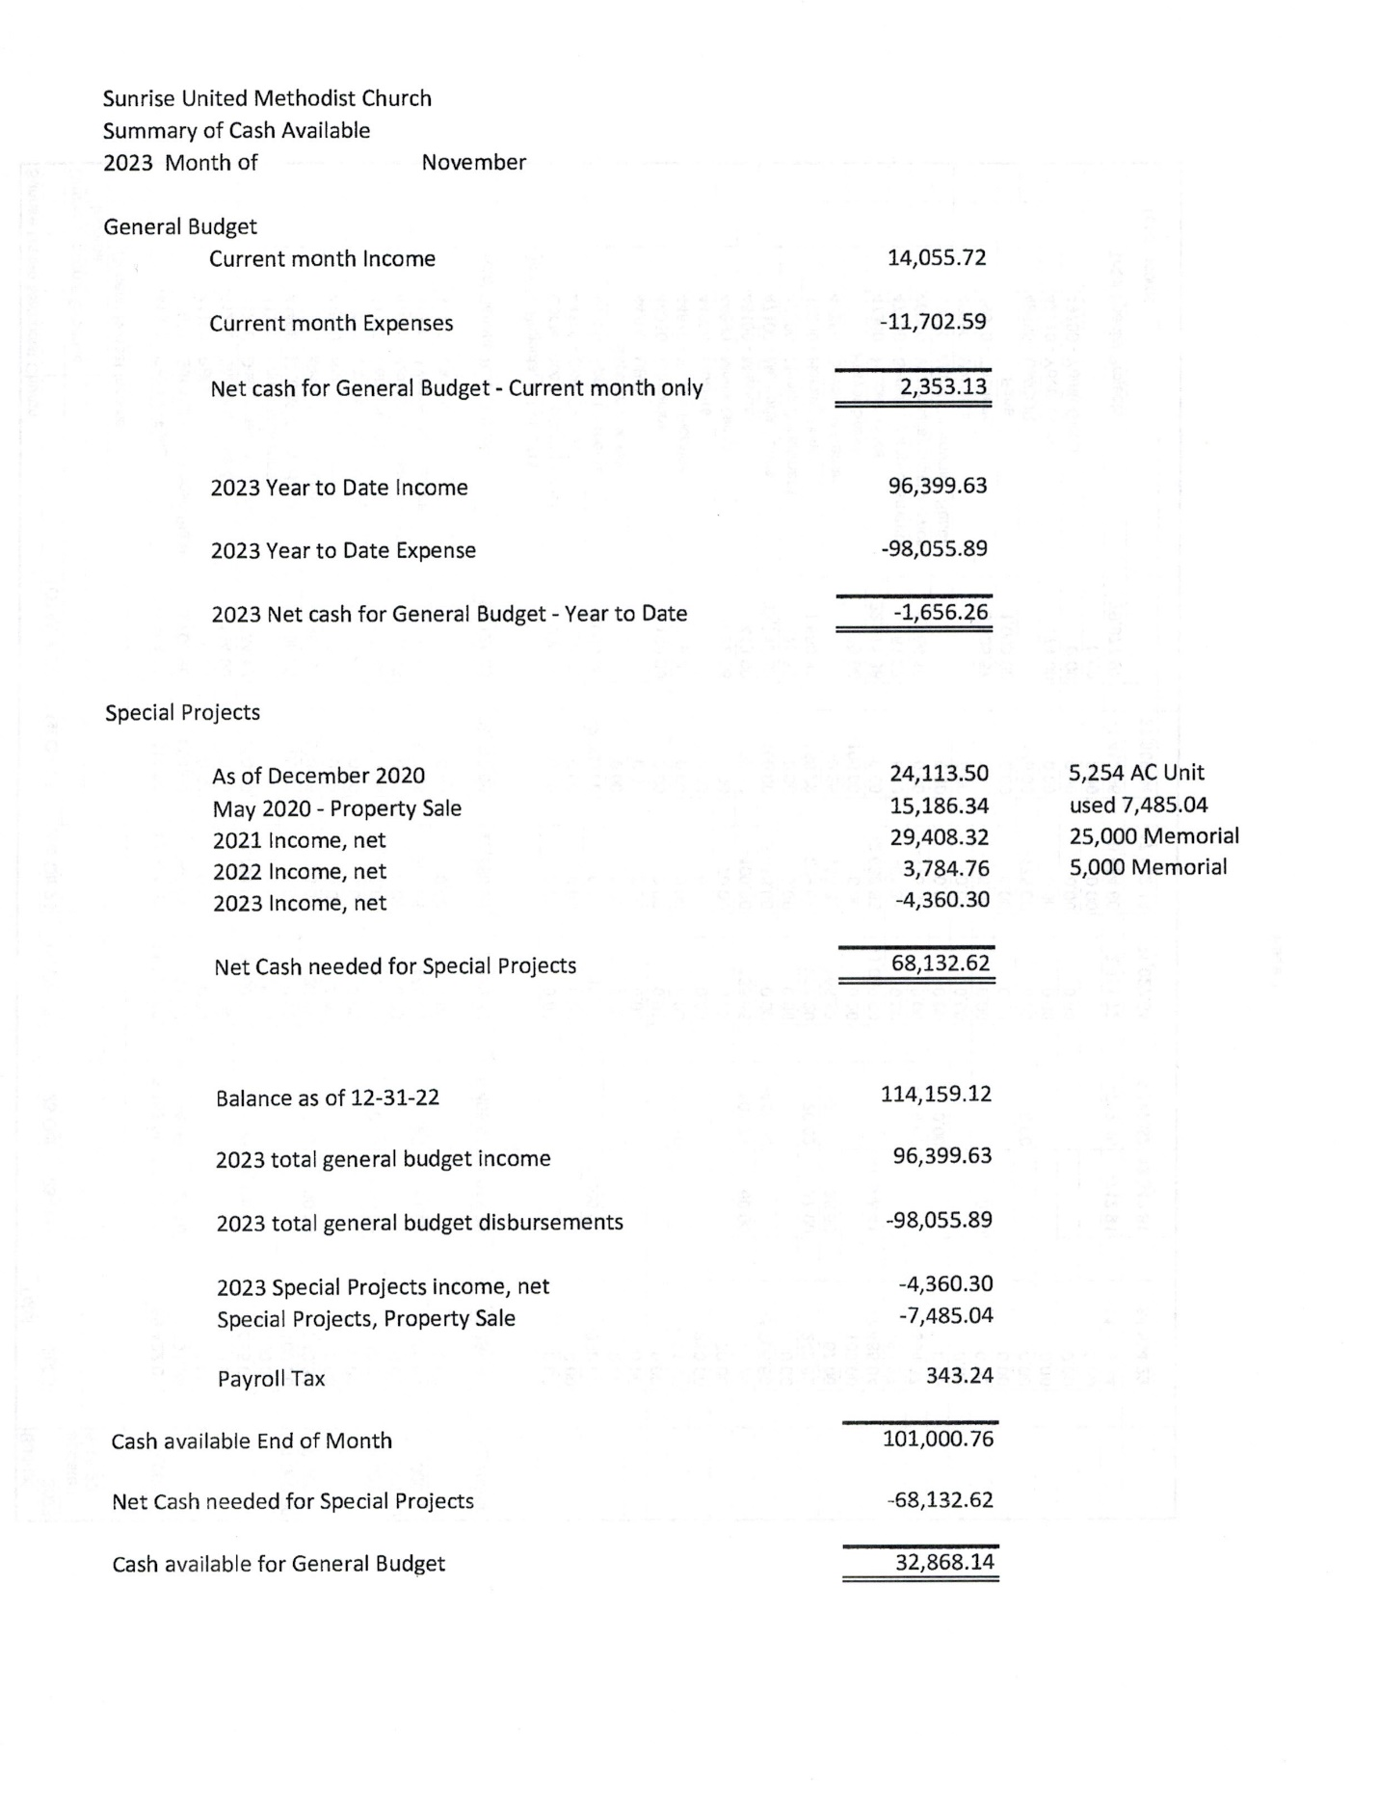



**FACEBOOK** – are you a participant on Facebook? If so, please LIKE Sunrise. It is a new page and we need people to LIKE us @

**[sunriseumcphx](https://www.facebook.com/sunriseumcphx/)** [**#sunriseumcphx**](https://www.instagram.com/sunriseumcphx/)



[This Photo](http://commons.wikimedia.org/wiki/File:Facebook_Shiny_Icon.svg) by Unknown Author is licensed under [CC BY-SA](https://creativecommons.org/licenses/by-sa/3.0/)



[This Photo](https://radiouniversidad.uca.edu.ni/instagram-agrega-stickers-animados-historias/) by Unknown Author is licensed under [CC BY-SA](https://creativecommons.org/licenses/by-sa/3.0/)