 Sunrise UMC

**May**

**2023**



From the desk of your Pastor

 As I was looking at the calendar and what occurs in May, the first thing I noticed was that our country’s National Day of Prayer is on May 4th. Now folks, I am NOT trying to be political by what I am going to say in what follows, at least it isn’t meant that way. If we, (U.S.) ever needed prayer, it is now. I say this because of the deep divisions in our country regarding the political situation we hear of on TV and on the radio. We also read about the strife every day in the newspaper. I am asking each of you to join with me in praying for our country and the coming together of our citizens. If Jesus could overcome death on a cross, we, the citizens of our country, can become one again and the divisions that have occurred and are still occurring can be overcome. Let’s make it our goal to pray for this to occur.

When I think about our country I am so proud to be an American, as I believe most (if not all) of you are. Last month my wife Joyce and I were part of a team from our Lions Club that went to schools and offered up a program called “Flags For First Graders.” Before giving each first grader a flag we presented a program sharing what our flag stood for and what each color and the stars and stripes represented and meant. From our country’s very beginning men fought for liberty, giving themselves up so that we could be free and live in a country that was free. That means we are free to disagree, we are free to vote for our leaders, attend the church or house of worship that we chose. We don’t have to worry about being locked up because our political belief is different from the party in power. I Praise God for the USA

After church last Sunday I was asked by a church member what the different colors upon the cross and the altar table represented? I responded that the colors represented the Christian Season on the calendar. On April 9th we entered the Easter Season which is NOT just one week. There are 7 Sundays in the Easter Season, thus you will see White represented on the Altar and Cross and I will wear a White Stole over my robe. White represents God and purity. On the last of those Sundays we will remember Jesus’ Ascension. Dear Ones, this means that we have at least seven weeks to be lifting up prayers for our country and the divisions that have separated so many. On Sunday, May 28th the church celebrates our next Christian Season. That is the Season of Pentecost, red is the color you will see on the altar and cross and I will wear a red stole. In the United Methodist Church John Wesley, the founder of the Methodist Movement, shared that “his heart was strangely warmed” as he walked along Aldersgate Street in London. That is when he said he felt the Holy Spirit coming upon him. Thus, in Methodism we have the cross and the flame (representing the Holy Spirit) as our emblem or symbol. Pentecost is known as the time of the birth of the church. It is when the Holy Spirit came upon the people and some began speaking in tongues.

Again, Louie, you have been taught not to bring politics up in the church but speaking in tongues is another way that might be thought of doing so. You see, for some, the speaking in tongues or “glossolalia” is not understood, uncomfortable and frightening. When the Holy Spirit came upon many that first day of Pentecost words were spoken that didn’t make much sense to those who might have been near. The Apostle Paul said that one who speaks in a tongue “Speaks not to men but to God.” Your pastor does not speak in tongues but I respect and accept those that do. Again, the Apostle Paul says that the speaking in Tongues is one of the gifts given to some and not all of us have been given the same gifts. If anyone would like more details about Pentecost or the Speaking in tongues feel free to ask me and I will share what I know in more detail. By the way, there are churches that are known as Pentecostal Churches and their emphasis is on having the gift of speaking in tongues. The United Methodist Church is not one of those churches.

As I close out this month’s pastor’s article I want to ask you to place the date of Friday, May 12th on your calendar. That is the evening that our church’s men’s group will be hosting a Spaghetti Dinner and a Movie Night. You will see more details on that event elsewhere in this month’s issue of the newsletter.

**Shalom,**

**Pastor Louie**



**Pastor Louie’s May Sermon Schedule**

May 7th: “What Is Your Faith Built Upon?” John 14:1-14.

May 14th: “I Will Not Leave You” John 14:15-21.

May 21st: **Ascension Sunday -** “We Are Connected To God” Luke 24:44-53.

May 28th: **Pentecost Sunday –** “Real Communication Is A Good Thing” Acts 2:1-21.





**MOTHER’S DAY/FESTIVAL OF THE CHRISTING HOME**

Dear Ones,

I know that on the second Sunday of May in the United States we celebrate a day that Hallmark sells more cards than any other time of the year. Of course, the event is Mother’s Day, oh yeah, florist like that day too. I do not even need to tell you why they like that day, do I? For those that still have their moms it can be a joyous day but I say, it is a shame that it is only one day… Let me share why in what follows and I ask you to consider what I say here…

Why should there only be one day to Celebrate Mother’s Day and make a big deal of it? Should it not be every day? For some it is a sad day because of not having our mom’s with us anymore but yet for others it is a sad day because of estrangement. Yes, not every family is “Ozzie and Harriet” or “Father Knows Best.” You will note that at the top of this article it states, “The Festival of the Christian Home”. In our Protestant tradition the church wants to celebrate a time where we recognize homes that are made up of homes that provide love and care and that is what is celebrated. In today’s world we have many “broken homes” and there are substitutes for a birth mother.

Now, that I have the above out of the way here is where “the meat” of this article comes….

This month when we Celebrate the Festival of the Christian Home and Mother’s Day I want each of us to stop taking ALL our loved one for granted. We need to regularly tell them how much they mean to us and how important they are in our lives. I well remember how I took my late wife, Gwen, for granted, I mean she will always be there, right? For those of you that still have your parents alive take the time to spend some time with them. I was always too busy with my life and my friends to prioritize time with my parents. As “we grow-up” we sometimes get it, but at other times it is too late. I want your Mother’s Day to be a time of Joy for you all dear ones. For those of us that no longer have our mothers with us I am praying that you that focus in on the gift she was to you and be Glad for that Gift. For those that still have your moms with you I pray that you will cherish this time and tell your mom how much she means to you. But, last but not least I know from being “Disowned” by my family because I became a Christian how hard the Festival of the Christian Home or Mother’s Day can be. But, I still have a task for you… That task is writing a note or a letter to the one that you might be estranged from and letting them know that you care for them and miss them at this time. After writing and then sharing that letter with them, “Let Go” and give it to God. God did work out the estrangement in His time with my parents, may it be so for you too.

Dear Ones, we are all part of God’s Family and I thank Him for loving and caring for me as He does for you. May you feel His Love not only this month but each day.

Shalom,

Pastor Louie



**NEWS FROM the conferenc**

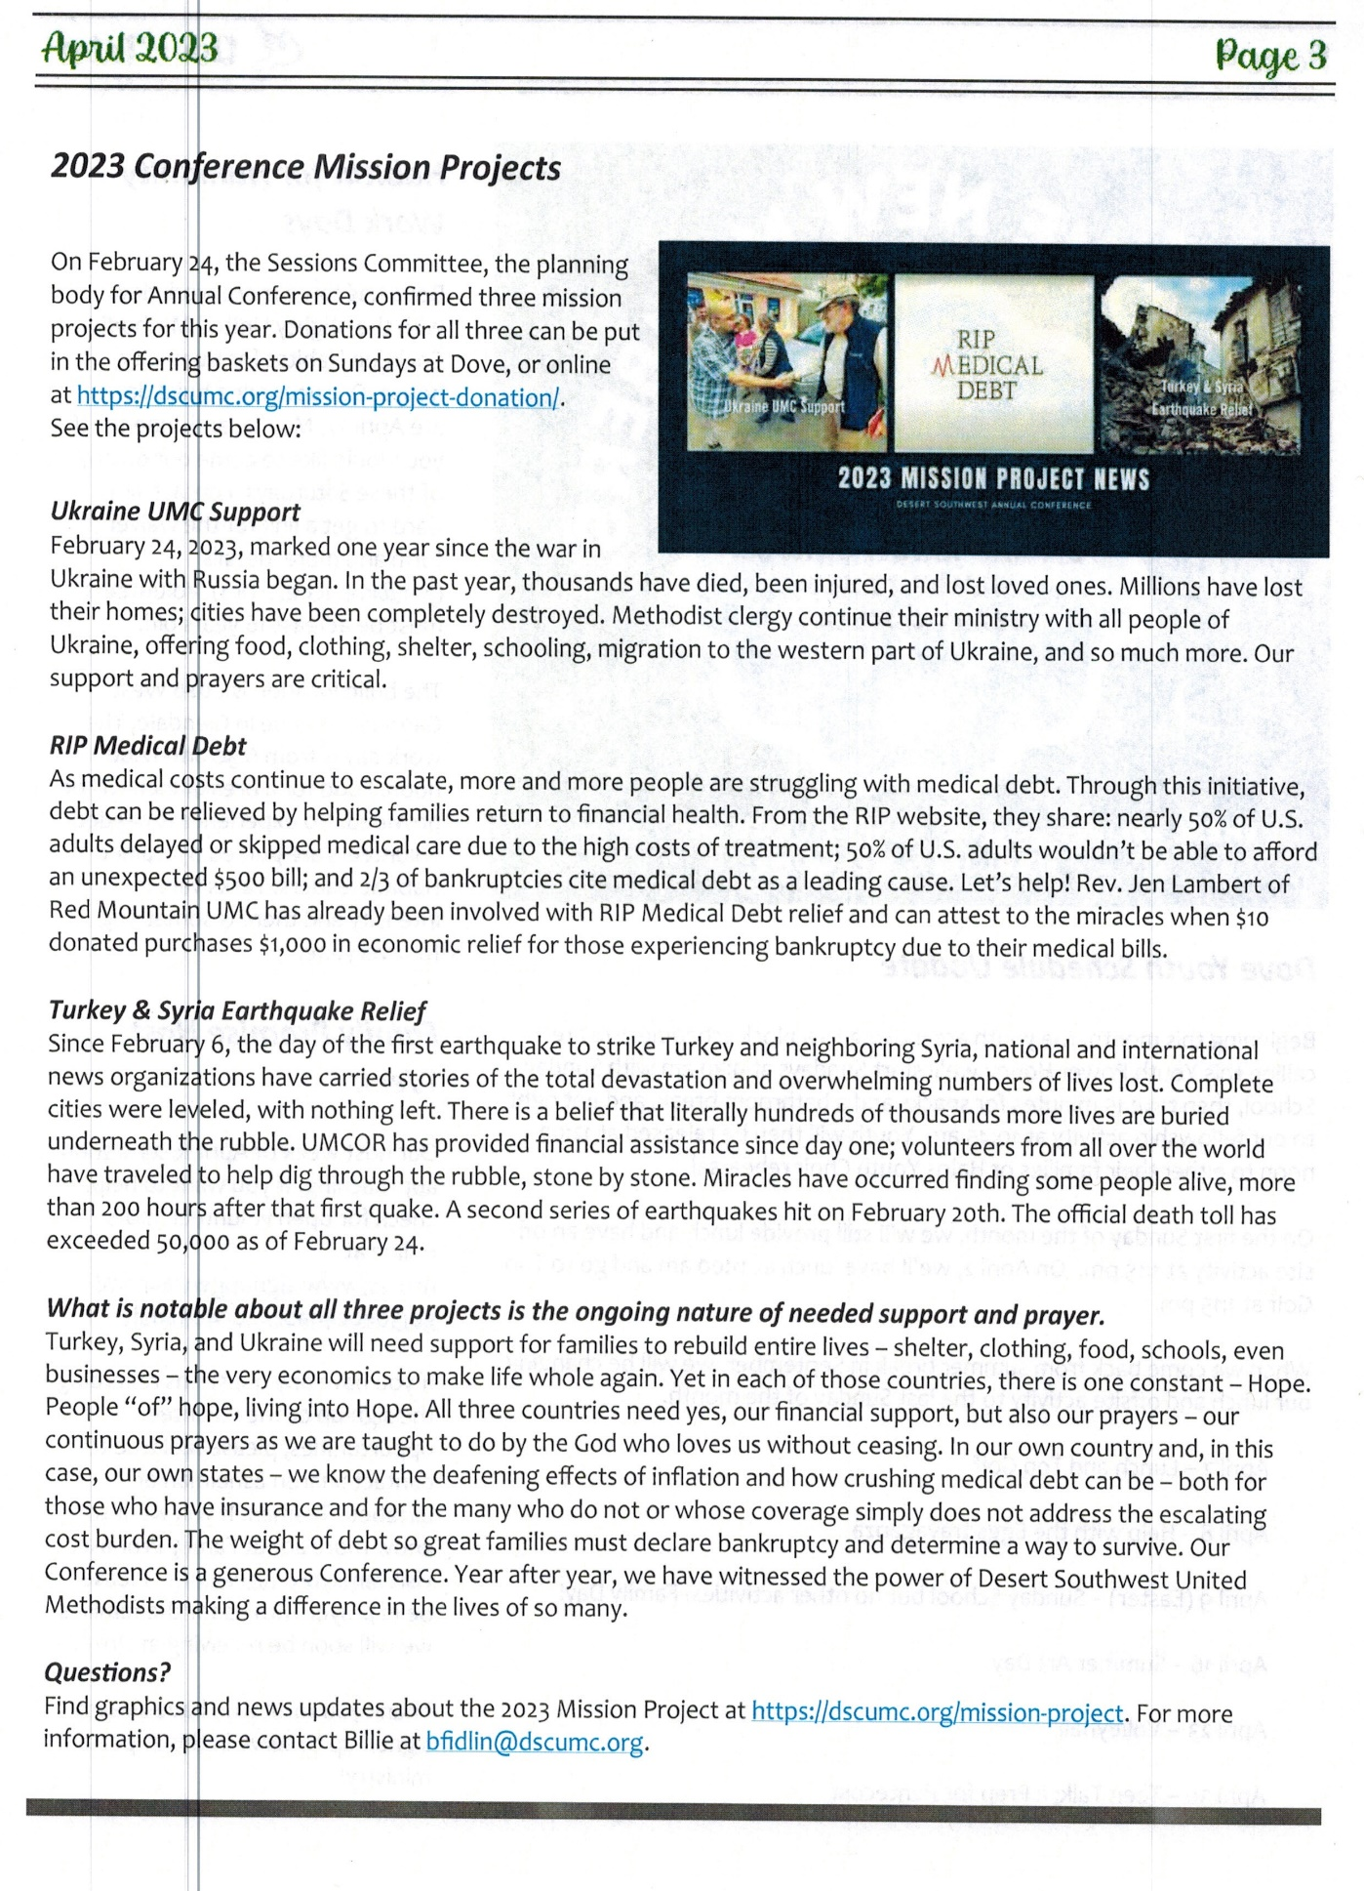

HELP UKRAINE

United Methodists respond to Ukraine Invasion: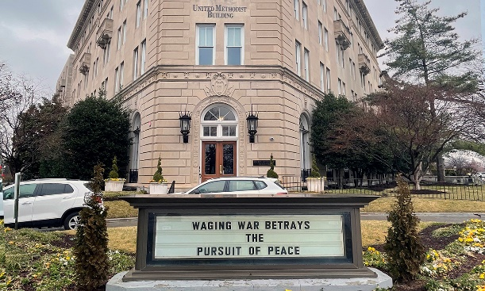

<https://www.umnews.org/en/news/united-methodists-respond-to-invasion-of-ukraine>

How we can help those in Ukraine:

Donations can be made to the United Methodist Committee on Relief’s International Disaster Response and Recovery through [Advance #982450](https://umcmission.org/advance-project/982450/).

United Methodist Global Ministries’ [Advance #14053A](https://umcmission.org/advance-project/14053a/) supports pastors in Ukraine and Moldova.

In case you were wondering if we are helping, go to below link to see how DSC is helping. <https://dscumc.org/blog/2023/01/05/update-on-ukraine/>

Creation Care  
The Creation care team is in the process of receiving information and ideas for us as individuals, for our neighbors, and for God's creation.  The monthly 90 minute sessions are attended by people from various denominations from all over the country.  Our first suggestion was to use reusable plates and silverware for our church gatherings either from home or Sunrise.  We will continue to collect ideas to share.  There is still room for interested individuals to join us.   
Your Green Team,  
Stephanie Newcomer, Alice Mildenberger

**Church News**

**Help with Worship:**

We are still looking for greeters and liturgist to assist with our Sunday

worship services. Please let Rev. Louie or Joyce know if interested.

**Building Use:**

We have about 9 outside groups that meet in the building each month. If you would like more information about these groups, please contact the church office.

**Daily Prayer:**

[prayer.forwardmovement.org](http://prayer.forwardmovement.org/)

[dailyofficeexpress.org](http://dailyofficeexpress.org/)

[lectionary.library.vanderbilt.edu/daily.php?year=B](http://lectionary.library.vanderbilt.edu/daily.php?year=B)

Upperroombooks.com/neweverymorning/

If there have been any changes to your information; address, phone number, email address, please email the office at hello@sunrisephx.org and let them know of the changes. Thank you!

**I Want To Pray**

Sign-up sheet is on the back table. Please consider joining this ministry. You need to come 15 minutes early on Sunday morning and pray in the prayer room.

**Find Sunrise UMC on Social Media,**

**[sunriseumcphx](https://www.facebook.com/sunriseumcphx/)** [**#sunriseumcphx**](https://www.instagram.com/sunriseumcphx/)



[This Photo](http://commons.wikimedia.org/wiki/File:Facebook_Shiny_Icon.svg) by Unknown Author is licensed under [CC BY-SA](https://creativecommons.org/licenses/by-sa/3.0/)



[This Photo](https://radiouniversidad.uca.edu.ni/instagram-agrega-stickers-animados-historias/) by Unknown Author is licensed under [CC BY-SA](https://creativecommons.org/licenses/by-sa/3.0/)

**Easy Ways to Give:**

**Shop at Fry’s and help Sunrise UMC. 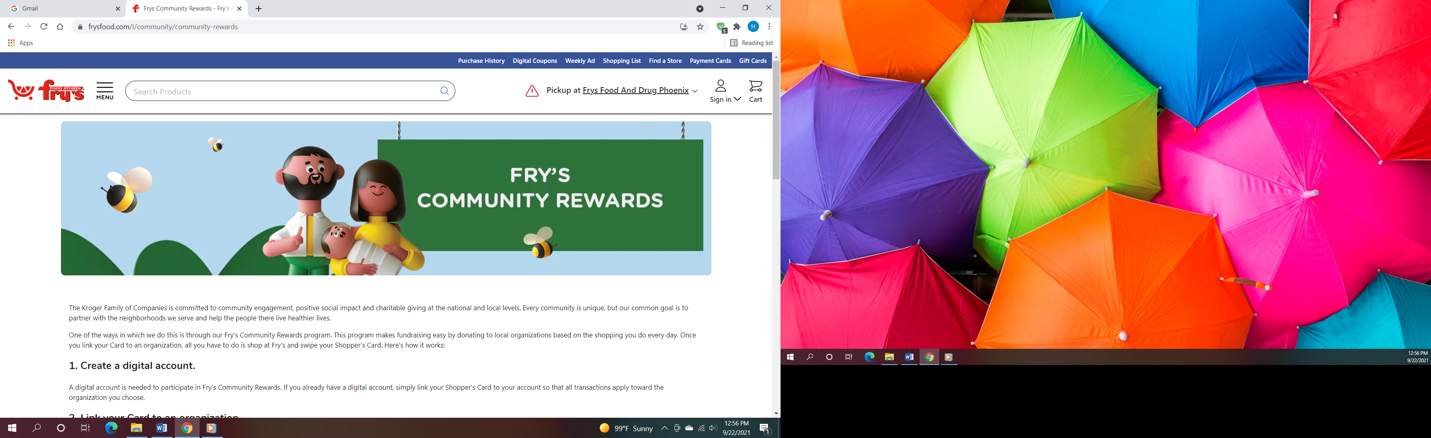Fry’s Community Rewards**

**program**. This program makes fundraising easy by donating to local organizations based on the shopping you do every day. Once you link your Card to an organization, all you have to do is shop at Fry’s and swipe your Shopper’s Card. Need help signing up, please, let the office know.

** We also collect cans; plastic bottles**

**Movie CD’s and TV Programs:**

Sunrise UMC has been given movie CD’s and have started a library. The CD’s are in room #4 in the fellowship hall. You may check out the movie to view and then return when you have watched it. Anyone who has movies they wish to donate can place on the shelf. Enjoy!



**NEWS FROM OUR MINISTRIES**



**Plan to Attend Our Spaghetti Dinner Fund Raiser May 12th**

The Men’s group at Sunrise would like to invite you to a delicious dinner that they are fixing up for our members and friends on Friday, May 12th in the church’s fellowship hall. It will be a full course Spaghetti Dinner which will begin at 6:00 p.m. and then after dinner we invite all in attendance to stay for a movie. Don’t forget to place this fun evening on your calendar right now so that you won’t forget. We ask you to purchase your tickets in advance so that we’ll know how many to prepare dinner for. Tickets can be purchased on Sunday morning at church or from the church office. The price of dinner and a movie is only $10. The church office is open Monday – Wednesday from 9:00 a.m. – 1:00 p.m.



**Trustees:**



[This Photo](http://www.picserver.org/t/trustee.html) by Unknown Author is licensed under [CC BY-SA](https://creativecommons.org/licenses/by-sa/3.0/)

Greetings Sunrise from your trustees!

Trustees have changed their meeting date and time to the first Wednesday of the month.

This month’s meeting will be 5/3/2023 at 6:00 PM

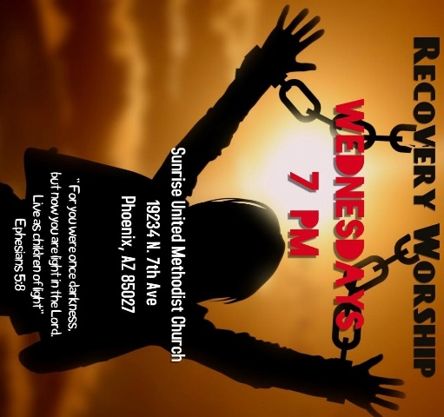

**Recovery Worship Service:**

The Wednesday Recovery Services is growing. We have great speakers, devotions, prayer and even a baptism. Everyone is welcome to join us on Wednesdays at 7:00PM.

To sign up to do devotions or for more information contact Art Erb or Charles Taylor.



[This Photo](http://justinsomnia.org/2009/09/breakfast-in-heathrow/) by Unknown Author is licensed under [CC BY](https://creativecommons.org/licenses/by/3.0/)

**Calling all Men!**

Come enjoy breakfast and good fellowship with other men from Sunrise. First Saturday, of the month at 8:00am. Contact Art Erb for more information.



**NEWS FROM OUR MINISTRIES**

**Missions ~ Mission Committee**



Family Promise

Mark your calendars for our next Family promise week October 15-22.  See you all there

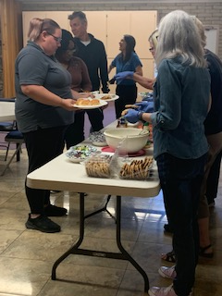**House of Refuge-Sunnyslope**

Members of Sunrise UMC served a meal at the House of Refuge on April 25th. If you are interested in being a part of this mission, please let the office 623.780.1008 or Alice Mildenberger know.  This is a 3-part process.  We choose a menu and divide the food responsibilities with interested participants, bring the food ready to be served by 4:45 to Sunnyslope, and serve the women and children.  We would love to have more people join us. What a blessing it is to share God's love by feeding the homeless. Our next feeding will be in June.

**Ongoing Mission Projects**

The Justa Center is still in need of the following items: **Can tuna, can chicken, can beans and can veggies; boxes or bags of pasta; laundry pods; and large bottles of shampoo.** They are also in need of: **warm clothing, coats, sweaters, hoodies, socks,** please bring to church and it will be taken to Justa Center



They are always in need of shoes, sunscreen, toothpaste (2.30z or larger) shampoo and water. Donations of money is always welcome. Place in envelope and write Missions- Justa Center.

Mission Committee will meet Wednesday, May 3rd at 10:30am in the church library.

Mission Committee Members are:

Linda DeYoung Pat Heppele Alice Mildenberger Rich Mildenberger

Dana Fischer Frank Fischer

Donna and Carl Richeson

**Prayer Shawl Ministry**



[This Photo](http://sweetbeebuzzings.blogspot.com/2014/08/nordic-shawl.html) by Unknown Author is licensed under [CC BY-SA-NC](https://creativecommons.org/licenses/by-nc-sa/3.0/)

**This ministry began in February 2022 and has handed out over 20 prayer shawls.  What a blessing this ministry has been for those who need to feel God's presence and the love and support of our knitters/crochets.**

Prayer shawls have been made for centuries. They are universal and embracing, and offer comfort while they enfold, and shelter. Sunrise's prayer shawl ministry will be for anyone who wants to share God's love and care by creating a prayer shawl.  If you have ever knitted or crocheted, please pray about being a part of this ministry.

I received enough skeins of yarn from a friend of Billie's to allow any interested person a chance to try making a shawl.  Typically, knitting needles size 11 or 13 and crochet hooks size K-P can be used and I have those to share as well. Most shawls are between 26"-30" wide x 60" in length. I will have copies of basic instructions on how to cast on, knit, plural, and crochet as well as general information at the back of the sanctuary.

**We will gather on the first Saturday of the month, May 6th at 9:00am. There will be yarn, knitting needles, crochet hooks, and people to assist as needed.  Join us as we begin this ministry.**

Contact Alice Mildenberger for more information.





Lynne Tressler May 6

Allan Fusler May 24

Becky Ockensfels May 25

Kelly Baker May 31



Please let us know if we have missed your special day.

**NEWS FROM OUR MINISTRIE****s**

**Prayer Ministry**

**NATIONAL DAY OF PRAYER**

The National Day of Prayer is observed annually on the first Thursday in May. This day observance, designated by the United States Congress, asks people “to turn to God in prayer and meditation.”

For many, prayer is an integral part of daily life. Prayer offers a rich connection to our spiritual lives, nurturing our relationships and faith. It also provides comfort in times of crisis or need.

**HOW TO OBSERVE #National Day Of Prayer** People of many different faiths join in prayer on this day. While some will attend the church, synagogue, mosque, temple or monasteries of their choice to pray, others will attend interdenominational prayer events. Some will join prayer groups or meditate. Use #NationalDayOfPrayer to post on social media.

**NATIONAL DAY OF PRAYER HISTORY** In the early 1950s, an evangelical movement called for Congress and the President to proclaim a National Day of Prayer. The movement grew and a young leader, Evangelist Billy Graham, led services for approximately 20,000 on the steps of the Capitol on February 3, 1952. Later that year, Congress proclaimed a joint resolution for a National Day of Prayer. President Harry S. Truman [proclaimed a National Day of Prayer](https://www.presidency.ucsb.edu/documents/proclamation-2978-national-day-prayer-1952) to be observed on July 4, 1952. Each year since that date, Americans have observed the day in their own way. The observance moved to the first Thursday in May by President Ronald Reagan and has been proclaimed each year since. As a Nation, presidents and government officials have called for national days of prayer or thanks intermittently since before the country’s existence.

* July 20, 1775 – The Continental Congress issued a proclamation recommending “a day of public humiliation, fasting, and prayer” be observed.
* In 1795**–** George Washington proclaimed a day of public thanksgiving and prayer.
* May 9, 1798 – John Adams declared this day as “a day of solemn humility, fasting, and prayer.”
* March 1863 –  On March 3**,** Abraham Lincoln signed a Congressional resolution, during the Civil War, which called for April 30, 1863, as a day of fasting and prayer.

For more information on National Day of Prayer visit the website [nationaldayofprayer.org](https://www.nationaldayofprayer.org/).

2023 National Prayer For America

We come with fervent hearts to praise You Lord.

You are The Word, the Way, Truth and Life.

The Alpha and Omega, Lion of Judah, Almighty God

who was, and is, and is to come. You clothed

Yourself in flesh and dwelt among us, to remove

our sin and clothe us in Your righteousness that

we might dwell with You forever and ever.

With broken, humbled hearts we repent of our

sins. Confessing to You our faithlessness,

prayerlessness, and disobedience. Forgive us for

our doubt, our prideful and quarrelsome words

that reveal our unclean hearts. Cleanse us and

renew a right and steadfast spirit within us we

pray.

With grateful hearts we thank You fervently for

the blessings in our life and throughout

America; they are more than we are able to

count. We will remember Your grace and testify

o Your goodness in all generations. Help us to

refrain from complaining, but instead be

prompted to pray faithfully in every

circumstance. Teach us to have a content heart

knowing You are always enough for our every

need.

As the Church we commit to pray and love our

neighbor and nation as You loved us, that our

reputation in this world would be rooted in Your

love. Holy Spirit work and overflow through us

in every prayer, thought, word, and deed. May

our character, conversations, and conduct

reflect the righteousness in which You clothed

us and command us to live.

With an obedient heart we put on the full armor

of God; Your breastplate of righteousness

guards our heart from which flows the springs of

life. We pray fervently for our communities and

country; the people who are in the Church,

Family, Education, Business and Workplace,

Military, Government, Arts, Entertainment and

Media. Every person is Your workmanship,

fearfully and wonderfully created and loved.

With hopeful hearts we pray that all would

choose to receive Your love and follow You. We

pray that America would confess, “Jesus is

Lord” and reflect Your righteousness in every

sphere of influence, and every aspect of our

lives. We ask that heavenly hope would flood

our hearts, silence hate, and that You will heal

our land.

Believing You; all You are, all You said, and all

You have promised, we pray fervently in

righteousness and avail much. In Jesus Name

we pray, Amen!

***Kathy Branzell***

*President, National Day of Prayer Task Force*



**Prayer Team**

|  |  |
| --- | --- |
| Rev. Louie | pastor@sunrisephx.org |
| Taylor Allen | [t.bone6@aol.com](mailto:t.bone6@aol.com) |
| Cathy Bennett | [catbennett2@gmail.com](mailto:catbennett2@gmail.com) |
| Art Erb | [alerb1111@gmail.com](mailto:alerb1111@gmail.com) |
| Susan Rowland | [susan.rowland46@iCloud.com](mailto:susan.rowland46@iCloud.com) |
| Roy Trevolt | [rctdrums@cox.net](mailto:rctdrums@cox.net) |
| Mary Stein | [mlkstein32@gmail.com](mailto:mlkstein32@gmail.com) |
| Katy Moore-Odoud | [Katymoore01@gmail.com](mailto:Katymoore01@gmail.com) |
| Christine Powell | [cphummingbirdstudio@gmail.com](mailto:cphummingbirdstudio@gmail.com) |
| Susan Allen | [allenfamilyaz@gmail.com](mailto:allenfamilyaz@gmail.com) |
| Ralph Pittman | [ralphpittman@yahoo.com](mailto:ralphpittman@yahoo.com) |
| Dana Fischer | [Deefischer002@msn.com](mailto:Deefischer002@msn.com) |
|  |  |

**NEWS FROM oUR MINIST****ry**

**Finance Ministry**

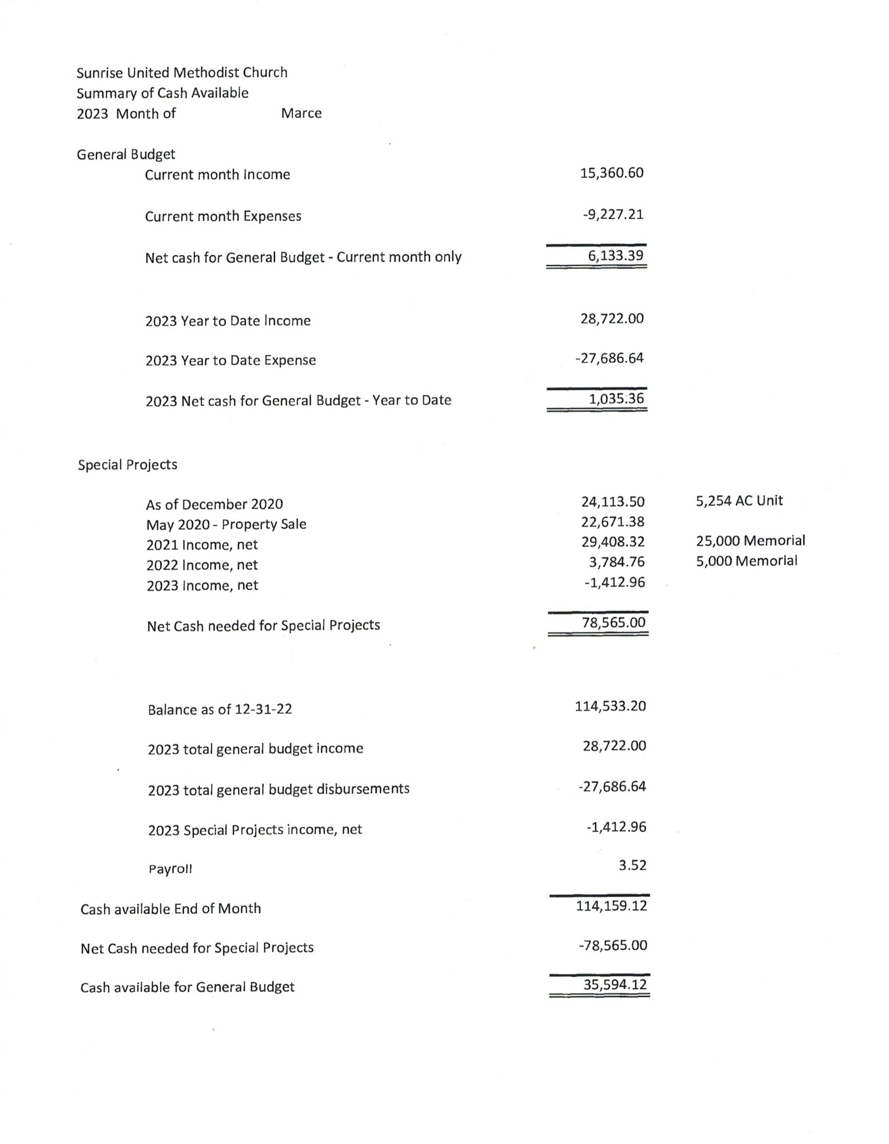

May Leadership Talk: Effective Committee Leadership

by [DSC Communications](https://dscumc.org/author/communications/) | Feb 20, 2023 | [Clergy and Lay Leadership Development](https://dscumc.org/blog/category/clld/), [Conference Newsletter](https://dscumc.org/blog/category/news/newsletter-mailchimp2020/)

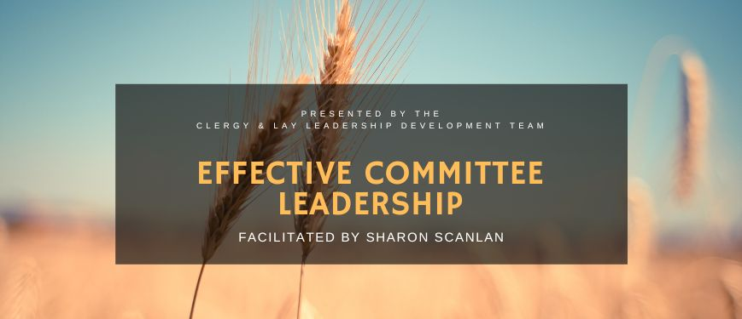

On May 8, 2023, at 7:00 PM, the Clergy and Lay Leadership Development team from the Desert Southwest Conference are hosting a Leadership Talk on Zoom featuring presenter Sharon Scanlan for a stimulating discussion titled “Effective Committee Leadership.”

**About the Presenter**

Sharon Scanlan is an active member of Vista de la Montana United Methodist Church in north Tucson. She and her family have been active Methodists for seven generations in Wisconsin and Cornwall, England.

She graduated from the University of Wisconsin- Madison with a degree in retailing and spent 33 years with Sears. Her career focus was in store and operations management in many different positions that she held throughout the West. During the last 13 years of her career, she was a regional vice president based out of the Chicago Headquarters.

She has belonged to many Methodist churches around the country and has been a member of Vista UMC for eight years. Previously, she was a member of Prescott UMC for 11 years before moving to Saddle Brooke in 2014.

Sharon is Finance Chair at Vista UMC, leads a weekly bible study, and volunteers for many worship duties. She occasionally preaches.

Register

Don’t miss this learning and enriching opportunity. Register for this leadership talk go to [https://dscumc.org/event/leadership-talk-effective-committee-leadership/](https://dscumc.org/event/leadership-talk-effective-committee-leadership/%20%20%20%20%20%20%20%20%20%20%20%20%20%20%20%20%20%20%20)

add this session to your calendar. If you have questions, please contact Judy Martin at stilljudymartin@gmail.com at 602-329-9935 or Jeannie Ward at cjward44@q.com at 928-772-6760.



**FACEBOOK** – are you a participant on Facebook? If so, please LIKE Sunrise. It is a new page and we need people to LIKE us @

**[sunriseumcphx](https://www.facebook.com/sunriseumcphx/)** [**#sunriseumcphx**](https://www.instagram.com/sunriseumcphx/)



[This Photo](http://commons.wikimedia.org/wiki/File:Facebook_Shiny_Icon.svg) by Unknown Author is licensed under [CC BY-SA](https://creativecommons.org/licenses/by-sa/3.0/)



[This Photo](https://radiouniversidad.uca.edu.ni/instagram-agrega-stickers-animados-historias/) by Unknown Author is licensed under [CC BY-SA](https://creativecommons.org/licenses/by-sa/3.0/)