 Sunrise UMC

**June**

**2023**



From the desk of your Pastor

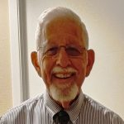

Dear Ones,

This is the last Pastor’s article that I will write to you as my time at Sunrise concludes on June 30th. Joyce and I have been blessed with the opportunity to be amongst you. We started out here this past December to fill in for Pastor Donna for three weeks while she recovered from a concussion, but our time turned out to be a bit longer. In our time here we got to know you, and you us. You have treated us so well and we feel like we are one of you. You are a Wonderful Congregation. As I write this article, we now know that your new pastor, the Rev. Galene Boyett will be appointed starting July 1 and it is my role to give you some instructions on what is to happen in the days ahead.

For those of you that have been United Methodist for a long time you know that once a pastor leaves a congregation, he or she, is not to return or be involved with the congregation. It isn’t because we don’t love you or care for you but to give the new pastor a chance to get to know you and you the new pastor. Thus, when Joyce and Louie say good-bye after our last Sunday in June it will be good-bye. Most of you know the history here at this church and you know that because you are a small church you have not had pastors stay with you for a long time. In your past few appointments, you have had part time retired pastors and a brand new starting out pastor, so it was either young or old but only for a short time. In order to try to break that cycle it was agreed upon by your church Staff Parish Relations Committee and the Bishop and Cabinet that something different occur this time. I would like to explain what is different in what follows….

Sunrise United Methodist Church will become part of a two-point charge. That means that instead of you having a person who is only a part-time minister you will have a full-time appointed minister who will be serving and dividing their time between two different churches. Before you “freak-out” about this arrangement let me tell you that I have served as a pastor at a two-point charge, and I also oversaw and served a Greater Parish that consisted of three churches. Yes, this arrangement can and will work for both congregations BUT some changes and compromises need to occur in order to make it work. The first among the compromises is a need to change the worship time of each church, especially since both churches currently offer worship at the same time. (You have received an email about this previously). Spirit of Hope UMC, the congregation we are being yoked with was open to either the earlier or later time but since Sunrise holds a monthly potluck at the conclusion of the fourth Sunday of each month, it was thought that Sunrise would move to the later worship hour so that potlucks can continue. In addition, your new choir practices an hour and a half before the start of worship on Sunday mornings. This means that your worship service will now start at 11:00 a.m. each Sunday. The other congregation will move to a 9:00 a.m. worship hour, allowing your new pastor to be there for both congregations and then spend time with you after worship instead of having to rush to the other church.

When I said there are compromises to be made it also means that each congregation will need to realize that what was, might not be in this new arrangement. Regularly scheduled church meeting times might need to be changed since a pastor can’t be at two places at once. Also, your new pastor’s office hours might be different than mine. Each church will have to work together as they schedule events and meetings. But now let me tell you the **Good this arrangement brings.** You will have an experienced pastor that will be with you for a long period of time, thus you can plan and know that the pastor isn’t looking to go elsewhere to provide for their family. Two congregations will be paying an equal share of a pastor’s salary and benefits package.

As an Interim pastor it has been my responsibility to prepare a congregation for a new pastor and get everything ready for that person to come in. With that in mind your Staff Parish Relations thought it best that the change in worship hour begin NOT on July 2nd which will be your new pastor’s first Sunday with you **but on June 4th** so that the congregation would be used to the change and that you wouldn’t be mad at the pastor for the change in time, as Rev. Boyett had nothing to do with that. So, dear ones, please mark down on your calendar right now that **worship as of June 4th will begin at 11:00 a.m.** Then mark down **July 2nd** to Greet and Welcome your new pastor, the Rev. Galene Boyett. Each time I have prepared to leave a congregation I have always been asked by members of the congregation if I knew the pastor coming in. In all but one case the answer was YES, I did and that we have been friends for a long time. Yes, I know your new incoming pastor and we too have been friends for a long time. But there is a second part of an answer to that question. It is, knowing a person as a friend and a brother or sister in ministry does not mean we know the person as a pastor. This is because we each lead our own congregations and do not worship with nor had not been involved in their congregations. I tell you that I believe that each of us in ministry are in ministry to serve the Lord and our brothers and sisters in Christ. Each Pastor has different gifts and graces. I ask you to let go of Louie Lyon and his ways and welcome and appreciate your Pastor Galene for the gifts and graces she will bring to Sunrise UMC in the days, months and years ahead.

I hope that we can make these last four weeks together special, Joyce and Louie truly feel blessed being with you. If you might have any questions regarding what I have written here, feel free to give me a call or drop by the church office to talk. See you on Sunday.

**Shalom,**

**Pastor Louie**



**Louie’s June Sermon Titles and Scriptures**

**June 4th: “You Have Been Called” Matthew 28:16-20**

**June 11th: “God Says, ‘I Will Show You the Way”’ Genesis 12:1-9**

**June 18th: “Laughter Is Healthy” Genesis 18:1-15**

**June 25th: “Is Christ Lord of Our Lives?” Matthew 10:24-33**



**NEWS FROM the conferenc**

**The below article was first published in The Dove of the Desert Newsletter and written by the Pastor Dave Wasson**

**Desert Southwest Annual Conference**

**Thoughts from Dave**

**It’s June in Arizona, which can only mean one thing... it’s time for**

**The Desert Southwest Annual Conference of the UMC to meet! If you aren’t familiar with Annual Conferences in the UMC that’s okay, I’ll try to give you a birds-eye view of what it’s about, and then share some of the good work that we are doing through it.**

**An Annual Conference of the United Methodist Church (UMC) is a gathering of clergy and lay members from various churches within a specific geographic area. Our conference is called the Desert Southwest Conference, and it includes all of Arizona, churches from the southern tip of Nevada (including Las Vegas), and the many river cities along the California side of the Colorado River.**

**Our Annual Conference serves as a time for worship, fellowship, and decision-making. During the conference, attendees (both clergy and lay members of the local churches) engage in worship services, receive reports on church ministries, approve budgets, elect leaders, and discuss matters of church policy. It is a time for collaboration, accountability, and setting the vision for the coming year. Through the Annual Conference, the UMC seeks to strengthen connections, nurture spiritual growth, and provide guidance for the local churches within its jurisdiction.**

**I am excited to share with you three mission projects that our Annual Conference is supporting this year. Each year our Conference chooses a worthy project to collaborate on, and each year the churches that make up our conference are incredibly generous. These projects provide us with meaningful opportunities to make a lasting impact in the world and exemplify our commitment to love and serve others. I invite you to prayerfully consider supporting these initiatives through donations and long-term prayers.**

**Medical Debt Relief**

**The first mission project is focused on providing medical debt relief. Countless individuals and families, face overwhelming medical bills that can lead to financial hardship and even bankruptcy. By partnering with organizations dedicated to relieving medical debt, we can alleviate the burdens weighing on those in our community and offer them a fresh start. Through your generous donations, we can multiply the impact of our giving and make a tangible difference in the lives of those burdened by medical expenses.**

**Ukraine UMC**

**The second mission project supports our brothers and sisters in the Ukraine UMC. As part of our connectional ministry, we can stand in solidarity with churches and individuals in Ukraine who face significant** **challenges. By providing financial support, we can contribute to their ongoing ministry efforts, assist in the maintenance, and repair of church buildings, and help provide resources for programs that offer hope and healing to their communities. Your donations will join with others in our Conference to**

**demonstrate the power of unity and shared mission.**

**Earthquakes**

**The third mission project focuses on providing relief to those affected by**

**recent earthquakes in Turkey and Syria. Natural disasters can leave**

**communities devastated, and our collective efforts can bring hope and**

**restoration. Through your contributions, we can support organizations on the**

**ground that are providing emergency aid, shelter, and necessary resources to**

**those impacted by the earthquakes. Together, we can show God's love in**

**action and provide tangible assistance to those in desperate need.**

**Again, I invite you to prayerfully consider supporting these mission projects by**

**making a financial donation. Your donations can be made by contacting our**

**office or through online giving on our website (www.doveofthedesert.org).**

**Remember that no contribution is too small, as the power of our collective**

**giving multiplies our impact and enables us to make a significant difference.**

**In addition to financial support, I encourage each of us to lift these mission**

**projects in prayer.**

**•  Pray for the individuals and families burdened by medical debt, asking for**

**relief and peace.**

**•  Pray for our brothers and sisters in Ukraine, interceding for their**

**ministries, strength, and perseverance.**

**•  Pray for those affected by the earthquakes in Turkey and Syria, asking for**

**healing, provision, and hope.**

**As we come together as a church community, our support and prayers have**

**the potential to transform lives and communities. By participating in these**

**mission projects, we demonstrate our commitment to being the hands and**

**feet of Christ in the world. Let us remember the power of connectional**

**ministry, where our individual efforts join with others to create an even**

**greater impact. You can explore more about each mission project and the**

**impact they will make by visiting the provided link: https://dscumc.org/**

**blog/2023/02/24/annual-conference-mission-projects-2023.**

**May we respond to the call to action, donate generously, and faithfully lift**

**these mission projects in prayer, knowing that through our collective efforts,**

**we can bring about meaningful change and reflect God's love and compassion**

**to a world in need.**

**Blessings,**

**Pastor Dave**

HELP UKRAINE

United Methodists respond to Ukraine Invasion: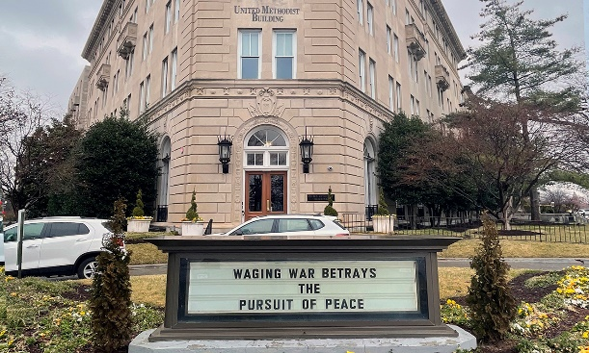

<https://www.umnews.org/en/news/united-methodists-respond-to-invasion-of-ukraine>

How we can help those in Ukraine:

Donations can be made to the United Methodist Committee on Relief’s International Disaster Response and Recovery through [Advance #982450](https://umcmission.org/advance-project/982450/).

United Methodist Global Ministries’ [Advance #14053A](https://umcmission.org/advance-project/14053a/) supports pastors in Ukraine and Moldova.

In case you were wondering if we are helping, go to below link to see how DSC is helping. <https://dscumc.org/blog/2023/01/05/update-on-ukraine/>

Creation Care  
The Creation care team is in the process of receiving information and ideas for us as individuals, for our neighbors, and for God's creation.  The monthly 90 minute sessions are attended by people from various denominations from all over the country.  Our first suggestion was to use reusable plates and silverware for our church gatherings either from home or Sunrise.  We will continue to collect ideas to share.  There is still room for interested individuals to join us.   
Your Green Team,  
Stephanie Newcomer, Alice Mildenberger

First to all who have continued to Go Green for our monthly Potlucks. We don’t know how much this will help in saving our planet or help with climate control, but we are doing a small bit to help save and preserve God’s creation.

**A Special Thank you!**



The Spaghetti dinner was fun and festive. Thank you to all who helped cook and serve

**Church News**

**Help with Worship:**

We are still looking for greeters, liturgist and AV persons to assist with our Sunday worship services. Please let Rev. Louie or Joyce know if interested.

**Building Use:**

We have about 9 outside groups that meet in the building each month. If you would like more information about these groups, please contact the church office.

**Daily Prayer:**

[prayer.forwardmovement.org](http://prayer.forwardmovement.org/)

[dailyofficeexpress.org](http://dailyofficeexpress.org/)

[lectionary.library.vanderbilt.edu/daily.php?year=B](http://lectionary.library.vanderbilt.edu/daily.php?year=B)

Upperroombooks.com/neweverymorning/

If there have been any changes to your information; address, phone number, email address, please email the office at hello@sunrisephx.org and let them know of the changes. Thank you!

**I Want To Pray**

Sign-up sheet is on the back table. Please consider joining this ministry. You need to come 15 minutes early on Sunday morning and pray in the prayer room.

**Find Sunrise UMC on Social Media,**

**[sunriseumcphx](https://www.facebook.com/sunriseumcphx/)** [**#sunriseumcphx**](https://www.instagram.com/sunriseumcphx/)



[This Photo](http://commons.wikimedia.org/wiki/File:Facebook_Shiny_Icon.svg) by Unknown Author is licensed under [CC BY-SA](https://creativecommons.org/licenses/by-sa/3.0/)



[This Photo](https://radiouniversidad.uca.edu.ni/instagram-agrega-stickers-animados-historias/) by Unknown Author is licensed under [CC BY-SA](https://creativecommons.org/licenses/by-sa/3.0/)

**Easy Ways to Give:**

**Shop at Fry’s and help Sunrise UMC.** **Fry’s Community Rewards**

**program**. This program makes fundraising easy by donating to local organizations based on the shopping you do every day. Once you link your Card to an organization, all you have to do is shop at Fry’s and swipe your Shopper’s Card. Need help signing up, please, let the office know.

** We also collect cans; plastic bottles**

**Movie CD’s and TV Programs:**

Sunrise UMC has been given movie CD’s and have started a library. The CD’s are in room #4 in the fellowship hall. You may check out the movie to view and then return when you have watched it. Anyone who has movies they wish to donate can place on the shelf. Enjoy!



**NEWS FROM OUR MINISTRIES**

**Trustees:**



[This Photo](http://www.picserver.org/t/trustee.html) by Unknown Author is licensed under [CC BY-SA](https://creativecommons.org/licenses/by-sa/3.0/)

Greetings Sunrise from your trustees!

Trustees have changed their meeting date and time to the first Wednesday of the month.

This month’s meeting will be 6/7/2023 at 6:00 PM

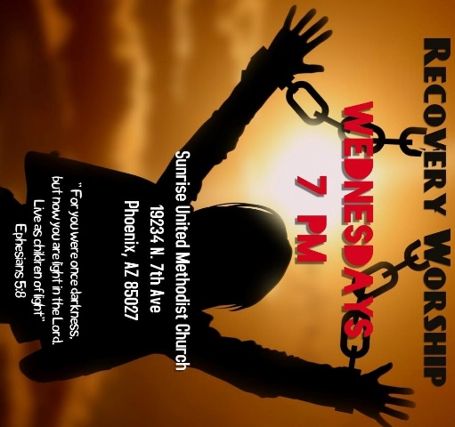

**Recovery Worship Service:**

The Wednesday Recovery Services is growing. We have great speakers, devotions, prayer and even a baptism. Everyone is welcome to join us on Wednesdays at 7:00PM.

To sign up to do devotions or for more information contact Art Erb or Charles Taylor.



[This Photo](http://justinsomnia.org/2009/09/breakfast-in-heathrow/) by Unknown Author is licensed under [CC BY](https://creativecommons.org/licenses/by/3.0/)

**Calling all Men!**

Come enjoy breakfast and good fellowship with other men from Sunrise. First Saturday, of the month at 8:00am. Contact Art Erb for more information.

**NEWS FROM OUR MINISTRIES**

**Missions ~ Mission Committee**



Family Promise

Mark your calendars for our next Family promise week October 15-22.  See you all there

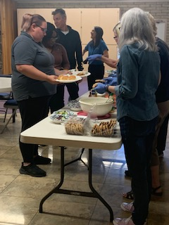**House of Refuge-Sunnyslope**

Members of Sunrise UMC will served a meal at the House of Refuge on June 13. If you are interested in being a part of this mission, please let the office 623.780.1008 or Alice Mildenberger know.  This is a 3-part process.  We choose a menu and divide the food responsibilities with interested participants, bring the food ready to be served by 4:45 to Sunnyslope, and serve the women and children.  We would love to have more people join us. What a blessing it is to share God's love by feeding the homeless. Our next feeding will be in June.

**Ongoing Mission Projects**

The Justa Center is still in need of the following items: **Can tuna, can chicken, can beans and can veggies; boxes or bags of pasta; laundry pods; and large bottles of shampoo.** They are also in need of: **warm clothing, coats, sweaters, hoodies, socks,** please bring to church and it will be taken to Justa Center



They are always in need of shoes, sunscreen, toothpaste (2.30z or larger) shampoo and water. Donations of money is always welcome. Place in envelope and write Missions- Justa Center.

Mission Committee will meet Wednesday, August 9th at 11:00am in the church library.

Mission Committee Members are:

Linda DeYoung Pat Heppele Alice Mildenberger Rich Mildenberger

Dana Fischer Frank Fischer

Donna and Carl Richeson

**Prayer Shawl Ministry**



[This Photo](http://sweetbeebuzzings.blogspot.com/2014/08/nordic-shawl.html) by Unknown Author is licensed under [CC BY-SA-NC](https://creativecommons.org/licenses/by-nc-sa/3.0/)

**This ministry began in February 2022 and has handed out over 20 prayer shawls.  What a blessing this ministry has been for those who need to feel God's presence and the love and support of our knitters/crochets.**

Prayer shawls have been made for centuries. They are universal and embracing, and offer comfort while they enfold, and shelter. Sunrise's prayer shawl ministry will be for anyone who wants to share God's love and care by creating a prayer shawl.  If you have ever knitted or crocheted, please pray about being a part of this ministry.

**We will gather on the first Saturday of the month, June 3rd at 9:00am. There will be yarn, knitting needles, crochet hooks, and people to assist as needed.  Join us as for this ministry.**

Contact Alice Mildenberger for more information.



Dana Fischer June 16

Linda DeYoung June 17

Billie Albright June 18

Scott Gilpin June 30



Please let us know if we have missed your special day.

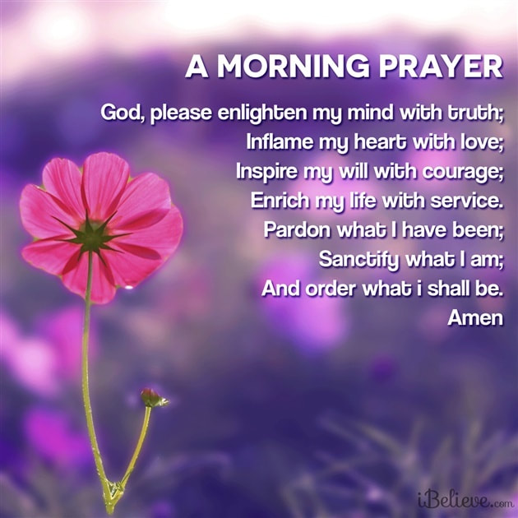

**NEWS FROM OUR MINISTRIE****s**

**Prayer Ministry**

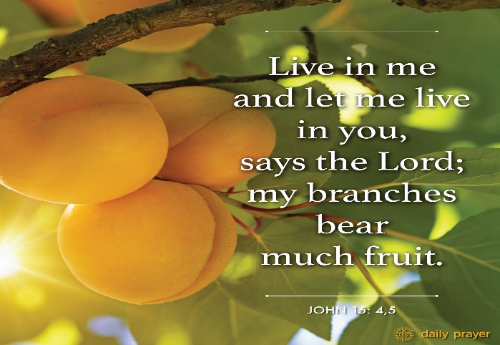

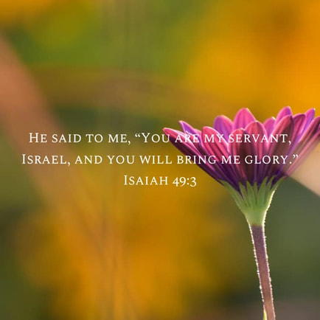

**Prayer Team**

|  |
| --- |
| Rev. Louie |
| Taylor Allen |
| Cathy Bennett |
| Art Erb |
| Susan Rowland |
| Roy Trevolt |
| Mary Stein |
| Katy Moore-Odoud |
| Christine Powell |
| Susan Allen |
| Ralph Pittman |
| Dana Fischer |

**NEWS FROM oUR MINIST****ry**

**Finance Ministry**

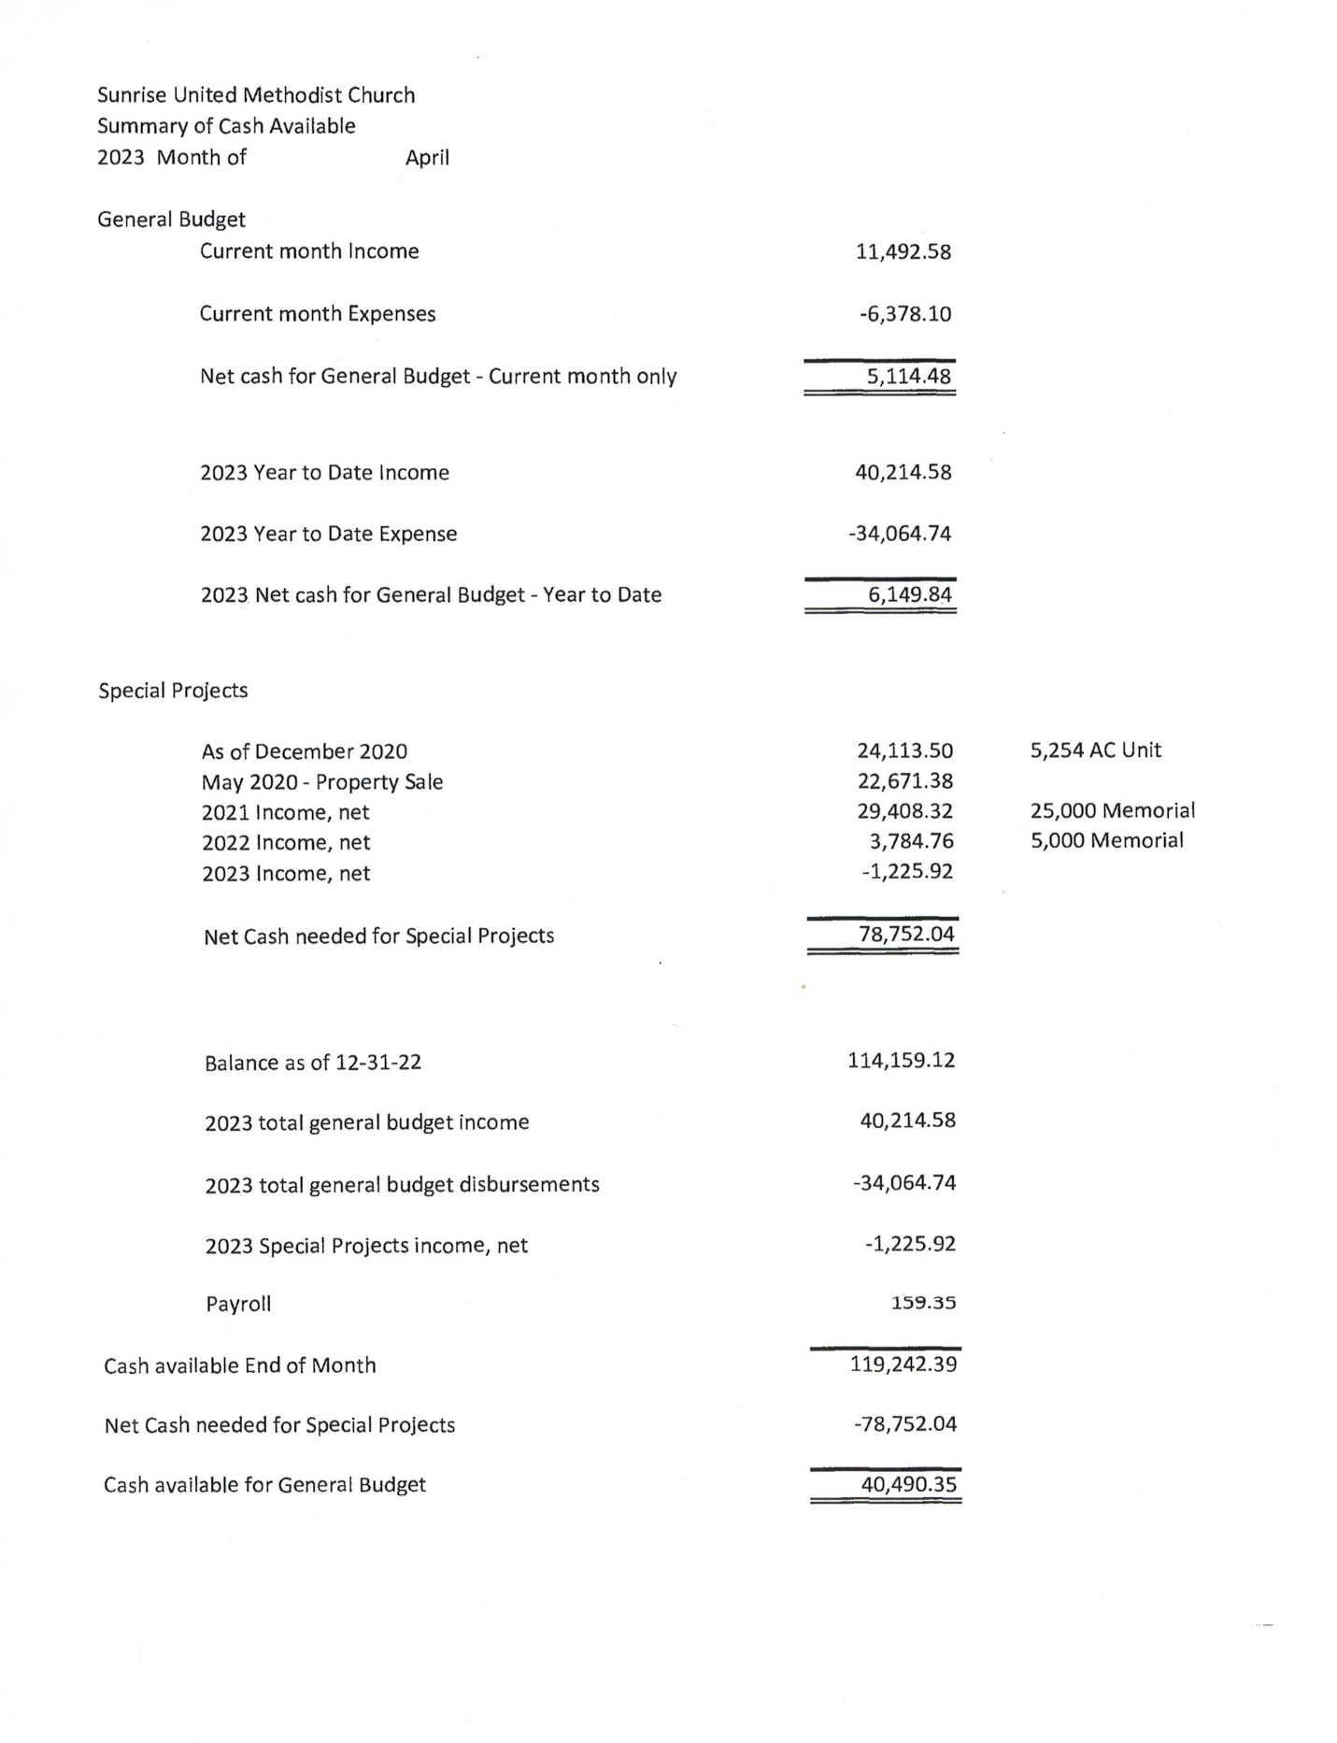



**FACEBOOK** – are you a participant on Facebook? If so, please LIKE Sunrise. It is a new page and we need people to LIKE us @

**[sunriseumcphx](https://www.facebook.com/sunriseumcphx/)** [**#sunriseumcphx**](https://www.instagram.com/sunriseumcphx/)



[This Photo](http://commons.wikimedia.org/wiki/File:Facebook_Shiny_Icon.svg) by Unknown Author is licensed under [CC BY-SA](https://creativecommons.org/licenses/by-sa/3.0/)



[This Photo](https://radiouniversidad.uca.edu.ni/instagram-agrega-stickers-animados-historias/) by Unknown Author is licensed under [CC BY-SA](https://creativecommons.org/licenses/by-sa/3.0/)