 Sunrise UMC

**March**

**2023**





From the desk of your Pastor

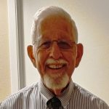As I begin to write this month’s Pastor’s article I am thinking how fast time has moved along since Joyce and I were asked to be with you on December 18th for a short time while Pastor Donna recovered from her concussion. As you know, sadly her recovery did not go as planned, thus I have been appointed as your Interim Pastor. One of the things that I NEVER liked doing as a Pastor was to talk to a congregation about money. I used to say to the congregations I served, “You’ll only hear me talk about money once a year and that is for our Stewardship Campaign. RELAX, we aren’t about to have a Stewardship Campaign, but I need to share some information with you that was shared with me by your Church Council at their January 29th meeting.

At that meeting I was informed that Sunrise’s Annual Apportionments had gone up over $3,000 for this coming year. As your Interim Pastor it is my responsibility to get everything moving ahead smoothly for whoever will be appointed as your permanent pastor on July 1st. I believe that we all know that transparency is important, thus I am sharing a need that your church has. That need is making sure that Sunrise United Methodist Church pays 100% of their assigned apportionments. For those of you that might not know what Apportionments are, let me explain in the following paragraph.

In the United Methodist Church, we are part of a “Connection.” That means that we are tied together with other United Methodist Churches, not only in the Phoenix area but all through the United States. We are tied together by being part of the Desert Southwest Annual Conference. The Desert Southwest Annual Conference is tied together by being part of the General Conference that is tied together with the 54 Annual Conference in the United States and then 75 Annual Conferences in Africa, Europe, Asia and elsewhere around the world. What is pertinent when discussing apportionments is that all the members and church budget expenditures are added together from the 54 United States Annual Conferences and then divided up equally to come up with a sum that is required to operate the United Methodist Church system and then do ministry in the world. Once that is divided up they come up with something called a “grade point figure” and that determines what each church (based on their membership and amount spent in their budget) is to be apportioned for the coming year. Based on that figure our church was given an increase. By the way, the figures are always 2 years behind, meaning it was based on membership and budget from two years ago.

I have been told by your church leaders how faithful you are as a congregation. I Praise you for ending the 2022 year in the back financially and I have no question in my mind that you will do so again in 2023. It is just my intention to share with you that your church has been given a higher amount to pay this year for our apportionments. Since I stated early I only speak about money once a year, let me go a bit further and speak to you about “Money”. I told you that I do not as a pastor like speaking about money, but I do a disservice to you and others if I don’t explain why we ALL Should share with God out of our abundances as I believe everything we have is a gift from God.

Dear Ones, the Bible, both in the Old and New Testaments tell us that God expects us to give back to the Lord a portion of what God has given us. The Old Testament calls it a Tithe which is 10% of our income. Before you say “Ouch” please remember, “You can’t out give God.” When I look back at the first time my late wife and I decided that we were going to trust God and give back to God 10% of our income I was scared to death. But our pastor challenged us to try to do so and we did. It has been 50 years since I have been tithing and I have never wanted for anything. Yes, there were times I never knew how a bill was going to be paid but somehow, some way it was provided for.

I asked your church treasurer, Mary Pierce if Sunrise had held a stewardship drive and I was told, “No.” Again, I say Relax, I am not proposing one here, at least not now but let me tell you why it is important in the future to have one. I can explain it this way; in your life do you go out and buy things not knowing where the money is coming from? I mean, don’t you ask yourself if you have enough money to pay for it before you buy something? Well, the church is no different. A church needs to know what is coming in so that they can honestly see if there is going to be enough to pay their expenses. How will the church know if it can operate if they don’t know what is coming in?

In this article I have just given you a few things to think about and pray about. First, how God has blessed you and then if you are returning to God out of gratitude a portion of your blessings. Secondly, I have shared with you that the church will have an added expense with a higher apportionment figure. Lastly, I shared about transparency, your church’s need by years end. You are good folks and you are a faithful group, I KNOW that you will come through for your church.

I’ll look forward to seeing you on Sunday.

Shalom,

Louie





**PASTOR LOUIE’S LENTEN SEASON PREACHING SCHEDULE & SERMON TITLES**

**March 5th: “How Much Faith Do We Need?” based on John 3:1-17**

**March 12th: “Marriage Partners at the Well” based on John 4:5-42**

**March 19th: “Do We See the Light?” based on John 9:1-41**

**March 26th: “God Unleashes Us From All That Binds” based on John11:1-45**

**April 2nd/Palm Sunday: “Jesus Was Exalted” based on Philippians 2:5-11**

**April 6th/Maundy Thursday: “A New Command” based on John 13:1-17, 31b-35**

**April 7th/Good Friday Tenebrae Service: “The Garden Tomb” based on John 12:27, 32-33**

**April 9th/Easter Sunday: “Do I Have a Story to Tell You” based on John 20:1-18**

**SPECIAL HOLY WEEK SERVICES**

Dear ones, please place these dates on your calendar right now and plan to attend our Holy Week Services. The concluding days of Lent occur during Holy Week with the Last Supper on an evening called Maundy Thursday (April 6th). Our service will begin at 6:00 p.m. as we remember the events of Jesus Last Supper with a foot washing ceremony and the serving of the Lord’s Supper/Holy Communion (His Last Supper Meal)

On Friday, April 7th at 6:00 p.m. we will remember the Most Solemn Day on the Christian Calendar when Jesus was placed on the cross and suffered for us. This evening service is called a Tenebrae Service. During this service various scriptures will be read depicting what Jesus went through beginning with his betrayal and arrest, the arraignment, trial and sentencing and the Crucifixion… As each event is remembered a light is extinguished thus a Tenebrae Service is called a Service of Darkness.

Then on Sunday, April 9th we hope you will join us for a Celebration of our Lord’s Resurrection at our regular 10:00 a.m. worship hour.

**Seasonal Reflections From Pastor Louie**

As one that sits in a church pew or seat on Sunday mornings I used to wonder “What are these Church Seasons all about?” Upon entering the ministry and worship I found my answer, thus this reflection for you, just in case you too “Wondered.”

These are the Christian Seasons in a church year: Advent – Preparing for Jesus Birth; Christmas Tide – His Birth; Epiphany – Birth and bringing of His light into the world; Lent – A time of reflection of where we are in our “Walk with the Lord”: Easter – His Resurrection; Kingdom Tide (Ordinary Time) – Lessons but no particular main events; Pentecost – The Birth of the Church or the Coming of the Holy Spirit – Kingdom Tide again and back to a new church year with the Season of Advent.

Let’s look at the Seasons of Lent and Easter in what follows… At the heart of our faith is the life, suffering, death, resurrection and ascension of our Lord, Jesus. We have proclaimed that “The Word became flesh” and lived amongst us. This brings us to where we are now, the “Paschal Mystery.” The “Lamb of God” who suffered and died for us, in the process taking away our sins before His Heavenly Father. In Judaism we have the Passover where the Angel of Death passed over the homes of the Jews whose first born males were saved from the death that the Egyptians suffered. In old Judaism there was a sacrifice of a unblemished lamb to appease God for our sins. As Christians we believe that Jesus became our lamb, those the Paschal Mystery. We can say that the Seasons of Lent and Easter celebrate the most definitive aspects of God’s redemptive acts on our behalf. This is where our time of Reflection begins with a day called “Ash Wednesday.” At an Ash Wednesday service we admit to God that we have   
“Fallen Short” of where God would probably have us be in our daily walk with Him. Ashes are offered to be placed on your forehead in the sign of the cross by your minister. This symbol is you and I admitting we have fallen short. As we walk out of this service we are beginning to honestly reflect where we are in our walk with God. Lent continues on for forty days, begins Feb. 22nd and goes through April 6th.

The last week of Lent is called Holy Week. During that week we spend time remembering the Last Supper on a night called Maundy Thursday, then Good Friday when Jesus was crucified on the Cross. Then we enter into the next Christian Season, Easter. Easter of course is the Celebration of Jesus’ Resurrection. I am looking forward to “Walking” with you all and helping us reflect on what these events mean in our lives. Feel free to ask me questions as we walk through this season, I will do the best I can to answer.

Shalom,

Pastor Louie

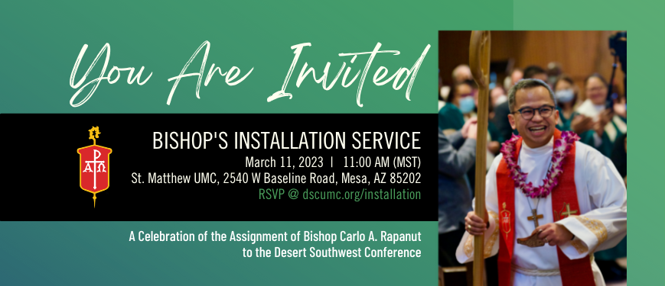

The Episcopacy Committee of the Desert Southwest Conference invites you to the Installation Service of Bishop Carlo A. Rapanut on **Saturday, March 11th** at 10:00 am (pacific)/11:00 am (mountain) at St. Matthew United Methodist Church (2540 West Baseline Road, Mesa, AZ 85202) with a reception following the service.

The service will be live-streamed, and for those that require translation, it will also be available via Zoom. The link to watch or join will be provided when you register. Please see the link below to **register by March 1st.**

<https://dscumc.org/2023-bishop-installation-service-registration/?ct=t(RSS_EMAIL_CAMPAIGN)&mc_cid=25ee484328&mc_eid=d7f117b4cd>

|  |
| --- |
|  |
|  |

**MEET THE BISHOP**

Bishop Carlo A. Rapanut

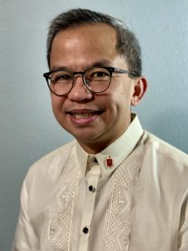

Bishop Carlo A. Rapanut

Carlo Axibal Rapanut is the eldest of two sons of Jose, a government employee, community organizer and ordained deacon of the UMC and Teofina, a university professor. He was born and raised in Baguio City, Philippines and was nurtured in faith in the Baguio City First United Methodist Church where, as a youth, he felt a call to serve.

Carlo went to the University of the Philippines (UP) where he earned his Bachelor of Science in Mathematics in 1994. After college, he served as president of his annual conference United Methodist Youth Fellowship for four years and it was during that time that he discerned a call to ordained ministry.

After a brief stint working as a scriptwriter, anchor and voice-over talent for a local TV station and serving on staff managing databases for Bishop Daniel C. Arichea, Carlo answered the call. He was first appointed to serve Philex Mines UMC in Benguet, Philippines in 1998 while he was finishing his Master of Management, major in Business Management (MBA equivalent), also from UP.

Carlo attended Wesley Divinity School in Cabanatuan City, Philippines where he finished his Master of Divinity, magna cum laude, in 2003. He served the Baguio City First UMC for 6 years, first as associate pastor while he was in seminary and then as senior pastor after his graduation.

In 2006, Carlo was ordained elder in the Northwest Philippines Annual Conference by Bishop Benjamin A. Justo who also appointed him to serve as his Assistant to the Bishop in the Baguio Episcopal Area. In 2008, Carlo and his family answered the call to serve in the Alaska Missionary Conference and was appointed to the UMC of Chugiak where he served for six years.

Bishop Grant J. Hagiya invited Carlo in 2014 to serve on the cabinet of the Greater Northwest Area as Conference Superintendent and Director of Connectional Ministries of the Alaska Conference. He also served as one of the deans of the cabinet, representing Alaska. Bishop Elaine JW Stanovsky continued this appointment and then eventually invited Carlo to be her Assistant to the Bishop in 2021. It was from that role that he was elected to the episcopacy by the Western Jurisdiction on November 4, 2022 in Salt Lake City, UT.

Carlo’s leadership in the church included service as delegate to the Philippines Central Conference (1996 as a layperson & 2008 as clergy), Western Jurisdictional Conference (2016 as head of delegation) and General Conference (2016 & 2019 as head of delegation). He also was a director of the General Board of Global Ministries (2016-2022) where he served on the Mission Engagement and the Policy and By-laws committees. In both the Northwest Philippines Annual Conference and the Alaska Conference, Carlo served on various boards and agencies as member and chair.

Carlo is joyfully married to Zoraida “Radie” Sanchez Rapanut, a certified public bookkeeper. They make a home with their two sons Karl Caleb and Titus Carl. Carlo fell in love with long-distance running as an adult and has done many races in the past 10 years from 10Ks to Ultra marathons. He also enjoys cycling, photography, and hiking with Radie.



HELP UKRAINE

United Methodists respond to Ukraine Invasion: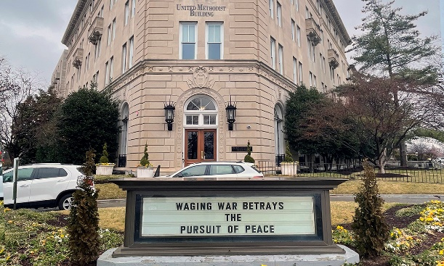

<https://www.umnews.org/en/news/united-methodists-respond-to-invasion-of-ukraine>

How we can help those in Ukraine:

Donations can be made to the United Methodist Committee on Relief’s International Disaster Response and Recovery through [Advance #982450](https://umcmission.org/advance-project/982450/).

United Methodist Global Ministries’ [Advance #14053A](https://umcmission.org/advance-project/14053a/) supports pastors in Ukraine and Moldova.

In case you were wondering if we are helping, go to below link to see how DSC is helping. <https://dscumc.org/blog/2023/01/05/update-on-ukraine/>

Creation Care  
The Creation care team is in the process of receiving information and ideas for us as individuals, for our neighbors, and for God's creation.  The monthly 90 minute sessions are attended by people from various denominations from all over the country.  Our first suggestion was to use reusable plates and silverware for our church gatherings either from home or Sunrise.  We will continue to collect ideas to share.  There is still room for interested individuals to join us.   
Your Green Team,  
Stephanie Newcomer, Alice Mildenberger



[This Photo](https://pngimg.com/download/70161) by Unknown Author is licensed under [CC BY-NC](https://creativecommons.org/licenses/by-nc/3.0/)

*Easter Lilies*

The Worship team will be decorating the sanctuary with Lilies this Easter. If you would be interested in purchasing a Lily ‘in memory of’ or ‘in honor of’ a loved one, please remit $10.00 per lily by April 2nd. Thank you for your support.

In Honor of________________________________________________________________________

In Memory of _____________________________________________________________________

Amount $_____________________ No. of Lilies___________________________

Name:_______________________________________________________________________________

**Church News**

**Help with Worship:**

We are still looking for greeters and liturgist to assist with our Sunday

worship services. Please let Rev. Louie or Joyce know if interested.

**Building Use:**

We have about 9 outside groups that meet in the building each month. If you would like more information about these groups, please contact the church office.

**Daily Prayer:**

[prayer.forwardmovement.org](http://prayer.forwardmovement.org/)

[dailyofficeexpress.org](http://dailyofficeexpress.org/)

[lectionary.library.vanderbilt.edu/daily.php?year=B](http://lectionary.library.vanderbilt.edu/daily.php?year=B)

Upperroombooks.com/neweverymorning/

If there have been any changes to your information; address, phone number, email address, please email the office at hello@sunrisephx.org and let them know of the changes. Thank you!

**I Want To Pray**

Sign-up sheet is on the back table. Please consider joining this ministry. You need to come 15 minutes early on Sunday morning and pray in the prayer room.

**Find Sunrise UMC on Social Media,**

**[sunriseumcphx](https://www.facebook.com/sunriseumcphx/)** [**#sunriseumcphx**](https://www.instagram.com/sunriseumcphx/)



[This Photo](http://commons.wikimedia.org/wiki/File:Facebook_Shiny_Icon.svg) by Unknown Author is licensed under [CC BY-SA](https://creativecommons.org/licenses/by-sa/3.0/)



[This Photo](https://radiouniversidad.uca.edu.ni/instagram-agrega-stickers-animados-historias/) by Unknown Author is licensed under [CC BY-SA](https://creativecommons.org/licenses/by-sa/3.0/)

**Easy Ways to Give:**

**Shop at Fry’s and help Sunrise UMC.** **Fry’s Community Rewards**

**program**. This program makes fundraising easy by donating to local organizations based on the shopping you do every day. Once you link your Card to an organization, all you have to do is shop at Fry’s and swipe your Shopper’s Card. Need help signing up, please, let the office know.

** We also collect cans; plastic bottles**

**Movie CD’s and TV Programs:**

Sunrise UMC has been given movie CD’s and have started a library. The CD’s are in room #4 in the fellowship hall. You may check out the movie to view and then return when you have watched it. Anyone who has movies they wish to donate can place on the shelf. Enjoy!

**NEWS FROM OUR MINISTRIES**

**Trustees:**



[This Photo](http://www.picserver.org/t/trustee.html) by Unknown Author is licensed under [CC BY-SA](https://creativecommons.org/licenses/by-sa/3.0/)

Greetings Sunrise from your trustees!

Trustees have changed their meeting date and time to the first Wednesday of the month.

This month’s meeting will be 3/1/2023 at 6:00 PM.

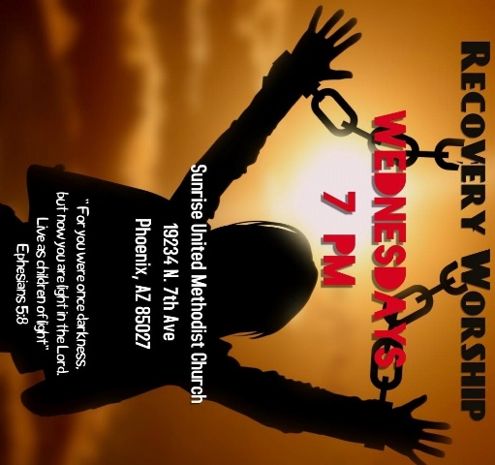

**Recovery Worship Service:**

The Wednesday Recovery Services is growing. We have great speakers, devotions, prayer and even a baptism. Everyone is welcome to join us on Wednesdays at 7:00PM.

To sign up to do devotions or for more information contact Art Erb or Charles Taylor.



[This Photo](http://justinsomnia.org/2009/09/breakfast-in-heathrow/) by Unknown Author is licensed under [CC BY](https://creativecommons.org/licenses/by/3.0/)

**Calling all Men!**

Come enjoy breakfast and good fellowship with other men from Sunrise. First Saturday, of the month at 8:00am. Contact Art Erb for more information.

**NEWS FROM OUR MINISTRIES**

**Missions ~ Mission Committee**



**LOVE FOR TEACHERS:** Missions will be collecting items for the teachers at Constitution Elementary School February 5 – March 12, 2023. The items will be used in the classroom and as rewards for the students. School items such as: Kleenex, hand sanitizer, note pads, stickers, pencils, flash cards etc. or wrapped candy may be left on the table in the narthex. Thank you for your support**.**



Family Promise

Sunrise hosted a truly God inspired week last month. We began with 3 families and ended with 4. This was made possible by all of the volunteers who cooked, spent the night, shopped for breakfast and lunch items, and washed bed clothes.  Thank you all for participating in this mission.  Our next Family promise week will be October 15-22.  See you all there

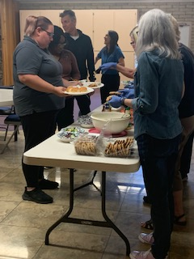**House of Refuge-Sunnyslope**

Members of Sunrise UMC serves meals at the House of Refuge. You are welcome to **join us on March 28th** and experience the blessing that comes from feeding the homeless. If you are interested in being a part of this mission, please let the office 623.780.1008 or Alice Mildenberger know.  This is a 3-part process.  We choose a menu and divide the food responsibilities with interested participants, bring the food ready to be served by 4:45 to Sunnyslope, and serve the women and children.  We would love to have more people join us. What a blessing it is to share God's love by feeding the homeless.

**Ongoing Mission Projects**

The Justa Center has an ***URGENT*** need for the following items: **Can tuna, can chicken, can beans and can veggies; boxes or bags of pasta; laundry pods; and large bottles of shampoo.** They are also in need of: **warm clothing, coats, sweaters, hoodies, socks,** please bring to church and it will be taken to Justa Center



They are always in need of shoes, sunscreen, toothpaste (2.30z or larger) shampoo and water. Donations of money is always welcome. Place in envelope and write Missions- Justa Center.

Mission Committee meets the 2nd Wednesday of the month at 11:00am. March 8, 2022

Mission Committee Members are:

Linda DeYoung Pat Hepperle

Laura Diamond Alice Mildenberger

Dana Fischer Rich Mildenberger

Frank Fischer Donna and Carl Richeson

**Prayer Shawl Ministry**



[This Photo](http://sweetbeebuzzings.blogspot.com/2014/08/nordic-shawl.html) by Unknown Author is licensed under [CC BY-SA-NC](https://creativecommons.org/licenses/by-nc-sa/3.0/)

**This ministry began in February 2022 and has handed out over 20 prayer shawls.  What a blessing this ministry has been for those who need to feel God's presence and the love and support of our knitters/crochets.**

Prayer shawls have been made for centuries. They are universal and embracing, and offer comfort while they enfold, and shelter. Sunrise's prayer shawl ministry will be for anyone who wants to share God's love and care by creating a prayer shawl.  If you have ever knitted or crocheted, please pray about being a part of this ministry.

I received enough skeins of yarn from a friend of Billie's to allow any interested person a chance to try making a shawl.  Typically, knitting needles size 11 or 13 and crochet hooks size K-P can be used and I have those to share as well. Most shawls are between 26"-30" wide x 60" in length. I will have copies of basic instructions on how to cast on, knit, plural, and crochet as well as general information at the back of the sanctuary.

**We will gather on the first Saturday of the month, March 4th at 9:00am. There will be yarn, knitting needles, crochet hooks, and people to assist as needed.  Join us as we begin this ministry.**

Contact Alice Mildenberger for more information.



Larry Diamond March 3

Joel Behrends March 11

Matt Brown March 13

Janice Fusler March 21

Patti Tone’ March 28



Please let us know if we have missed your special day.

**NEWS FROM OUR MINISTRIE****s**

**Prayer Ministry**

### An Old Irish Blessing

May love and laughter light your days,  
and warm your heart and home.  
May good and faithful friends be yours,  
wherever you may roam.  
May peace and plenty bless your world  
with joy that long endures.  
May all life's passing seasons  
bring the best to you and yours!

**Prayer Changes Things**

You have heard me say that prayer is simply a conversation between you and your Heavenly Father. Prayer is one of the disciplines that all Christians should be participating in. I do understand that lifting others up in prayer is not something you are used to doing, it can be uncomfortable at times because you might feel that you don’t know what to pray. But dear ones, if I find myself in that situation, I just lift up a prayer to God saying, “Lord, show me what to pray.” Then I wait for God to respond to me though the Holy Spirit.

I want to ask YOU a question… “If you needed prayer for an illness, a particular situation or even a death of a family member or friend, would YOU want others praying for you?”

Sunrise has an email prayer chain that when a prayer need is brought to our attention, it is sent out via email to ask those on the prayer chain email list to lift the need up in prayer to our Heavenly Father. I am being honest with you when I say, **“I am Disappointed** that so few of our congregation are involved in our church’s prayer chain. I am praying that after you read this that you would consider adding your name to our church prayer chain warrior list. You can do so by emailing Pastor Louie and he will place you on the Prayer Chain Email Address List and you will begin receiving prayer needs as they come up.

Please send your email address to Pastor Louie at: [louiepreacher@gmail.com](mailto:louiepreacher@gmail.com) and he will add you to the Prayer Chain Email List. I KNOW that you will find it a Blessing to be there for those that have a prayer need. I thank you for your consideration of this request. If you would like to speak with me about this or have any questions please feel free to contact me.

Pastor Louie

**Prayer Team**

|  |  |
| --- | --- |
| Rev. Louie |  |
| Taylor Allen |  |
| Cathy Bennett |  |
| Art Erb |  |
| Susan Rowland |  |
| Roy Trevolt |  |
| Mary Stein |  |
| Katy Moore-Odoud |  |
| Christine Powell |  |
| Susan Allen |  |
| Ralph Pittman |  |
| Dana Fischer |  |
|  |  |

**NEWS FROM oUR MINIST****ry**

**Finance Ministry**



**NEWS FROM the conference**

March 13 Leadership Talk – Start with Why

by [Jeannie Ward](https://dscumc.org/author/jward/) | Feb 1, 2023 | [Clergy and Lay Leadership Development](https://dscumc.org/blog/category/clld/), [Conference Newsletter](https://dscumc.org/blog/category/news/newsletter-mailchimp2020/)

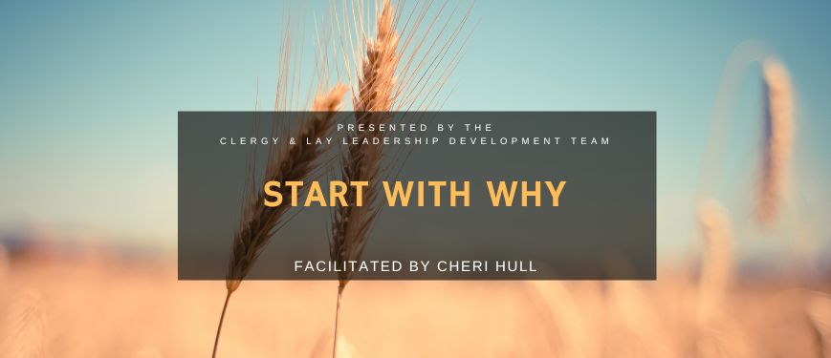

The Clergy and Lay Leadership Development team is hosting a Leadership Talk via Zoom with Cheri Hull, chair of the Conference Commission on Communication as the guest speaker. This event is free on March 13 at 7:00 PM MST. Register now and be sure to share this with others.

[Register Here](https://dscumc.org/event/start-with-why-leadership-talk/)

Book reference: “Start with Why: How Great Leaders Inspire Everyone to Take Action” by  Simon Sinek.

**START WITH WHY** shows that the leaders who have had the greatest influence in the world all think, act and communicate the same way—and it’s the opposite of what everyone else does. Sinek calls this powerful idea The Golden Circle, and it provides a framework upon which organizations can be built, movements can be led, and people can be inspired. And it all starts with WHY.

About the Presenter

Cheri Hull, is an executive business consultant and owner of Conquest Consulting. Her career spans 35+ years of executive management, business development, leadership training, marketing, strategic planning, culture change, and team training within major trade associations, State government and other private sector corporations. She is currently the Chairperson of the Desert Southwest Conference Communication Commission, and she has served multiple roles within Methodist churches from SPRC to church camp counselor as a lifetime Methodist.

Prior to her retirement from ADOT as the Assistant Director of Internal Communications, Leadership and Employee Engagement, Cheri developed and led ADOT’s leadership training program for over 4 years.  Her work included developing and managing internal communications strategies, culture change initiatives and connectional teamwork encompassing executive coaching and communication processes.



**Sponsored by Christ Community UMC Avondale**

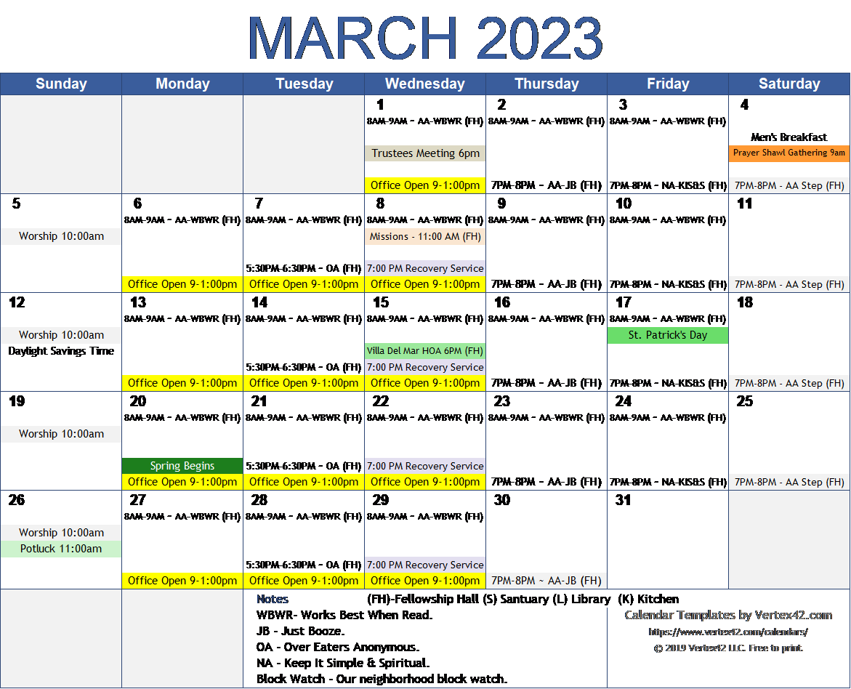

**FACEBOOK** – are you a participant on Facebook? If so, please LIKE Sunrise. It is a new page and we need people to LIKE us @

**[sunriseumcphx](https://www.facebook.com/sunriseumcphx/)** [**#sunriseumcphx**](https://www.instagram.com/sunriseumcphx/)



[This Photo](http://commons.wikimedia.org/wiki/File:Facebook_Shiny_Icon.svg) by Unknown Author is licensed under [CC BY-SA](https://creativecommons.org/licenses/by-sa/3.0/)



[This Photo](https://radiouniversidad.uca.edu.ni/instagram-agrega-stickers-animados-historias/) by Unknown Author is licensed under [CC BY-SA](https://creativecommons.org/licenses/by-sa/3.0/)