 Sunrise UMC

**February**

**2023**



**Church News**

SPRC Alice Mildenberger

Rev Donna has resigned as Pastor of Sunrise UMC effective immediately. Although her plan was to return, her concussion symptoms have not lessened.  Rev Louie Lyon will be our Interim pastor until our new pastor begins July 1st.  There will be a reception for Rev Donna after church on Feb 5th.  Please keep Rev. Donna and Sunrise in your prayers as we make this transition.  
Alice Mildenberger  
SPRC Chair



Words from desk of the Interim Pastor

Dear Ones,

In last month’s newsletter I told you that I was with you while Pastor Donna recovers from her concussion and would be here through the end of the January. Well, this morning, Jan. 26th, I received a call from our District Superintendent Rev. Javier Olivares asking me if I would consider becoming your Interim Pastor as Pastor Donna has decided that at this time her health is not allowing her to continue on as your pastor.

For those who might be wondering, “What is or what does an Interim Pastor do? An Interim Pastor in the United Methodist Church is someone the Bishop appoints in between the regular appointment period, this occurs at the conclusion of an Annual Conference in June of each year. The role of an Interim Pastor **is to prepare the congregation to get ready to receive their new permanent pastor.** In this case that would be on July 1, 2023. I have much experience in that role as this will be my 5th Interim Appointment since I retired 10 years ago. By the way at one Interim appointment someone called the D.S. to ask the question, “Does the Interim have the same authority to act as our minister as the ‘regular’ minister does?” The answer is YES, he is your minister, Interim just means another one will follow after him. Oh yes, in between the Interim Appointments I served for 2½ years as the Pastoral Care Pastor at Dove of the Desert UMC in Glendale. Pastoral Care is very important to me. On my first Sunday as a Pastor at any new church to which I am appointed to I have made the following statement…

“Pastoral Care is very important to me… the only thing that makes me really mad is to find out, after the fact, that someone was in the hospital, needed prayer or needed to talk but didn’t call or let me know because they thought I was too busy, and they didn’t want to bother me.” I can be reached at any time, on my cell phone (623) 238-8455. Now you know what makes me mad so I am sure you will feel comfortable in calling as I am here for YOU!

Each month in your newsletter you will find the title of each week’s sermons and the Scriptures they are based on. I am looking forward to being here with you and getting to know each of you better. If you would like me to visit, give me a call and we can set up a time to do so. There is another thing that I have always done at each church I have served through the years. That is Celebrate something called “Golden Wed Sunday.” I do so on the Sunday closest to Valentine’s Day. This year that is on Feb. 12th or Super Bowl Sunday. Please look for an article about that Sunday elsewhere in this newsletter.

Dear Ones, let’s all keep Pastor Donna and her husband in our prayers as she transitions from Sunrise. She loves you all and it is very hard for her to leave you.

Shalom,

Pastor Louie





**Louie’s February Sermon Schedule**

**Feb. 5th:** “Flavor in a Dark World”based on Matthew 5:13-20.

**Feb. 12th: “Golden Wed Sunday”** “Can I Love as God Loves?” 1 Corinthians 3:1-9.

**Feb. 19th:** “Where Do We Find God Today?” Matthew 17:1-9.

**ASH WEDNESDAY Service –** “WeShould Change Our Hearts, Not Our Diets” Matthew 6:1- 6, 16 – 21.

**Feb. 26th:** “We Are Free To Make a Choice” Matthew 4:1 – 11.



**CELEBRATE GOLDEN WED SUNDAY WITH US AT SUNRISE**

On Sunday, February 12th Pastor Louie would like to invite all who would like to re-create their Wedding Vows to do so. Having served in mainly Senior Congregations Pastor Louie has been used to having up to 100+ couples who have been married 50 years or more at his congregations participate in the recreation of wedding vows on a Golden Wed Sunday. He has invited those couples to participate in the recreation of their Wedding Vows on the Sunday closest to Valentine Day. At Sunrise, being that we are a small size congregation Pastor Louie would like to invite any couple who would like to recreate their wedding vows to do so.

If you, or if you have a friend or family member, who would like to participate bring them along. I share with you that each time I do a group recreation of wedding vows I am BLESSED! I am blessed because I see the couples looking at each other so lovingly and not taking one another for granted as they recite their vows. I have also been told by one or two who have lost a spouse that it is hard for them to view this and I say to them, as I said to myself after I lost my late wife, that we need to focus in on the “Gift that God had given us for the years we had them in our life” as we view the couples who are recreating their vows.

I invite you all to participate if you would like to. Feel free to ask me any questions you might have about Feb. 12th and I’ll do my best to answer them.

Pastor Louie

|  |  |
| --- | --- |
|  |  |
|  |  |
| |  | | --- | | **NEWS FROM OUR conference** | | |

**2023 District Leadership Conference – Phoenix, AZ**

**February 4 @ 8:30 am - 1:30 pm UTC+0**

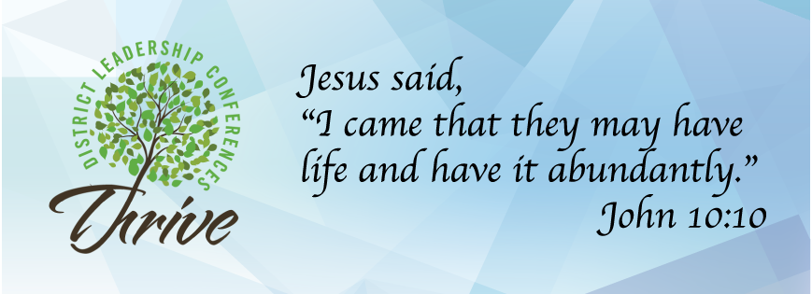

**Gathering time starts at 8:30 AM  |  Event start time is 9:00 AM**

The District Leadership Conference is a place to connect with other local church leadership, gain ideas and tools for effective and vital ministry, and be inspired as disciples of Jesus Christ who announced, *“I came that they may have life and have it abundantly.”* (John 10:10)

Bishop Carlo Rapanut, our newly elected and assigned bishop, will address each conference. Two Thriving Sessions will be presented, followed by lunch as a time to connect with others. The Thriving Sessions are:

**The Road Before Us**

Led by Rev. Rachel Gilmore, Director of New & Vital Faith Ministries  
Let’s be honest; most of our churches are struggling. People aren’t coming back to in-person worship, and giving isn’t what it used to be.  As a denomination, we continue to decline, and there is a disconnect between the church and the community. But what if it didn’t have to be that way? What if there was ongoing training for clergy and laity to help the church figure out how to reach people in new and innovative ways? What if we learned about the primary shifts the church needs to make in 2023 and beyond? Join us for a brief introductory workshop at the District Leadership Conference to learn more about this exciting ongoing training opportunity available to any church in the DSC.

**Counteracting Bias: Seeing People As They Are**

Led by Rev. Javier Olivares and Jess Brown  
The word bias simply means an evaluation or belief that is favorable or unfavorable. Bias in and of itself is a neutral term. Bias is a natural inclination or tendency for or against an idea, object, person, group, or belief. We can only see and perceive people, cultures, and the world from our perspective, regardless of how correct or skewed our perspective is. Of course, if our perspective is correct and we can see things the way they are, then there is no issue. However, an inherent bias in our perspective keeps us from seeing people and the world the way it is. Our faith teaches and encourages us that we do not need to be stuck in our biases. By the grace of God in Jesus Christ, we can overcome our biases and see people and the world as they are. The Holy Spirit lets us see whatGod sees in people, especially those different from us.

Here is the link to sign up for this leadership event. Cost is $20.00

https://dscumc.org/event/2023-district-leadership-conference-phoenix-az/

Counteracting Bias: Seeing People as They Are

by [Javier Olivares](https://dscumc.org/author/jolivares/) | Jan 18, 2023 | [Conference Newsletter](https://dscumc.org/blog/category/news/newsletter-mailchimp2020/), [Religion and Race](https://dscumc.org/blog/category/religion-and-race/)

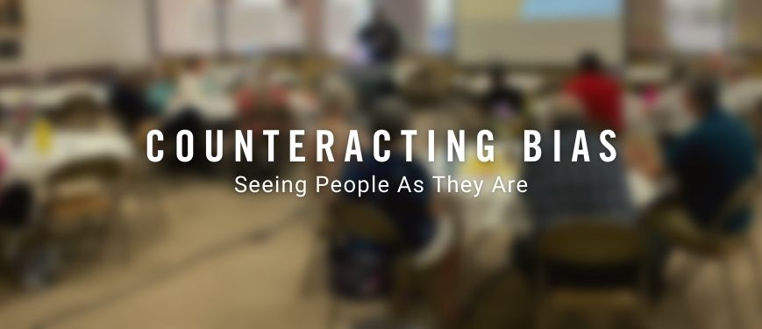

The word bias simply means an evaluation of a belief that is favorable or unfavorable. Bias in and of itself is a neutral term. Bias is a natural inclination or tendency for or against an idea, object, persons, groups, or beliefs. We can only see and perceive people, cultures, and the world from our perspective, regardless of how correct or skewed our perspective is. Of course, if our perspective is correct and we can see things the way they are, there is no issue. However, there is an inherent bias in our perspective that keeps us from seeing people and the world the way it is. Our faith teaches and encourages us that we do not need to be stuck in our biases. By the grace of God in Jesus Christ, we can overcome our biases and see people and the world as they are. The Holy Spirit enables us to see what God sees in people, especially those who are different from us.

Counteracting Bias training is available and free at the following dates and locations. Please select the training you are interested in attending to access the registration.

* [February 11 at University UMC](https://dscumc.org/event/counteracting-bias-training-at-university-umc/)
* [February 18 at Trinity UMC](https://dscumc.org/event/counteracting-bias-training-at-trinity-umc-phx/)
* [February 18 at Catalina UMC](https://dscumc.org/event/counteracting-bias-training-at-catalina-umc/)
* [February 25 at St. Matthew UMC](https://dscumc.org/event/counteracting-bias-training-at-st-matthew-umc-mesa/)

<https://dscumc.org/blog/2023/01/18/counteracting-bias-seeing-people-as-they-are/?utm_source=rss&utm_medium=rss&utm_campaign=counteracting-bias-seeing-people-as-they-are&ct=t(RSS_EMAIL_CAMPAIGN)&mc_cid=2442bc4d78&mc_eid=3dd942b7df#:~:text=Counteracting%20Bias%3A%20Seeing,St.%20Matthew%20UMC>



HELP UKRAINE

United Methodists respond to Ukraine Invasion: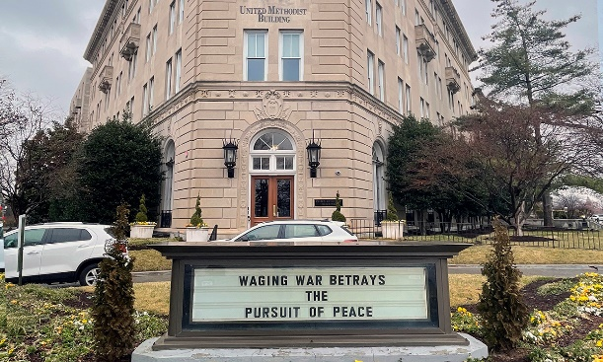

<https://www.umnews.org/en/news/united-methodists-respond-to-invasion-of-ukraine>

How we can help those in Ukraine:

Donations can be made to the United Methodist Committee on Relief’s International Disaster Response and Recovery through [Advance #982450](https://umcmission.org/advance-project/982450/).

United Methodist Global Ministries’ [Advance #14053A](https://umcmission.org/advance-project/14053a/) supports pastors in Ukraine and Moldova.

Creation Care  
The Creation care team is in the process of receiving information and ideas for us as individuals, for our neighbors, and for God's creation.  The monthly 90 minute sessions are attended by people from various denominations from all over the country.  Our first suggestion was to use reusable plates and silverware for our church gatherings either from home or Sunrise.  We will continue to collect ideas to share.  There is still room for interested individuals to join us.   
Your Green Team,  
Stephanie Newcomer, Alice Mildenberger

**Church News**

**(Proposed) Sunrise 2023 Leadership Team**

|  |  |
| --- | --- |
| **Nominations (2023)**  Pastor – Chair  Jean Danielson – Lay Leader  Joyce Trevolt  **SBG:**  Teresa Candeleria- Chair  Alice Mildenberger – SPRC Chair  Art Erb – Trustee Chair  Mary Pierce – Finance Chair  Jean Danielson – Lay Leader  Nancy Pittman – Finance Secretary  Frank Fischer – Missions Chair  Taylor Allen – At Large  Pastor  **Finance Team:**  Mary Pierce --Chair  Nancy Pittman  Jean Danielson    **Trustees:**  Art Erb - Chair  Dave Pierce  Charles Taylor  Jerry Meyers  Dave Newcomer  Angie Erb  **SPRC:**  Alice Mildenberger –Chair  Jean Danielson – Lay Leader  Ralph Pittman  Julie Moody  Linda DeYoung  Pastor  **Missions:**  Frank Fischer – Chair  Dana Fischer  Pat Hepperle  Linda DeYoung  Alice and Rich Mildenberger  Donna and Carl Richeson | **Worship:**  Jean Danielson - chair  Jill Greene – AV  Taylor Allen –AV  Dave Pierce—Sound  Christine Powell – piano  Cathy Bennett- Piano  Pastor  **Baptism Team:**  Dave Pierce  **Hospitality Team:**  Jean Danielson  Mary Pierce  Lynn Tressler  Billie Albright  Janice Fussler  **Delegate to Annual Conference**  Jean Danielson  Alternate -  **Nurture Team**  Dana Fischer - Chair  Linda DeYoung  Pat Hepperle  Janice Fussler  Rebecca Shannon  **Prayer Team:**  Pastor - Chair  Susan Rowland  Art Erb  Roy Trevolt  Taylor Allen  Mary Stein  Cathy Bennett  Christine Powell  Katy Moore-O’Dowd  Susan Allen  **Recovery Team:**  Art Erb  Charles Taylor |

**Church News**

**Help with Worship:**

We are still looking for greeters and liturgist to assist with our Sunday

worship services. Please let Rev. Louie or Joyce know if interested.

**Building Use:**

We have about 9 outside groups that meet in the building each month. If you would like more information about these groups, please contact the church office.

**Daily Prayer:**

[prayer.forwardmovement.org](http://prayer.forwardmovement.org/)

[dailyofficeexpress.org](http://dailyofficeexpress.org/)

[lectionary.library.vanderbilt.edu/daily.php?year=B](http://lectionary.library.vanderbilt.edu/daily.php?year=B)

Upperroombooks.com/neweverymorning/

If there have been any changes to your information; address, phone number, email address, please email the office at hello@sunrisephx.org and let them know of the changes. Thank you!

**I Want To Pray**

Sign-up sheet is on the back table. Please consider joining this ministry. You need to come 15 minutes early on Sunday morning and pray in the prayer room.

**Find Sunrise UMC on Social Media,**

**[sunriseumcphx](https://www.facebook.com/sunriseumcphx/)** [**#sunriseumcphx**](https://www.instagram.com/sunriseumcphx/)



[This Photo](http://commons.wikimedia.org/wiki/File:Facebook_Shiny_Icon.svg) by Unknown Author is licensed under [CC BY-SA](https://creativecommons.org/licenses/by-sa/3.0/)



[This Photo](https://radiouniversidad.uca.edu.ni/instagram-agrega-stickers-animados-historias/) by Unknown Author is licensed under [CC BY-SA](https://creativecommons.org/licenses/by-sa/3.0/)

**Easy Ways to Give:**

**Shop at Fry’s and help Sunrise UMC. 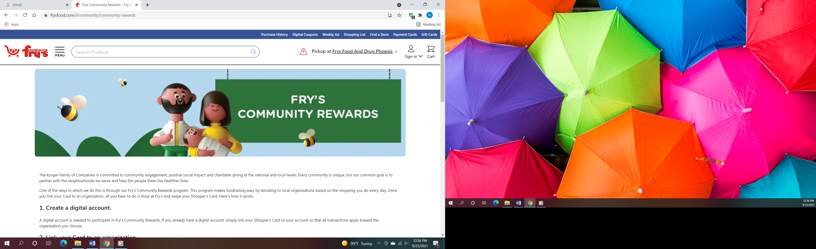Fry’s Community Rewards**

**program**. This program makes fundraising easy by donating to local organizations based on the shopping you do every day. Once you link your Card to an organization, all you have to do is shop at Fry’s and swipe your Shopper’s Card. Need help signing up, please, let the office know.

** We also collect cans; plastic bottles**

**Movie CD’s and TV Programs:**

Sunrise UMC has been given movie CD’s and have started a library. The CD’s are in room #4 in the fellowship hall. You may check out the movie to view and then return when you have watched it. Anyone who has movies they wish to donate can place on the shelf. Enjoy!

**NEWS FROM OUR MINISTRIES**

**Trustees:**



[This Photo](http://www.picserver.org/t/trustee.html) by Unknown Author is licensed under [CC BY-SA](https://creativecommons.org/licenses/by-sa/3.0/)

Greetings Sunrise from your trustees!

Trustees have changed their meeting date and time to the first Wednesday of the month.

This month’s meeting will be 2/1/2023 at 6:00 PM.

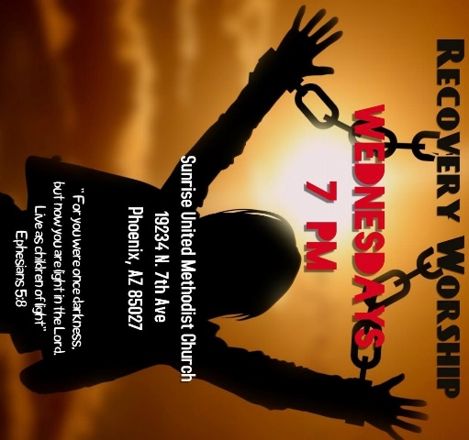

**Recovery Worship Service:**

The Wednesday Recovery Services is growing. We have great speakers, devotions, prayer and even a baptism. Everyone is welcome to join us on Wednesdays at 7:00PM.

To sign up to do devotions or for more information contact Art Erb or Charles Taylor.



[This Photo](http://justinsomnia.org/2009/09/breakfast-in-heathrow/) by Unknown Author is licensed under [CC BY](https://creativecommons.org/licenses/by/3.0/)

**Calling all Men!**

Come enjoy breakfast and good fellowship with other men from Sunrise. First Saturday, of the month at 8:00am. Contact Art Erb for more information.

**NEWS FROM OUR MINISTRIES**

**Missions ~ Mission Committee**



**LOVE FOR TEACHERS:** Missions will be collecting items for the teachers at Constitution Elementary School February 5 – March 12, 2023. The items will be used in the class room and as rewards for the students. School items such as: Kleenex, hand sanitizer, note pads, stickers, pencils, flash cards etc. or wrapped candy may be left on the table in the narthex. Thank you for your support**.**



Family Promise

Sunrise will be hosting families in the Family Promise program **February 12 – 19, 2023 and October 15 – 22, 2023**. **Sign-up sheets are currently at the back of the Sanctuary for the upcoming February dates.** Please consider helping with this mission by spending the night, preparing a meal or purchasing food.  **We need people to spend the night. Please help!** Mark your calendars now so you can share in this outreach. You share God's love all week long and are a blessing to the families. Reach out to Alice or Rich Mildenberger if you have questions.

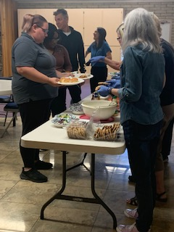**House of Refuge-Sunnyslope**

Members of Sunrise UMC serves meals at the House of Refuge You are welcome to join us and experience the blessing that comes from feeding the homeless. If you are interested in being a part of this mission, please let the office 623.780.1008 or Alice Mildenberger know.  This is a 3-part process.  We choose a menu and divide the food responsibilities with interested participants, bring the food ready to be served by 4:45 to Sunnyslope, and serve the women and children.  We would love to have more people join us.

**Ongoing Mission Projects**

The Justa Center has an ***URGENT*** need for the following items: **Can tuna, can chicken, can beans and can veggies; boxes or bags of pasta; laundry pods; and large bottles of shampoo.** They are also in need of: **warm clothing, coats, sweaters, hoodies, socks,** please bring to church and it will be taken to Justa Center



They are always in need of shoes, sunscreen, toothpaste (2.30z or larger) shampoo and water. Donations of money is always welcome. Place in envelope and write Missions- Justa Center.

Mission Committee meets the 2nd Wednesday of the month at 11:00am. January 11, 2022

Mission Committee Members are:

Linda DeYoung Pat Hepperle

Laura Diamond Alice Mildenberger

Dana Fischer Rich Mildenberger

Frank Fischer Donna and Carl Richeson

**Prayer Shawl Ministry**



[This Photo](http://sweetbeebuzzings.blogspot.com/2014/08/nordic-shawl.html) by Unknown Author is licensed under [CC BY-SA-NC](https://creativecommons.org/licenses/by-nc-sa/3.0/)

**This ministry began in February 2022 and has handed out over 20 prayer shawls.  What a blessing this ministry has been for those who need to feel God's presence and the love and support of our knitters/crochets.**

Prayer shawls have been made for centuries. They are universal and embracing, and offer comfort while they enfold, and shelter. Sunrise's prayer shawl ministry will be for anyone who wants to share God's love and care by creating a prayer shawl.  If you have ever knitted or crocheted, please pray about being a part of this ministry.

I received enough skeins of yarn from a friend of Billie's to allow any interested person a chance to try making a shawl.  Typically, knitting needles size 11 or 13 and crochet hooks size K-P can be used and I have those to share as well. Most shawls are between 26"-30" wide x 60" in length. I will have copies of basic instructions on how to cast on, knit, plural, and crochet as well as general information at the back of the sanctuary.

**We will gather on the first Saturday of the month, January 7th at 9:00am. There will be yarn, knitting needles, crochet hooks, and people to assist as needed.  Join us as we begin this ministry.**

Contact Alice Mildenberger for more information.



Karen Gilpin February 5



Frank & Dana Fischer February 1

Allan & Janice Fusler

February 14

Please let us know if we have missed your special day.

**NEWS FROM OUR MINISTRIE**

**Prayer Ministry**

A Valentine Prayer

I said a valentine prayer for you

And asked the Lord above

To fill your heart

and bless your soul with

The precious gift of love.

I asked Him for sincere love,

The kind that’s meant to stay

Just like the generous

love You give to those

You touch each day.

I prayed for love

From family

And from every

cherished friend

Then I asked the Lord

to give you His love

That knows no end.

(Author unknown)



Love is a symbol of eternity

It wipes out all sense

of time, destroying all

Memory of a beginning

and all fear of an

End.

(author unknown)

**NEWS FROM oUR MINIST****ry**

**Finance Ministry**

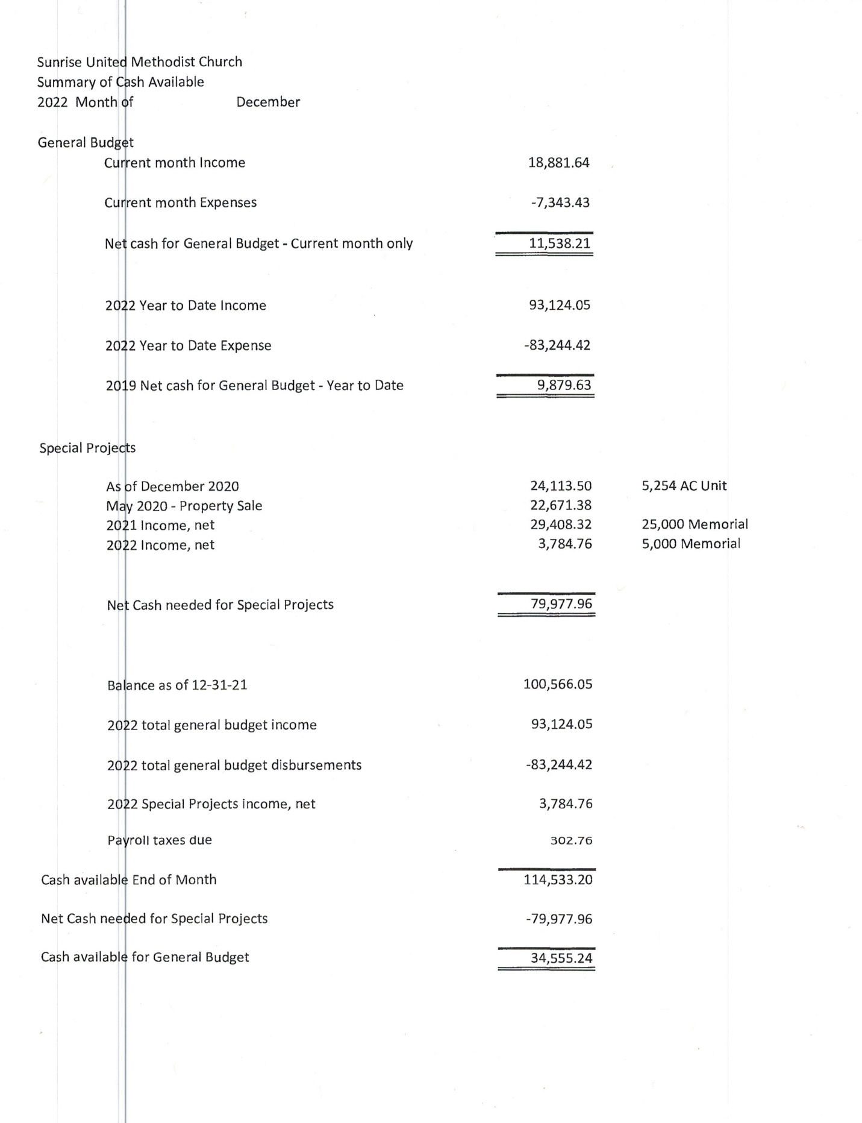



**FACEBOOK** – are you a participant on Facebook? If so, please LIKE Sunrise. It is a new page and we need people to LIKE us @

**[sunriseumcphx](https://www.facebook.com/sunriseumcphx/)** [**#sunriseumcphx**](https://www.instagram.com/sunriseumcphx/)



[This Photo](http://commons.wikimedia.org/wiki/File:Facebook_Shiny_Icon.svg) by Unknown Author is licensed under [CC BY-SA](https://creativecommons.org/licenses/by-sa/3.0/)



[This Photo](https://radiouniversidad.uca.edu.ni/instagram-agrega-stickers-animados-historias/) by Unknown Author is licensed under [CC BY-SA](https://creativecommons.org/licenses/by-sa/3.0/)