 Sunrise UMC

**May**

**2022**



Hello Sunrise!

Words from the Pastor

I love Easter! Everything it represents from the beautiful flowers of spring, to the fragrant lilies in the sanctuary, from the garden of Eden to the garden at the tomb, from the sweetness of Easter candy to the preciousness of God’s Easter people, from the grief of Holy Week to the celebration of Easter, from the songs of the birds to the resounding sounds of Up From the Grave He Arose, He Lives, Morning has Broken! Friends Easter is the real reason for all seasons for we Christians! The **RESURRECTION** is what gives us life, gives us hope, gives us peace and gives us power.

We had a wonderful Easter Celebration here at Sunrise UMC with so many folks at our Good Friday service (thanks Christine for your piano playing), Easter sunrise service (thanks Alice for playing your violin) and our regular Easter service (thanks Cathy for the piano music). It was exciting to see so many new faces and feel the energy of God’s Resurrected People. As wonderful as our Easter was, for Christians, Easter is not just one day - it's a season of 50 days, a week of weeks, derived in its length from the fifty days between Passover and Pentecost (which means fiftieth) in Judaism. Easter season begins at sunset on the eve of Easter and ends with [Pentecost](https://www.umc.org/en/content/glossary-pentecost), the day we celebrate the gift of the Holy Spirit and the birth of the Church (see Acts 2).

*“This Easter season gives us time to rejoice and experience what we mean when we say Christ is risen and that we, as the church, are the body of the Risen Lord. It’s a season for focusing on the core doctrines and mysteries of the faith and for preparing for the ministries the Spirit has empowered us to undertake in Jesus’ name”. UMC.org*

We begin this season with a baptism during our Recovery Worship service and will end it with the flames of Pentecost! As we journey in between may we embrace mystery, may we dig into our faith, may we look for signs of Resurrection all around us, may we practice being Easter People! We are witnesses to the Resurrection! Go tell somebody!

He is Risen! He is Risen Indeed!

*Rev. Donna Hughes*

P.S. My summer plans begin the first Sunday in June and Doug and I will be traveling to cooler climates in northern Arizona, southern Colorado, and northern New Mexico. We are excited to be back out in our 5th wheel doing a bit of traveling. You are blessed to have Rev. Tom Kiracofe and Rev. Pam Wagner as your preachers and pastors during June and July. Here are their biographies and as you can see, they bring a wonderful array of pastoral experience to Sunrise UMC and are so excited to be in ministry with you for these two months!

**Rev. Donna** 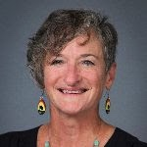

Meet your pastors for June and July.

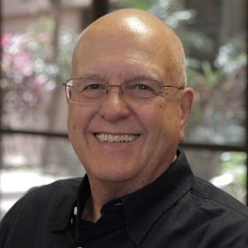Tom Kirakofe

I was born and raised in a small rural town in southern Ohio. After high school, I graduated from Hanover College in southern Indiana. I taught junior high U.S. History in Miamisburg, Ohio. Two years later I responded to the “Call” to ministry, graduating from The Methodist Theological School of Ohio. While serving a church in Fairborn, Ohio for a year I heard the advice of Horace Greeley “go west young man go west” and accepted a position on the staff of 1st UMC Riverside, California. I have served churches in Cucamonga, N. Las Vegas, Tucson, Mesa, Phoenix before retiring from Dayspring in Tempe. During my retirement years I have been called to serve as interim at Via de Cristo and then at Aldersgate twice over a six-year span ending January of this year. I have served the Conference on the Board of Ministry, the retired ministers board (ARMS), organizing and launching Strength for the Journey retreats and working on various other committees through the years.  
I have two sons, my oldest, Tom, lives in north Phoenix and youngest, Ted, is married to Brandie, they have two sons Kaiden and Quinten and live in Tucson.  
Retirement has been wonderful with the freedom to travel and to choose what I would like to do. I enjoy my home in central Phoenix and spending most of my summer in Flagstaff to escape the heat.  
An important appointment of my ministry was in 1983 to a piece of ground in North Phoenix. Upon that ground was birthed Sunrise United Methodist Church. I am excited to serve you for a short while in the church that I help to create along with many dedicated lay people

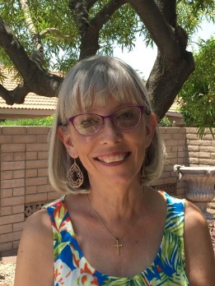Pam Wagner

Rev. Pamela Wagner is a retired United Methodist Minister who has served churches all over the Desert Southwest. She also served as the chair of the Conference Board of Ordained Ministry for a few years. Her first appointment was at a student pastor at Sunrise United Methodist Church and she has great memories of her short time there! Her last appointment was in retirement, at Velda Rose UMC.

The call to ministry actually came later in life for Pam. Her first career was teaching in elementary school. It was after she attended the Walk to Emmaus that she began to feel again the call that God had first placed upon her heart when she was baptized at age eleven.

Pam finally had to retire for good in 2020 to care for her husband Bob, to whom she had been married for 50 years when he passed away in early 2021. She has two wonderful daughters, two delightful sons-in-law, and three brilliant and talented teenaged grandchildren who still think she is the coolest grandma!

I want to thank:

Everyone who read for Good Friday, Christine for playing the piano on Good Friday, Alice for playing violin for Easter Sunrise, Cathy for playing for our Easter service and every Sunday.  Joyce for ordering our Easter lilies, Jean for decorating the church for Easter, Susan Rowland for my Good Friday and Easter Stoles,

Art and Charles for getting the window in the office, Roy for putting in "two" peepholes, Taylor for helping teach our Lenten study, Alice for coordinating Family Promise.

As referenced on Palm Sunday: Rev. Donna running with the Donkeys.



Watch Rev. Donna run with the donkeys. Just right double click on the blue square, a box will open and ask “do you want to open this file” click ‘open’ and enjoy a short video of her running with donkeys.



[This Photo](https://www.momentsofintrospection.com/2018/05/happy-mothers-day-to-all-mamas.html) by Unknown Author is licensed under [CC BY-SA](https://creativecommons.org/licenses/by-sa/3.0/)

1. “I don’t need a bath. Can’t you just Febreeze me?” -a 10-year-old

2. Upon being asked to unload the dishwasher after dinner, a pre-teen daughter asked her mom if there is anything “less strenuous” she could do.

3. “Dad, you were born back when everything was invented.”

4. “If Jesus walked on water, could he do a handstand, too?” -a 4-year-old

5. “Daddy, I know what sugar is. It is made from cookies.”

6. “Daddy! I thought you gave up ice cream for Lent! When we get home, I’m calling 911!”

7. “Daddy, if you help me clean the playroom, I’ll let you sleep with me!”

8. A 7-year-old boy said, “When you get old, you get lines and vines.” When asked to explain, he said, “Dad, you get lines on your face and vines on your legs.”

9. “You can’t be a man; you’re a dad!” -a 4-year-old girl

10. After getting in trouble for something, a little boy said, “I’m only 5—I don’t know all the rules yet!”

11. A 4-year-old with his first earache said, “Daddy, my ear has a cough in it!”

‎12. “Mom, are the little flowers on the tomato plant the cheerleaders for the tomatoes?” -a 5-year-old

13. On a long car ride back from vacation, a 10-year-old boy told his 8-year-old sister, “If you were Mrs. Potatohead, I would take your mouth right now.”

14. A little girl was studying her mother, who had just had a baby a few weeks earlier. She told her mom, “I know where your belly went—it all went to the back.”

**What is the funniest thing your kids have ever said?**

SUNRISE PAID 100% OF OUR APPORTIONMENTS FOR 2021

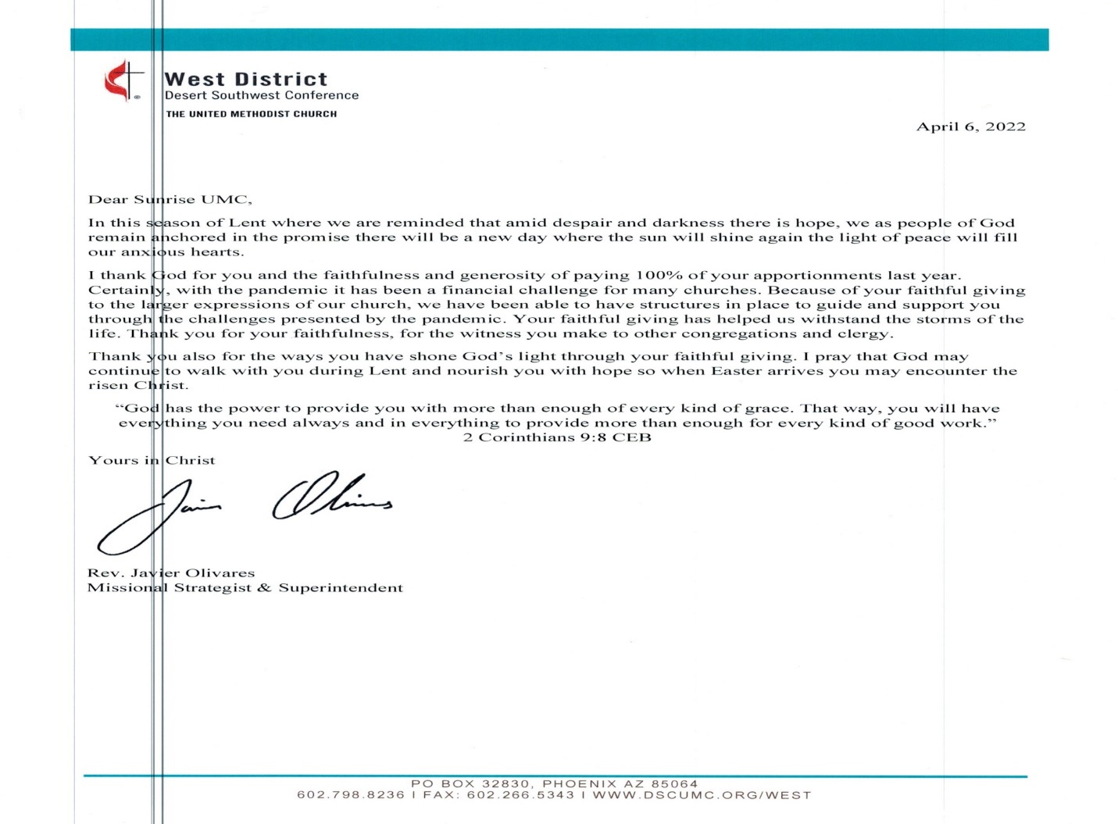Read the letter below from our District Superintendent

United Methodists respond to Ukraine Invasion: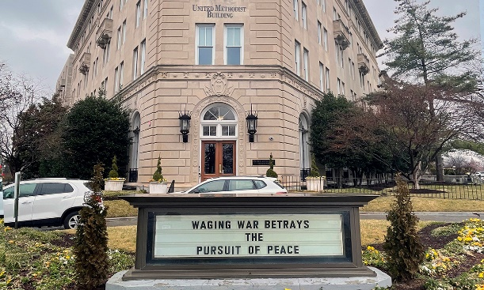

<https://www.umnews.org/en/news/united-methodists-respond-to-invasion-of-ukraine>

How we can help those in Ukraine:

Donations can be made to the United Methodist Committee on Relief’s International Disaster Response and Recovery through [Advance #982450](https://umcmission.org/advance-project/982450/).

United Methodist Global Ministries’ [Advance #14053A](https://umcmission.org/advance-project/14053a/) supports pastors in Ukraine and Moldova.

**Church News**

**Help with Worship:**

We are still looking for greeters to assist with our Sunday worship services. Please let Rev. Donna or Joyce know if interested.

**Building Use:**

We have about 9 outside groups that meet in the building each month. If you would like more information about these groups, please contact the church office.

**Daily Prayer:**

[prayer.forwardmovement.org](http://prayer.forwardmovement.org/)

[dailyofficeexpress.org](http://dailyofficeexpress.org/)

[lectionary.library.vanderbilt.edu/daily.php?year=B](http://lectionary.library.vanderbilt.edu/daily.php?year=B)

Upperroombooks.com/neweverymorning/

If there have been any changes to your information; address, phone number, email address, please email the office at hello@sunrisephx.org and let them know of the changes. Thank you!

Have you always wanted to see the places in the bible, travel where Jesus traveled?  Here is your opportunity!

Are you interested in experiencing the Holy Land?  Going to the River Jordan, Jericho, the Sea of Galilee, Caesarea and so much more.  Rev. Donna would love to host an Educational Opportunities trip to the Holy Land early December 2022 or Early January 2023.  More information to follow, but if you think you might be interested in this once in a lifetime journey, let her know!  Estimated cost all inclusive is $2500-3200.00.

**Find Sunrise UMC on Social Media,**

**@**[**sunrisephx**](https://www.facebook.com/sunrisephx/)[**#sunriseumcphx**](https://www.instagram.com/sunriseumcphx/)



[This Photo](http://commons.wikimedia.org/wiki/File:Facebook_Shiny_Icon.svg) by Unknown Author is licensed under [CC BY-SA](https://creativecommons.org/licenses/by-sa/3.0/)



[This Photo](https://radiouniversidad.uca.edu.ni/instagram-agrega-stickers-animados-historias/) by Unknown Author is licensed under [CC BY-SA](https://creativecommons.org/licenses/by-sa/3.0/)

**Easy Ways to Give:**

**Shop at Fry’s and help Sunrise UMC.** **Fry’s Community Rewards program**. This program makes fundraising easy by donating to local organizations based on the shopping you do every day. Once you link your Card to an organization, all you have to do is shop at Fry’s and swipe your Shopper’s Card. Need help signing up, please, let the office know.

**AmazonSmile:** Sign up for AmazonSmile, Enter the link below and it will automatically ask if you want to support Sunrise United Methodist Church. Say yes, and 0.5% of the price of eligible purchase will go to the church. Continue to shop and support the church. Just log in to AmazonSmile first.

[**https://smile.amazon.com/ch/86-0572433**](https://smile.amazon.com/ch/86-0572433)

** We also collect cans; plastic bottles**

**Movie CD’s and TV Programs:**

Sunrise UMC has been given movie CD’s and have started a library. The CD’s are in room #4 in the fellowship hall. You may check out the movie to view and then return when you have watched it. Anyone who has movies they wish to donate can place on the shelf. Enjoy!

**NEWS FROM OUR MINISTRIES**

**Trustees:**



[This Photo](http://www.picserver.org/t/trustee.html) by Unknown Author is licensed under [CC BY-SA](https://creativecommons.org/licenses/by-sa/3.0/)

Greetings Sunrise from your trustees!

Trustees have changed their meeting date and time to the first Wednesday of the month.

This month’s meeting will be 5/4/2022 at 6:00 PM.



A big THANK YOU! goes out to those who through the Community Restitution Project have been cleaning our church. Your service is greatly appreciated.

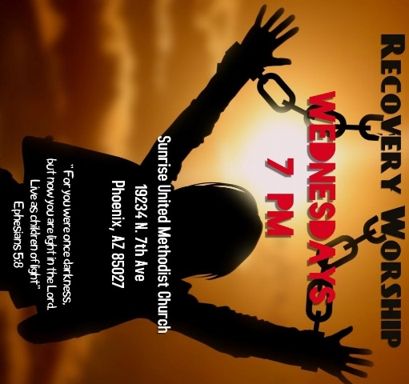

**Recovery Worship Service:**

The Wednesday Recovery Services is up and running with great speakers, devotions and even a baptism. Everyone is welcome to join us on Wednesdays at 7:00PM.



[This Photo](http://justinsomnia.org/2009/09/breakfast-in-heathrow/) by Unknown Author is licensed under [CC BY](https://creativecommons.org/licenses/by/3.0/)

Calling all Men!

Come enjoy breakfast and good fellowship with other men from Sunrise. May 14th at 8:00am in the fellowship hall.

**NEWS FROM OUR MINISTRIES**

Family Promise –

Family Promise

Thank you to everyone who volunteered to help provide a safe and supportive environment for our families.  Your positive interactions were noticed and appreciated. We continue to be amazed at the caring and giving nature of our Sunrise family.  You shared God’s love all week long.  God bless you all, Richard and Alice Mildenberger

**Our next service week is October 24-30**

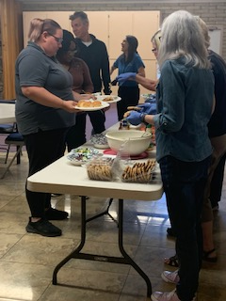House of Refuge, Sunnyslope

Our second meal for homeless women and children will be served on **Tuesday, May** **24th**.  If you are interested in being a part of this mission, please let the office or Alice Mildenberger know.  This is a 3 part process.  We choose a menu and divide the food responsibilities with interested participants, bring the food ready to be served by 4:45 to Sunnyslope, and serve the women and children.  We would love to have you join us.

**Prayer Shawl Ministry**  
Prayer shawls have been made for centuries. They are universal and embracing, and offer comfort while they enfold, and shelter. Sunrise's prayer shawl ministry will be for anyone who wants to share God's love and care by creating a prayer shawl.  If you have ever knitted or crocheted, please pray about being a part of this ministry.



[This Photo](http://sweetbeebuzzings.blogspot.com/2014/08/nordic-shawl.html) by Unknown Author is licensed under [CC BY-SA-NC](https://creativecommons.org/licenses/by-nc-sa/3.0/)

I received enough skeins of yarn from a friend of Billie's to allow any interested person a chance to try making a shawl.  Typically, knitting needles size 11 or 13 and crochet hooks size K-P can be used and I have those to share as well. Most shawls are between 26"-30" wide x 60" in length. I will have copies of basic instructions on how to cast on, knit, plural, and crochet as well as general information at the back of the sanctuary.

**We will gather on the first Saturday of the month, May 7th at 9:00am. There will be yarn, knitting needles, crochet hooks, and people to assist as needed.  Join us as we begin this ministry.**

Contact Alice Mildenberger for more information.

**Ongoing Mission Projects**

Justa Center: shoes, shoes and more shoes!

Constitution Elementary School: underwear, socks, and school supplies are always needed.

Mission Committee Members are:

Linda DeYoung Pat Hepperle

Laura Diamond Alice Mildenberger Dana Fischer Rich Mildenberger

Frank Fischer

***May***



[This Photo](http://all-en-a-days-work.blogspot.com/2010/10/happy-birthday-doris.html) by Unknown Author is licensed under [CC BY-ND](https://creativecommons.org/licenses/by-nd/3.0/)

Lynn Tressler May 6

Alan Fusler May 24

Rebecca Ockensfels May 25

Kelly Baker May 31



John and Lois Heyer May 1

Please let us know if we have missed your special day.

**NEWS FROM OUR MINISTRIES**

**Prayer Ministry**



**Prayer Team**

|  |  |
| --- | --- |
| Rev. Donna | pastor@sunrisephx.org |
| Taylor Allen | [t.bone6@aol.com](mailto:t.bone6@aol.com) |
| Cathy Bennett | [catbennett2@gmail.com](mailto:catbennett2@gmail.com) |
| Art Erb | [alerb1111@gmail.com](mailto:alerb1111@gmail.com) |
| Susan Rowland | [susan.rowland46@iCloud.com](mailto:susan.rowland46@iCloud.com) |
| Roy Trevolt | [rctdrums@cox.net](mailto:rctdrums@cox.net) |
| Mary Stein | [mlkstein32@gmail.com](mailto:mlkstein32@gmail.com) |

**NEWS FROM oUR MINISTRIES**

**Finance Ministry ~ Finance Committee**



**NEWS FROM OUR conference**

**Lay Servant Ministry ~ Joyce Trevolt**

**Lay Servants Lead in Conflict Resolution**

**June 15, 22, and 29 (Zoom)**

**Rev. Dave Summers - Instructor**

Every church deals with conflict, both healthy and unhealthy, and lay servants can be equipped and empowered to help lead through those times of conflict as a time of transformation.

This class will be offered on three Wednesdays in June you need to attend each class. We want all of you to be safe and will endeavor, through ZOOM classes to provide the same high quality Lay Servant Ministry Classes we have always provided in the West District.

The class is $15. If you have to cancel or postpone you will get a credit for a future class in the West District. The book you need to purchase and **read completely** before class begins is – *The Spirit and Art of Conflict Transformation* by Thomas Porter. You can find the book at Cokesbury or Amazon.

**The classes will be held on Wednesdays, June 15, 22, and 29, 6:30-9:30 PM each day.**

To register go to: <https://dscumc.org/lay-servant-ministries-training-sessions/>

**Leadership Talks**

**May 2 @ 7:00 pm MST**

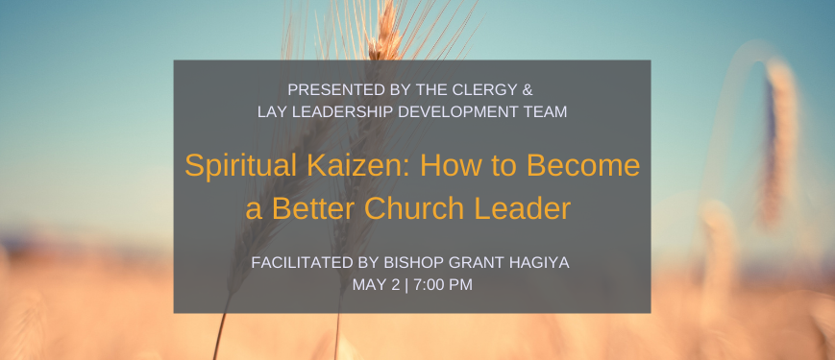

Sponsored by Clergy and Lay Leadership Development

*This month’s event Spiritual Kaizen: How to Become a Better Church Leader will be presented by Bishop Grant Hagiya and is based on the book he authored.* “Kaizen” is a Japanese word that translates roughly, “to change or correct for the better.” What are the traits, qualities and characteristics of effective clergy? Is it possible to transform an average local church pastor into a highly effective and growth-oriented pastor? Leadership is not defined at birth. All of us can grow and develop into more effective leaders and we can do this at any time during our careers. *Spiritual Kaizen* works from the best secular and ecclesial models of leadership in order to draw out the best leadership practices available for current and future leaders of the church.

*Spiritual Kaizen: How to Become a Better Church Leader*available from [Amazon](https://www.amazon.com/dp/B00BOX7Z64/) for purchase in print or for Kindle.

[Register Now](https://dscumc.org/leadership-talk-may-2022/)

**Grant J. Hagiya** is the Resident Bishop of the California-Pacific Annual Conference, which geographically extends to all of Southern California, Hawaii, and Guam; and the Desert Southwest Conference, which geographically extends to Arizona and Southern Nevada.

Education and Leadership:  
He graduated with an Educational Doctorate in Organizational Leadership from Pepperdine University in 2012. Abingdon published his book, Leadership Kaizen, based on his dissertation on the Traits, Qualities and Characteristics of Highly Effective UMC Clergy in 2013. He has worked and studied with Ron Heifetz and Marty Linksy at the Harvard Kennedy School, and is a member of the newly formed Adaptive Leadership network. He holds a Professional Coaching Certification (PCC) from the International Coach Federation as a professional certified coach. He is also a Gallup Strengths Finder Certified Coach. He is currently training as a Professional Team Coach with Peter Hawkins in his Systematic Team Coaching Training Program. He is a graduate of the Claremont School of Theology, where he received M.A., M.Div., and D.Min. Degrees. In 2019, he received an Honorary Doctorate Degree from Claremont School of Theology. He is an Adjunct Faculty Member at Claremont, where he teaches Religious Leadership and United Methodist Studies.

Ordained Ministry and Superintendency:  
Prior to his election to the episcopacy, he served as the Senior Pastor at churches in Berkeley, Gardena, and Los Angeles, California as well as the Los Angeles District Superintendent and Dean of the Appointed Cabinet of the California Pacific Annual Conference.

Episcopacy:  
Elected to the Episcopacy in 2008, he served for 8 years in the Greater Northwest Annual Conference, which includes 3 annual conferences: Alaska, Oregon-Idaho, and the Pacific Northwest. He was a member of the Commission on the Way Forward, tasked with forging a strategy on human sexuality for the United Methodist Church. He is the current chair of the Council of Bishop’s Task Force that plans the new Learning Retreats for all active Bishops. He is a former President of the College of Bishops for the Western Jurisdiction. He received an additional assignment in October 2021 to oversee the Desert Southwest Conference.

Family:  
Grant is married to Janet, a retired high school librarian, and has three children, Lexie, Jamie, and Trent; and four grandchildren.

Do you enjoy having opportunities to grow as a leader and to learn from other leaders? Do you find it enriching to share leadership ideas, concepts, and inspiration with others?

Opportunities are available to anyone in the Desert Southwest Conference interested in learning through a focused discussion of mixed media leadership resources, such as books, videos, podcasts, webinars, etc. Leadership is explored from various perspectives, including resources that look at leadership from more than one cultural lens.

A number of 1 1/2-hour, virtual evening conversations are offered this year.

The presenters and facilitators of these discussions may include recognized Desert Southwest Conference leaders, authors, and creators of the media being discussed and, as well as members of the CLLD Team. We hope you decide to try out any of the resources we have prepared for you, and join others interested in the same conversations!

Questions about this series may go to Judy Martin at [stilljudymartin@gmail.com](javascript:;) or Rev. Javier Olivares at [jolivares@dscumc.org](javascript:;).

Sunrise Social Media

[**@sunrisephx**](https://www.facebook.com/sunrisephx/)[**#sunriseumcphx**](https://www.instagram.com/sunriseumcphx/)



[This Photo](http://commons.wikimedia.org/wiki/File:Facebook_Shiny_Icon.svg) by Unknown Author is licensed under [CC BY-SA](https://creativecommons.org/licenses/by-sa/3.0/)



[This Photo](https://radiouniversidad.uca.edu.ni/instagram-agrega-stickers-animados-historias/) by Unknown Author is licensed under [CC BY-SA](https://creativecommons.org/licenses/by-sa/3.0/)