
Sunrise UMC
July
2022

Words from the Pastor

As Rev. Donna is on vacation, her ‘Words from the Pastor’ come via a prayer by Ted Loder

Help Me To Believe In Beginnings - Ted Loder

God of history and of my heart,
so much has happened to me during these whirlwind days:
I’ve known death and birth;
I’ve been brave and scared;
I’ve hurt, I’ve helped;
I’ve been honest, I’ve lied;
I’ve destroyed, I’ve created;
I’ve been with people, I’ve been lonely;
I’ve been loyal, I’ve betrayed;
I’ve decided, I’ve waffled;
I’ve laughed and I’ve cried.
You know my frail heart and my frayed history –
and now another day begins.
O God, help me to believe in beginnings
and in my beginning again,
no matter how often I’ve failed before.

Help me to make beginnings:
to begin going out of my weary mind
into fresh dreams,
daring to make my own bold tracks
in the land of now;
to begin forgiving
that I may experience mercy;
to begin questioning the unquestionable
that I may know truth
to begin disciplining
that I may create beauty;
to begin sacrificing
that I may make peace;
to begin loving
that I may realize joy.

Help me to be a beginning to others,
to be a singer to the songless,
a storyteller to the aimless,
a befriender of the friendless;
to become a beginning of hope for the despairing,
of assurance for the doubting,
of reconciliation for the divided;
to become a beginning of freedom for the oppressed,
of comfort for the sorrowing,
of friendship for the forgotten;
to become a beginning of beauty for the forlorn,
of sweetness for the soured,
of gentleness for the angry,
of wholeness for the broken,
of peace for the frightened and violent of the earth.

Help me to believe in beginnings,
to make a beginning,
to be a beginning,
so that I may not just grow old,
but grow new
each day of this wild, amazing life
you call me to live
with the passion of Jesus Christ. Amen.
Rev. Donna 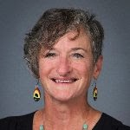
THIS SUMMER: I am also excited about the folks coming to be your pastors this summer; Revs.Tom Kiracofe and Pam Wagner. They have a history with our church and can’t wait to worship with you. Pam will be here just two Sundays and Tom will be here the rest and will be the pastor on call if you have pastoral care needs. Just a reminder that he will be in the church office on Mondays following preaching on Sundays if you want to drop in and connect. Joyce will continue to be in the church office M-W 9-1. I know you will be blessed by these two! So, keep coming to church, keep doing your financial commitment, love each other, greet the many visitors that we have drop in, pray for the church and for each other, enjoy the heat and I will see you July 31st!

Preaching Schedule for July
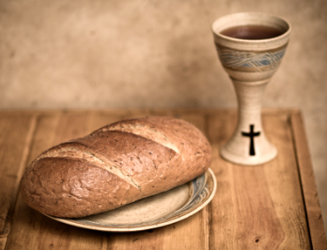
July 3: Rev. Tom Kiracofe (communion)
July 10: Rev. Pam Wagner
July 17: Rev. Tom Kiracofe
July 24: Rev. Tom Kiracofe
This Photo by Unknown Author is licensed under CC BY-NC-ND
July 31: Donna is back and preaching

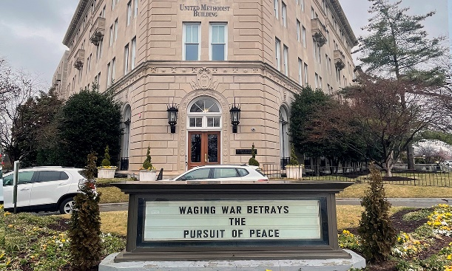
United Methodists respond to Ukraine Invasion:

https://www.umnews.org/en/news/united-methodists-respond-to-invasion-of-ukraine

How we can help those in Ukraine:

Donations can be made to the United Methodist Committee on Relief’s International Disaster Response and Recovery through Advance #982450.
United Methodist Global Ministries’ Advance #14053A supports pastors in Ukraine and Moldova.

A member of Sunrise’s congregation, Roy Trevolt has been appointed to serve as Lay Person Assigned at Faith United Methodist Church, in Phoenix beginning July 1, 2022. Faith United Methodist Church is a Reconciling Congregation. What does that mean? The below information is from the DSC website.

Welcoming and Reconciling Ministries (WARM)
A part of the Reconciling Ministries Network (RMN), the Desert Southwest Annual Conference defines itself as a Conference seeking the reconciliation of all people without regard to their race, socioeconomic class, or sexual orientation since 1993.

The Mission of RMN:
Reconciling Ministries Network equips and mobilizes United Methodists of all sexual orientations and gender identities to resist evil, injustice, and oppression in whatever forms they present themselves.
The language of RMN’s mission comes from the United Methodist baptismal vow, and that’s our charge. Simply put, we work to advance justice and inclusion for all LGBTQ people in The United Methodist Church and beyond.

To journey with a child, friend, or parent who “comes out” (shares with you that he/she/they are LGBTQIW+) can be a confusing one.
Here is a link for more information: https://dscumc.org/welcoming-and-reconciling-ministries/

Please keep Roy Trevolt and Faith United Methodist Church in your prayers as God uses Roy to further His Kingdom on earth.



Church News

Help with Worship:
We are still looking for greeters to assist with our Sunday worship services. Please let Rev. Donna or Joyce know if interested.

Building Use:
We have about 9 outside groups that meet in the building each month. If you would like more information about these groups, please contact the church office.

Daily Prayer:
prayer.forwardmovement.org
dailyofficeexpress.org
lectionary.library.vanderbilt.edu/daily.php?year=B
Upperroombooks.com/neweverymorning/

If there have been any changes to your information; address, phone number, email address, please email the office at hello@sunrisephx.org and let them know of the changes. Thank you!

TRAVEL TO THE HOLY LAND
Have you always wanted to see the places in the bible, travel where Jesus traveled? Here is your opportunity!
Are you interested in experiencing the Holy Land? Going to the River Jordan, Jericho, the Sea of Galilee, Caesarea and so much more. Rev. Donna would love to host an Educational Opportunities trip to the Holy Land Spring of 2023. More information to follow, but if you think you might be interested in this once in a lifetime journey, let her know! Estimated cost all inclusive is $2500-3200.00.

Find Sunrise UMC on Social Media,
 @sunrisephx  #sunriseumcphx
This Photo by Unknown Author is licensed under CC BY-SA
This Photo by Unknown Author is licensed under CC BY-SA
Easy Ways to Give:

Shop at Fry’s and help Sunrise UMC. Fry’s Community Rewards program. This program makes fundraising easy by donating to local organizations based on the shopping you do every day. Once you link your Card to an organization, all you have to do is shop at Fry’s and swipe your Shopper’s Card. Need help signing up, please, let the office know.


AmazonSmile: Sign up for AmazonSmile, Enter the link below and it will automatically ask if you want to support Sunrise United Methodist Church. Say yes, and 0.5% of the price of eligible purchase will go to the church. Continue to shop and support the church. Just log in to AmazonSmile first.
https://smile.amazon.com/ch/86-0572433

 We also collect cans; plastic bottles


Movie CD’s and TV Programs:
Sunrise UMC has been given movie CD’s and have started a library. The CD’s are in room #4 in the fellowship hall. You may check out the movie to view and then return when you have watched it. Anyone who has movies they wish to donate can place on the shelf. Enjoy!

NEWS FROM OUR MINISTRIES


Trustees:
This Photo by Unknown Author is licensed under CC BY-SA
Greetings Sunrise from your trustees!
Trustees have changed their meeting date and time to the first Wednesday of the month.
This month’s meeting will be 7/6/2022 at 6:00 PM.

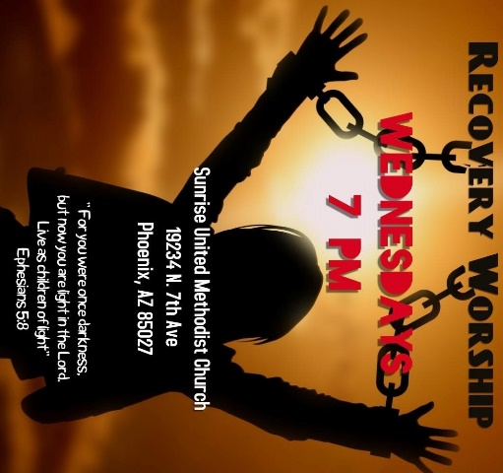

Recovery Worship Service:
The Wednesday Recovery Services is up and running with great speakers, devotions and even a baptism. Everyone is welcome to join us on Wednesdays at 7:00PM.


This Photo by Unknown Author is licensed under CC BY
Calling all Men!
Come enjoy breakfast and good fellowship with other men from Sunrise. Saturday, July 9th at 8:00am Denny’s I17 & Deer Valley Rd.

NEWS FROM OUR MINISTRIES


Family Promise –
Family Promise

Our next service week is October 24-30

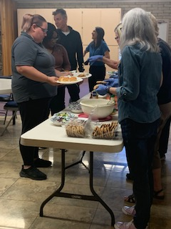
House of Refuge-Sunnyslope

Our next meal will be served on July 26th. You are welcome to join us and experience the blessing that comes from feeding the homeless. If you are interested in being a part of this mission, please let the office or Alice Mildenberger know. This is a 3 part process. We choose a menu and divide the food responsibilities with interested participants, bring the food ready to be served by 4:45 to Sunnyslope, and serve the women and children. We would love to have more people join us.


Prayer Shawl Ministry
Prayer shawls have been made for centuries. They are universal and embracing, and offer comfort while they enfold, and shelter. Sunrise's prayer shawl ministry will be for anyone who wants to share God's love and care by creating a prayer shawl. If you have ever knitted or crocheted, please pray about being a part of this ministry.
This Photo by Unknown Author is licensed under CC BY-SA-NC
I received enough skeins of yarn from a friend of Billie's to allow any interested person a chance to try making a shawl. Typically, knitting needles size 11 or 13 and crochet hooks size K-P can be used and I have those to share as well. Most shawls are between 26"-30" wide x 60" in length. I will have copies of basic instructions on how to cast on, knit, plural, and crochet as well as general information at the back of the sanctuary.

We will gather on the first Saturday of the month, July 2nd at 9:00am. There will be yarn, knitting needles, crochet hooks, and people to assist as needed. Join us as we begin this ministry.

Contact Alice Mildenberger for more information.

Ongoing Mission Projects
Justa Center: shoes, shoes and more shoes!
We also need sunscreen, toothpaste (2.30z or larger) shampoo and water. Donations of money is always welcome. Place in envelope and write Missions- Justa Center.

Mission Committee will resume meeting in August.

Mission Committee Members are:
Linda DeYoung Pat Hepperle
Laura Diamond Alice Mildenberger Dana Fischer Rich Mildenberger
Frank Fischer
July


Cassidy Erb July 8
This Photo by Unknown Author is licensed under CC BY-ND
Julie Moody July 18
Julie Erb July 21
Margery Simchak July 23
Frank Simchak July 23
Dan Jackson July 26

Please let us know if we have missed your special day.

NEWS FROM OUR MINISTRIES

Prayer Ministry



Independence Day Prayer
Lord, we stand today as our forefathers have stood
before You in times gone by,
Celebrating our history and reveling in all the great
things that our country has achieved.
On this day we rejoice in the favor You have
graciously given us.
We thank You for the blessings of liberty, for this
generation and for the generations to come.
We thank You for our independence, peace and for
all those who have bravely given their lives in the
defense of freedom and justice.
We thank You that Your gracious and provident hand has
given us so much.
Yet as a nation and people we have not always
chosen the right way.
We ask You to forgive us for these times.
On this day we commit ourselves to wholeheartedly
honoring and serving You.
With everything that we are, we lay our lives before
You.
Make us a generous people,
A holy nation,
A people set aside to love You forever,
For the sake of the land of the brave and free,
And the peoples and nations of this world.
Today, we do not presume Your grace for our
country.
Our land is in need of You,
Our people are in need of You,
Our industry and business is in need of You.
May we look only to You
This Independence Day, dependent on You.
Please come now by Your glorious Holy Spirit,
Breathe new life into the sinews of this nation.
May justice flow like rivers,
And righteousness like a never failing stream,
Until the whole of our country is covered with Your
glory,
As the waters cover the sea.
We ask all this in the wonderful name of Jesus,
Who lives and reigns with You and the Holy Spirit.
One God, now and for all eternity.
Amen.

(a modern prayer for the United States of America from www.lords-prayer-words.com)
Read more at: https://www.lords-prayer-words.com/times/independence_day_prayer.html

Prayer Team

Rev. Donna | pastor@sunrisephx.org
Taylor Allen | t.bone6@aol.com
Cathy Bennett | catbennett2@gmail.com
Art Erb | alerb1111@gmail.com
Susan Rowland | susan.rowland46@iCloud.com
Roy Trevolt | rctdrums@cox.net
Mary Stein | mlkstein32@gmail.com
Katy Moore-Odoud | Katymoore01@gmail.com
Christine Powell | cphummingbirdstudio@gmail.com

NEWS FROM oUR MINISTRIES
Finance Ministry ~ Finance Committee

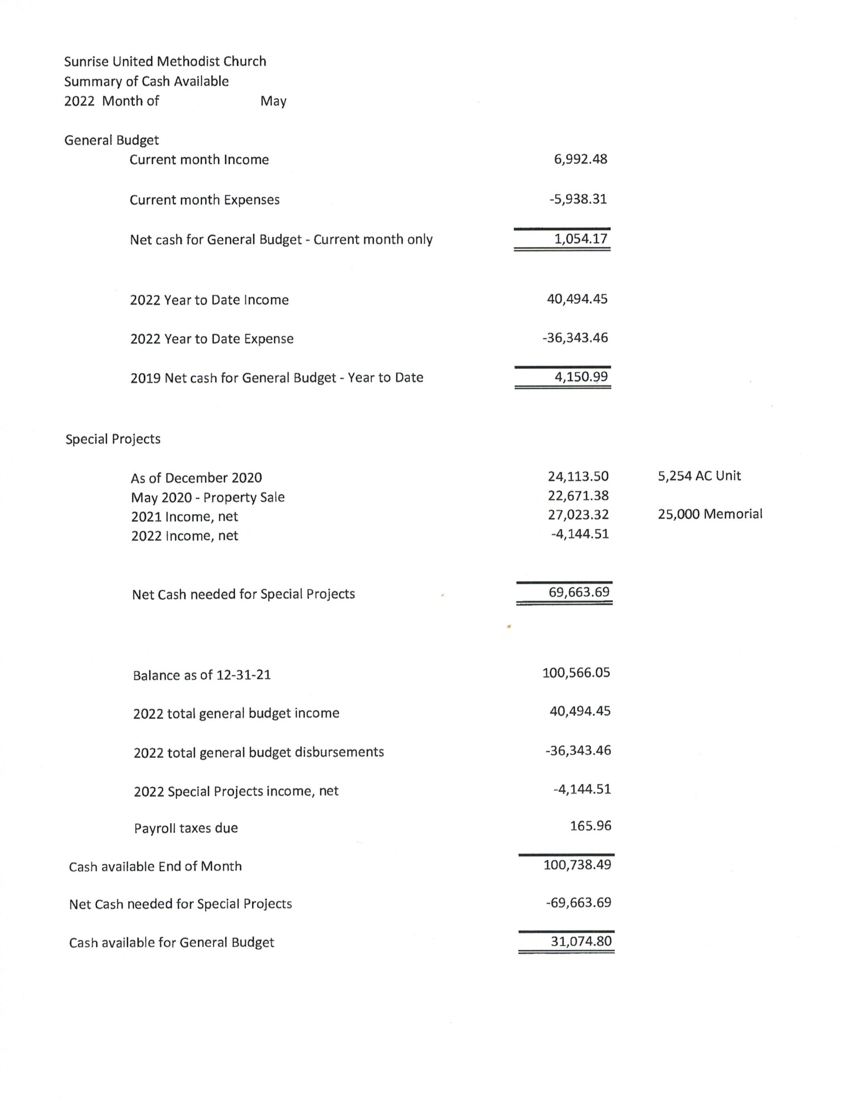

NEWS FROM OUR conference
Lay Servant Ministry ~ Joyce Trevolt
West District Summer / Fall Lay Servant Ministries Classes 2022

For more information and to sign up go to: https://dscumc.org/lay-servant-ministries-training-sessions/

“Intro/Basic Spanish Class taught in Spanish” - IN Person
August 6 and 20 9 a.m. to 3 p.m. lunch provided, Maryvale Bridge UMC,
taught by Rev. Efrain Zavala and assisted by Pastor Joel Arvizu.

“Intro/Basic Class” – IN Person
August 19 and 26, 10 a.m. to 3 p.m. working lunch provided.
Willowbrook UMC, taught by Rev. Gary Kennedy.

“For the Common Good – Discovering Your Spiritual Gifts” –
In Person, August 27, and September 3, 9 a.m. to 3 p.m. at
Dove of the Desert UMC Bring Your Own Bag Lunch and Treats
Taught by Certified Lay Speaker Jill Cristina-Krebs. Limit 12 Students

ZOOM “Leading Worship” September 10 and 17, 9 a.m. to 3 p.m.
Taught by Rev. Fred Mast, Sedona UMC. Limit 15 Students

ZOOM “Afire with God” Stewardship for the 21st Century. September 10 and 17, 9 a.m. to 3 p.m. Taught by the Desert Southwest Conference of the United Methodist Church Treasurer Randy Bowman. Limit 15 Students.

“Leading Public Prayer” – IN Person October 8 and 15 at Gila Mountain UMC, 9 a.m. to 3 p.m. Taught by Certified Lay Minister Marilyn Hohstein. Limit 15 Students. Bring Your Own Bag Lunch and Treats

“Called to Preach” – IN Person Wednesdays, November 2, 9, and 16 at Sunrise UMC in Phoenix, 5:30 p.m. to 9:30 p.m. taught by Rev. Donna Hughes

“Opening Ourselves to Grace: Basic Christian Practices” – IN Person at Dove of the Desert UMC November 12 and 19, 9 a.m. to 3 p.m. Taught by Rev. George Cushman. Limit 15 Students. Bring Your Own Bag Lunch and Treats.



Arizona Walk to Emmaus will be holding Women’s Walk #258 on October 13-16, 2022 at Gilbert First UMC with Janine Cluck Lay Director. The Walk to Emmaus is a
72-hour spiritual renewal based on Luke 24: For more information about AZ Walk to Emmaus you may visit their website at http://azemmaus.org/ or call the church office, 623.780.1008

Desert Southwest Annual Conference

THRIVE; From Languishing to Flourishing
Scripture: Deuteronomy 30:19 l John 10:10

Desert Southwest Annual Conference on June 10-11, 2022
In-Person at the Mesa Convention C, 263 N Center St, Mesa, (for
2022 Desert Southwest Annual Conference Report
By Christina Dillabough, Director of Communications
Desert Southwest Conference
The 38th session of the Desert Southwest Annual Conference took place on June 10-11, 2022, as a hybrid event for the first time. In person attendees gathered at the Mesa Convention Center, and online voting participants gathered via Zoom. Some of the credit for the seamless transitions from online to in person speakers is due to the AV support from GNTV Media Ministry. The session theme was Thriving: From Languishing to Flourishing, with Deuteronomy 30:19 and John 10:10 as the guiding scriptures.
The Clergy Session and Laity Session took place on June 8, 2022, via Zoom. The Laity Session included a guest speaker, Martha Lundgren, a United Methodist deaconess who responded to a call to provide faithful care to dying persons. Much of her work involves educating people about end-of-life issues, how to complete advance directive documents, and how to make dignified, meaningful, and affordable cremation, burial, funeral, and memorial arrangements. Her talk included guidance on overcoming stress and finding joy and God through it all. She said,
“What I’ve come to understand down to my core is that each of our breaths, our first breath, our last breath, and all the breaths in between, are of God’s spirit. Each is sacred.”
Bishop Grant J. Hagiya presided over the Annual Conference Session with grace and ease as the Annual Conference body heard reports, debated the various legislation items, and voted online and in person. The resolutions and legislation items are:
Consent Calendar
(Recommendations that are grouped under one heading and decided upon as a single item.)
- Council on Finance and Administration Recommendation 2 – Special Days and Causes
- Council on Finance and Administration Recommendation 3 – Conference Advance and Benevolence Specials
- Council on Finance and Administration Recommendation 4 – Other Recommendations (level 1 exempt compensation, employee expenses, mileage reimbursement rates, and spending within budgets
- Conference Board of Pension and Health Benefits Recommendation 1 – Annuity Rate and Past Service Obligation
- Conference Board of Pension and Health Benefits Recommendation 2 – Resolution Relating to Rental/Housing Allowance for Retired or Disabled Clergypersons of the Desert Southwest Conference
- Conference Board of Pension and Health Benefits Recommendation 3 – Resolution Relating to Local Church Funding for the Clergy Retirement Security Program in 2023
- Conference Board of Pension and Health Benefits Recommendation 4 – Resolution Relating to HealthFlex Exchange Participant Contribution Levels and Church Payment Rate
- Conference Personnel Committee Recommendation 1 – Changes to Exempt Salary Levels
- Conference Personnel Committee Recommendation 2 – Changes to Non-Exempt Wage Levels
- Conference Commission on Equitable Compensation Recommendation – Clergy Minimum Salary Schedule for 2023 – REMOVED FROM CONSENT CALENDAR
- Communication Commission Rule Change – Proposed change to Conference rule A.IV.U., as submitted by the Conference Commission on Communications and amended by the Conference Rules Committee
- Sick Leave Definition Rule Change – Proposed change to Conference rule B.V.I.4 on sick leave for Conference employees, as submitted by various individuals and amended by the Conference Personnel Committee and the Conference Rules Committee
ALL APPROVED with the exception of the Commission on Equitable Compensation Recommendation

Recommendations for Consideration at Annual Conference
- Council on Finance and Administration Recommendation 1 – 2023 Apportioned Conference Budget – APPROVED
- Board of Trustees Recommendation – APPROVED
- Conference Commission on Equitable Compensation Recommendation – Clergy Minimum Salary Schedule for 2023 – APPROVED
- Nominations Report – 06/11/2022 version 2 – APPROVED

Legislation
- Resolution Concerning Guns at Annual Conference – APPROVED
- Resolution Supporting Central Conference Leadership and the Christmas Covenant – WITHDRAWN
- Endorsement by the Desert Southwest Annual Conference – APPROVED

Memorable Moments
Pastor Deontez Wimbley shared a moving sermon during the Saturday morning virtual worship service. Watch the homily at https://youtu.be/sk39RJIZf0k.
The Desert Southwest Conference Board of Ordained Ministry recognized the sixteen provisional candidates from the Florida Annual Conference that were not commissioned. Watch a video clip of that portion of the session at https://youtu.be/mTZ-OTQwjE8. Learn more about the Florida decision at https://www.umnews.org/en/news/clergy-session-vote-highlights-lgbtq-divide.
The two Desert Southwest Annual Conference delegates for General Conference, Rev. Dan Hurlbert and Mr. Paul Gómez, and the reserve delegates, Rev. Anthony Tang and Ms. Julie O'Neal, addressed the body. Rev. Dan Hurlbert provided information about the nomination process for Episcopal candidates and encouraged prayerful discernment for nominations using the shared nomination form for the Western Jurisdiction available at https://dscumc.org/ac. Rev. Hurlbert announced that the Jurisdictional Conference will take place on November 2-5, 2022, in Salt Lake City, where bishops will be elected.
Paul Gómez provided an update on the latest status of the General Conference. He encourages everyone to read Heather Han's UM News article, Protocol's day has passed, some negotiators say, at https://www.umnews.org/en/news/protocols-day-has-passed-some-negotiators-say and the recent article, from the authors' that produced the Protocol of Reconciliation & Grace through Separation, at https://www.protocolresponse.com/ to learn why the authors' and most delegates no longer support this legislation.
Rev. Anthony Tang and Julie O'Neal updated the body about Jurisdictional and General Agency nominations inviting persons interested in serving to enter their names to be included in the Jurisdictional Nomination pool using the form linked in a green box labeled Western Jurisdiction Nomination at https://dscumc.org/ac.
During the Saturday evening ordination service, Rev. Melissa Rynders, Chair of the DSC Board of Ordained Ministry, named the Florida candidates to honor them. Watch a video clip from the ordination service at https://youtu.be/wwgb0TBsiNo.
Bishop Grant Hagiya’s message, Remember to Whom You Belong, was a personal reflection of his own ordination experience. He addressed the ordinands, saying,
“It is your time to enter the representative ministry of Jesus Christ. It is your time to commit to lead the people of God. It is the church’s time to revel in a new generation of spiritual leaders, and it is all of our time to take stalk of who we are and to whom we belong.” (Bishop Grant Hagiya)
The featured scripture, Matthew 25: 31-46, brought out stories of how difficult it is to be in ministry, committed to caring for the least, and a reminder of the sacrifice for all of us being judged daily. Watch the ordination service at https://youtu.be/BxGUcasz1U0.

The Desert Southwest Annual Conference candidates for ministry were:
- Brooke Burris Isingoma ordained as an Elder in Full Connection.
- Linda Larsen recognized as an Associate Member.
- Sylvia Harris, Michael Wilkerson, and Christopher Wurpts commissioned as Provisional Elders.
- Meredith Joubert, commission as a Provisional Deacon.

Clergy retiring this year are:

Watch the video clip of the retirement celebration at https://youtu.be/P7RYp7znBxc.
- Rev. Nancy Susan Brims
- Rev. Deborah Lerner
- Rev. Lyndon Mason
- Rev. David McPherson
- Rev. Donna Morley
- Pastor Deborah Schauer
- Rev. Dr. Richard Smith
- Rev. Stephanie Soon
- Rev. Jaime Vazquez

Church closures were:
- Korean United Methodist Church of Las Vegas, Nevada
- Aldersgate United Methodist Church

Memorial Service
During the memorial service on Friday night, Rev. Hannah Adair Bonner preached a heartfelt sermon recognizing those who have died over the past year. You can watch the service at https://youtu.be/97XuwprVijc. The following persons’ lives were celebrated as this year’s honored dead.

From the Council of Bishops
- Bishop Joseph H. Yeakel
- Bishop Beverly J. Shamana
- Jeffrey Joe Swenson
- Dania Soriano
- Jack D. Middleton
- Bishop Wilbur Choy
- Marjorie “Marji” Tuell
- Margaret Rose King

Desert Southwest Conference Death
- Pastor Lenore Renfro
- Mrs. Gladys (Rickey) Wise
- Pastor Sefo Jeffrey Fata-Misionare
- Mrs. Joanne "Betty" Mathis
- William "Bill" Denlinger
- Rev. John "Jack" Wise
- Rev. Robert "Bob" Peale
- Rev. Dr. Bert Lewis
- Rev. Michael Chamness
- Mrs. Aud Gundersen
- Rev. J. Lloyd Ewart Jr.
- Rev. Paul Self-Price
- Rev. Roy Ludlow
- Pastor Avis J. Emerson Black
- Rev. Lee Hirt
- Mrs. Kimberly Parrott
- Mrs. Judith Bobbitt
- Rev. Allan Nesbitt
- Mrs. Sandra Gladding
- Mr. Benjamin Bealor

This year’s statistical updates are as follows:
- Membership stands at 23,033, down 6.1% from the previous year.
- Worship attendance stands at 9,277, down 37.6% from the previous year.
- Church school attendance stands at 2,507, down 9.9% from the previous year.
- Professions or reaffirmations of faith for 2021 are 282, down 23.0% from 2020.
- Adults and young adults in small groups for 2021 are 5,125, down 17.9% from 2020.
- Worshippers engaged in mission for 2021 are 7,656,

and live-streamed on this page (for observers)
Link for more information https://dscumc.org/annual-conference/

Sunrise Social Media

@sunrisephx #sunriseumcphx
This Photo by Unknown Author is licensed under CC BY-SA
This Photo by Unknown Author is licensed under CC BY-SA

