 Sunrise UMC

**AUGUST**

**2022**



Words from the Pastor

Hello Sunrise!

It is so good to be back with you! I missed you!!! I had a great seven week leave/vacation. Doug and I spent our time in the mountains of Colorado. Every evening was in the 40-60 F degree range and the days were spent in the woods. Wow, Colorado is so beautiful! We hiked, rode our bikes, did some running, ate a lot of food (I gained 5 pounds in the process), played games, toured museums and old ghost towns, drove the scary but stunning million-dollar highway and just enjoyed our travels. Bailey, our last Weimareiner (the 15 year old) had her best life the last weeks of her life, hiking and hanging out with her humans before she crossed the rainbow bridge the last week of vacation. We are grateful for the generosity of the congregation for allowing this time off and so thankful for Rev. Tom and Rev. Pam’s preaching and care. They had a great time and I hear you did too! Attendance was steady as was your giving (not easy in the summer) and that says a lot about who Sunrise UMC is as a church and who you are as God’s people. Thanks so much!!!

This past Sunday I preached on Luke 12:15-21 about the Rich Fool and Greed. I was struck by this quote from St Augustine, who said, *“God is always trying to give us good things but our hands are often too full to receive them.*” The scripture tells us that “*We store up treasures but are not rich towards God”*. Friends, God wants to give us God’s self. God is wants to give us love, peace, worthiness, and presence but often our closets are too full, the garage is too packed, the day is too crammed, our lives are over flowing and our hands are too clenched to receive God’s good things. I feel like I had a chance to receive God’s “good things” these past few weeks while I was off. It was a good reminder to keep my hands wide open for God’s good gifts.

My prayer for each of us is to ask God to check us just a bit when our impulse is towards more and more, busier and busier, fuller and fuller. This scripture gave me pause to say, “why am i building a bigger barn, buying another book, getting more shoes, purchasing more clothes, getting another car, duplicating my tools, doing one more thing?” May each of us and as a church keep our hands open for God’s good gifts.

With open hands and a grateful heart,

Rev. Donna

|  |  |
| --- | --- |
|  |  |

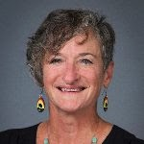

August Sermon Series:

Pillars of Faith:

August 7:  How Faith Acts:  Hebrew 11:1-3, 8-16

August 14:  The Eyes of Faith:  Hebrew 11:29-12;2/Luke 12:49-56

August 21:  Faith in the Face of Opposition: Luke 13:10-17

August 28:  Faith enough to wait:  Luke 14:1, 7-14

**A Journey into the Heart of Christ: Spiritual Healing and Justice (September 18-23, 2022)**

This year’s Five Day Academy for Spiritual Formation is a response to two of our greatest needs: a desire to deepen our life with God and a longing for justice.

Too often, the Church is split between those who pray and those who march. The reality is that the contemplative and the prophetic need each other. Without contemplation, those advocating for justice grow weary and cynical. Without prophetic awareness, those who pray become complacent and self-serving. We need both dimensions in order to be faithful followers of Jesus Christ.

Developed in 1983, the Academy is a retreat model that brings head and heart together. The balanced rhythm of gathering and solitude restores our sensitivity to ourselves and others. Faculty lectures are brief and focused, allowing time for integration and discovery.

To learn more about the Academy for Spiritual Formation, go to the Upper Room’s website (<https://academy.upperroom.org/>). Scroll through the list of “Shorter Academies” and you’ll see that you’re part of a global effort to reach lay and clergy in many places.

To register for Arizona’s Five Day Academy for Spiritual Formation, go to our Conference website (<https://dscumc.org/arizona-five-day-academy/>). The registration deadline is August 15, so hurry to reserve your spot.

For more information, contact Jerry Haas (jndhaas@gmail.com). Note that this event is for lay and clergy. Scholarships are available.

United Methodists respond to Ukraine Invasion: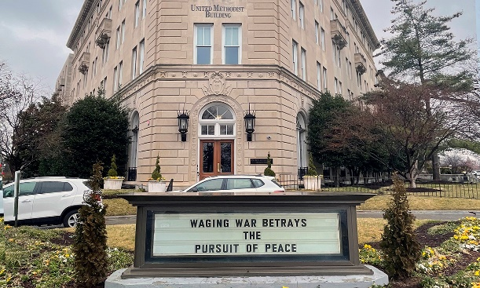

<https://www.umnews.org/en/news/united-methodists-respond-to-invasion-of-ukraine>

How we can help those in Ukraine:

Donations can be made to the United Methodist Committee on Relief’s International Disaster Response and Recovery through [Advance #982450](https://umcmission.org/advance-project/982450/).

United Methodist Global Ministries’ [Advance #14053A](https://umcmission.org/advance-project/14053a/) supports pastors in Ukraine and Moldova.

Annual Church Conference

Thursday, September 29th

SPRC 6:00pm

Meeting 7:00-8:30PM



Cultural Competence Training

At the 2021 Annual Conference Session, the resolution was passed to begin Cultural Competency/Inclusivity & Diversity training. As a leader in your local church, District Superintendent Javier Olivares would like to invite you to attend the Cultural Competency/Inclusivity & Diversity training. There are two dates and locations below for you to select from, lunch will be provided. This one-day event will increase awareness and understanding of one’s own culture and differing cultures and learn ways to be bridge builders connecting with those who are different.

*Training is available*

Saturday, August 20 ~ 10:00 AM-2:00 PM

at Shepherd of the Valley UMC

3039 W Cactus Rd, Phoenix, AZ

Saturday, September 17 ~ 10:00 AM-2:00 PM

at First UMC of Glendale

7102 N 58th Drive, Glendale, AZ

Email Cynthia Holly, [cholly@dscumc.org](mailto:cholly@dscumc.org) to register. Provide your name, church, and position and where you would like to attend. Registration at each location is limited to 30.

**Church News**

**Help with Worship:**

We are still looking for greeters to assist with our Sunday worship services. Please let Rev. Donna or Joyce know if interested.

**Building Use:**

We have about 9 outside groups that meet in the building each month. If you would like more information about these groups, please contact the church office.

**Daily Prayer:**

[prayer.forwardmovement.org](http://prayer.forwardmovement.org/)

[dailyofficeexpress.org](http://dailyofficeexpress.org/)

[lectionary.library.vanderbilt.edu/daily.php?year=B](http://lectionary.library.vanderbilt.edu/daily.php?year=B)

Upperroombooks.com/neweverymorning/

If there have been any changes to your information; address, phone number, email address, please email the office at hello@sunrisephx.org and let them know of the changes. Thank you!

**TRAVEL TO THE HOLY LAND**

Have you always wanted to see the places in the bible, travel where Jesus traveled?  Here is your opportunity!

Are you interested in experiencing the Holy Land?  Going to the River Jordan, Jericho, the Sea of Galilee, Caesarea and so much more.  Rev. Donna would love to host an Educational Opportunities trip to the Holy Land Spring of 2023.  More information to follow, but if you think you might be interested in this once in a lifetime journey, let her know!  Estimated cost all inclusive is $2500-3200.00.

**Find Sunrise UMC on Social Media,**

**@[sunrisephx](https://www.facebook.com/sunrisephx/)** [**#sunriseumcphx**](https://www.instagram.com/sunriseumcphx/)



[This Photo](http://commons.wikimedia.org/wiki/File:Facebook_Shiny_Icon.svg) by Unknown Author is licensed under [CC BY-SA](https://creativecommons.org/licenses/by-sa/3.0/)



[This Photo](https://radiouniversidad.uca.edu.ni/instagram-agrega-stickers-animados-historias/) by Unknown Author is licensed under [CC BY-SA](https://creativecommons.org/licenses/by-sa/3.0/)

**Easy Ways to Give:**

**Shop at Fry’s and help Sunrise UMC. 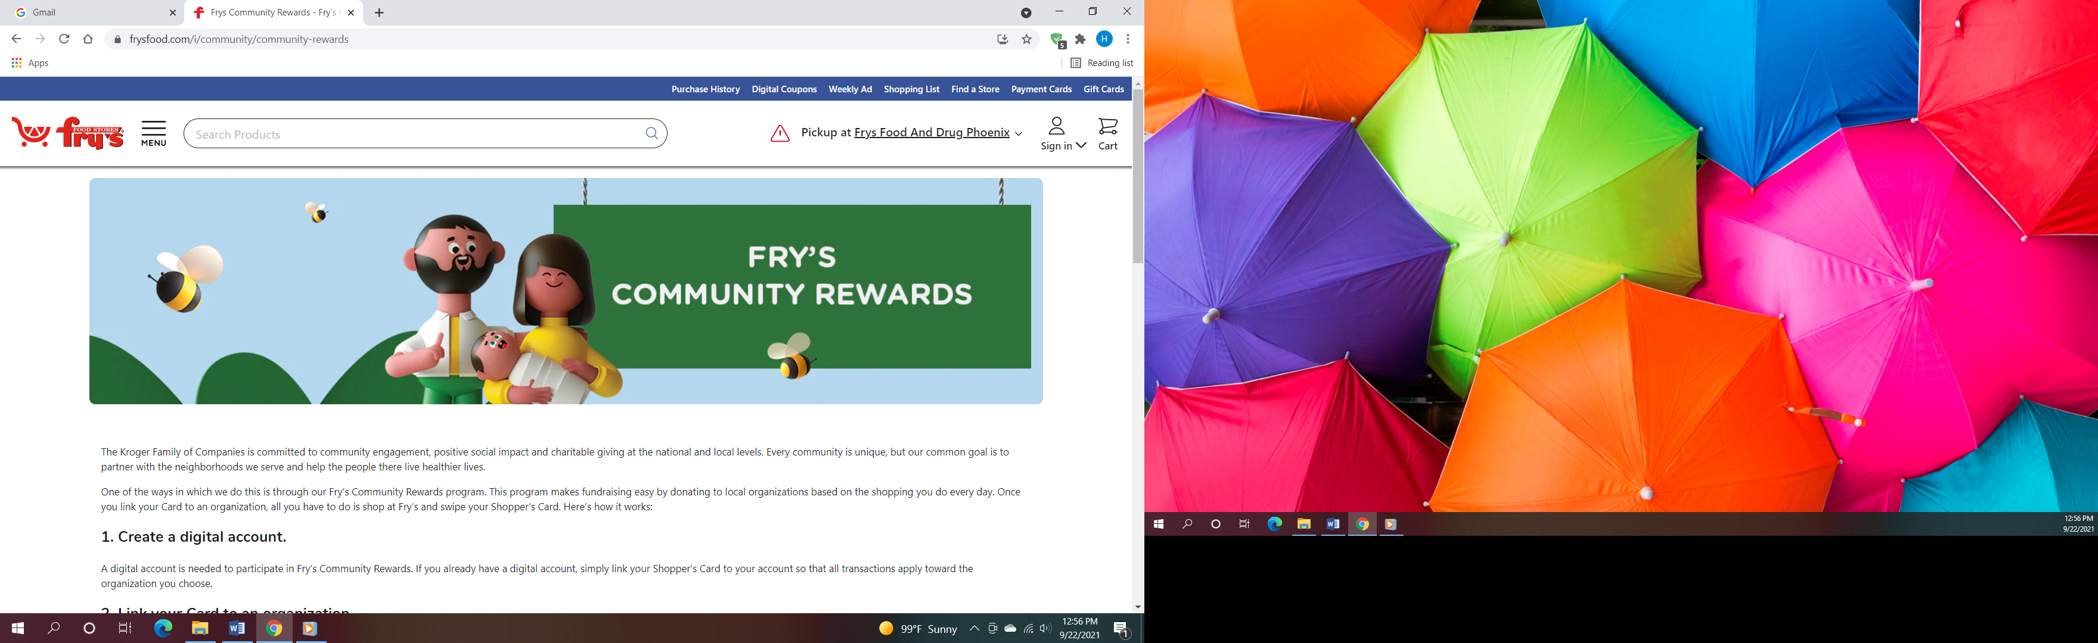Fry’s Community Rewards program**. This program makes fundraising easy by donating to local organizations based on the shopping you do every day. Once you link your Card to an organization, all you have to do is shop at Fry’s and swipe your Shopper’s Card. Need help signing up, please, let the office know.

**AmazonSmile:** Sign up for AmazonSmile, Enter the link below and it will automatically ask if you want to support Sunrise United Methodist Church. Say yes, and 0.5% of the price of eligible purchase will go to the church. Continue to shop and support the church. Just log in to AmazonSmile first.

[**https://smile.amazon.com/ch/86-0572433**](https://smile.amazon.com/ch/86-0572433)

** We also collect cans; plastic bottles**

**July total: $21.40**

**Movie CD’s and TV Programs:**

Sunrise UMC has been given movie CD’s and have started a library. The CD’s are in room #4 in the fellowship hall. You may check out the movie to view and then return when you have watched it. Anyone who has movies they wish to donate can place on the shelf. Enjoy!

**NEWS FROM OUR MINISTRIES**

**Trustees:**



[This Photo](http://www.picserver.org/t/trustee.html) by Unknown Author is licensed under [CC BY-SA](https://creativecommons.org/licenses/by-sa/3.0/)

Greetings Sunrise from your trustees!

Trustees have changed their meeting date and time to the first Wednesday of the month.

This month’s meeting will be 8/3/2022 at 6:00 PM.

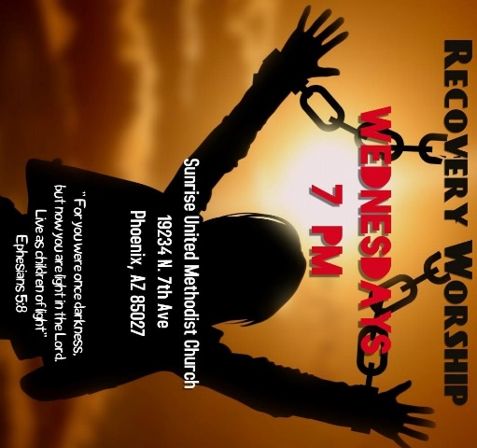

**Recovery Worship Service:**

The Wednesday Recovery Services is up and running with great speakers, devotions and even a baptism. Everyone is welcome to join us on Wednesdays at 7:00PM.



[This Photo](http://justinsomnia.org/2009/09/breakfast-in-heathrow/) by Unknown Author is licensed under [CC BY](https://creativecommons.org/licenses/by/3.0/)

**Calling all Men!**

Come enjoy breakfast and good fellowship with other men from Sunrise. Saturday, August 6th at 8:00am Denny’s I17 & Deer Valley Rd.

**NEWS FROM OUR MINISTRIES**

Family Promise –

Family Promise

Sunrise's final week will be October 23rd- 30th.  Please mark your calendars and plan on joining us.  We will need 7 meals provided, 7 overnights covered, and breakfast and lunch items bought for the Family Promise center.  Sign up sheets will be put out in August.

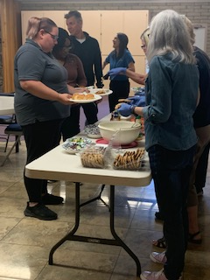**House of Refuge-Sunnyslope**

Members of Sunrise UMC enjoyed serving a meal at the House of Refuge on **July 26th.** You are welcome to join us and experience the blessing that comes from feeding the homeless. If you are interested in being a part of this mission, please let the office or Alice Mildenberger know.  This is a 3 part process.  We choose a menu and divide the food responsibilities with interested participants, bring the food ready to be served by 4:45 to Sunnyslope, and serve the women and children.  We would love to have more people join us.

**Prayer Shawl Ministry**  
Prayer shawls have been made for centuries. They are universal and embracing, and offer comfort while they enfold, and shelter. Sunrise's prayer shawl ministry will be for anyone who wants to share God's love and care by creating a prayer shawl.  If you have ever knitted or crocheted, please pray about being a part of this ministry.

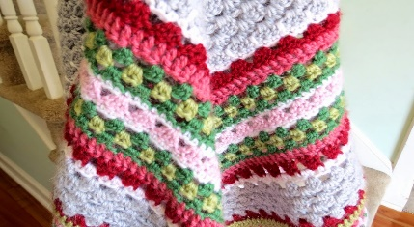

[This Photo](http://sweetbeebuzzings.blogspot.com/2014/08/nordic-shawl.html) by Unknown Author is licensed under [CC BY-SA-NC](https://creativecommons.org/licenses/by-nc-sa/3.0/)

I received enough skeins of yarn from a friend of Billie's to allow any interested person a chance to try making a shawl.  Typically, knitting needles size 11 or 13 and crochet hooks size K-P can be used and I have those to share as well. Most shawls are between 26"-30" wide x 60" in length. I will have copies of basic instructions on how to cast on, knit, plural, and crochet as well as general information at the back of the sanctuary.

**We will gather on the first Saturday of the month, August 6th at 9:00am. There will be yarn, knitting needles, crochet hooks, and people to assist as needed.  Join us as we begin this ministry.**

Contact Alice Mildenberger for more information.

**Ongoing Mission Projects**

Justa Center: shoes, shoes and more shoes!

We also need sunscreen, toothpaste (2.30z or larger) shampoo and water. Donations of money is always welcome. Place in envelope and write Missions- Justa Center.



It’s that time**! Back to School** for neighborhood children. Sunrise UMC will be collecting school items for **Constitution Elementary School.** Please bring **notebooks, pencils, crayons, markers and erasers** during the month of August. Thank you.

**Constitution Elementary School** offers a food bank for the neighborhood. They need the following Baby items: **diapers- all sizes; baby wipes, formula and baby food.** Please bring to the church and we will take to the school.

Mission Committee will resume their meeting on Wednesday, August 10th at 11:00am.

Mission Committee Members are:

Linda DeYoung Pat Hepperle

Laura Diamond Alice Mildenberger

Dana Fischer Rich Mildenberger

Frank Fischer



Jill August 9th

Joyce August 9th

Haley August 18

Frank August 21

A Belated Happy Birthday to

Mary – July 1

Frank & Margery

August 3rd

Scott & Karen August 9th

Please let us know if we have missed your special day.

**NEWS FROM OUR MINISTRIES**

**Prayer Ministry**

**Prayer for Students**

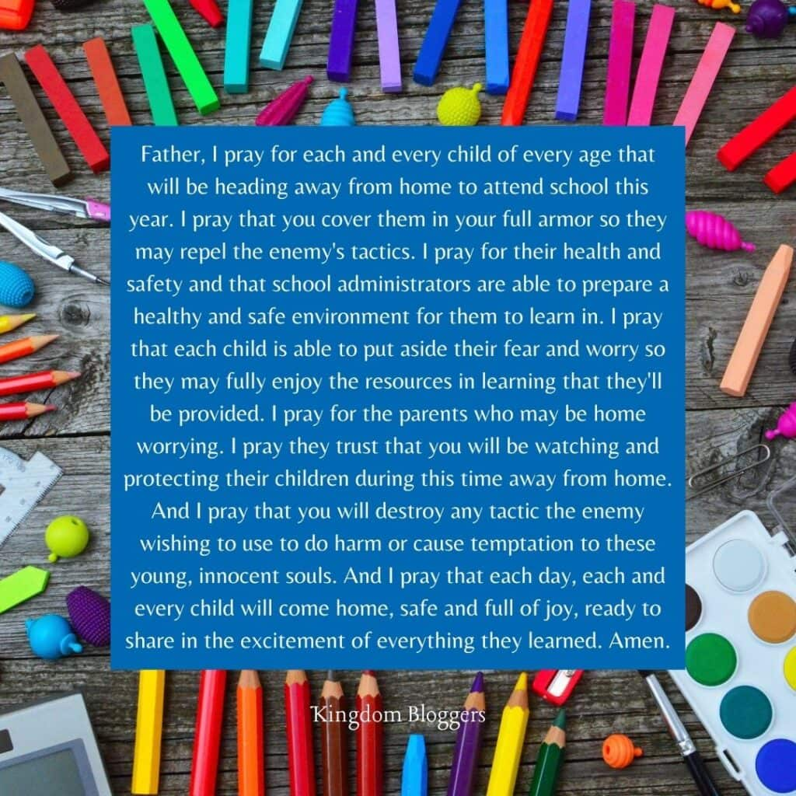

|  |  |
| --- | --- |
|  |  |
|  |  |
|  |  |
|  |  |
|  |  |
|  |  |
|  |  |
|  |  |
|  |  |
|  |  |

**NEWS FROM oUR MINISTRIES**

**Finance Ministry ~ Finance Committe**



**NEWS FROM OUR conference**

**Lay Servant Ministry ~ Joyce Trevolt**

**West District Summer / Fall Lay Servant Ministries Classes 2022**

For more information and to sign up go to: <https://dscumc.org/lay-servant-ministries-training-sessions/>

“I**ntro/Basic Spanish Class taught in Spanish”** - IN Person

August 6 and 20 9 a.m. to 3 p.m. lunch provided, Maryvale Bridge UMC,

taught by Rev. Efrain Zavala and assisted by Pastor Joel Arvizu.

**“Intro/Basic Class”** – IN Person

August 19 and 26, 10 a.m. to 3 p.m. working lunch provided.

Willowbrook UMC, taught by Rev. Gary Kennedy.

**“For the Common Good – Discovering Your Spiritual Gifts”** –

In Person, August 27, and September 3, 9 a.m. to 3 p.m. at

Dove of the Desert UMC Bring Your Own Bag Lunch and Treats

Taught by Certified Lay Speaker Jill Cristina-Krebs. Limit 12 Students

**ZOOM** **“Leading Worship”** September 10 and 17, 9 a.m. to 3 p.m.

Taught by Rev. Fred Mast, Sedona UMC. Limit 15 Students

**ZOOM** **“Afire with God”** Stewardship for the 21st Century. September 10 and 17, 9 a.m. to 3 p.m. Taught by the Desert Southwest Conference of the United Methodist Church Treasurer Randy Bowman. Limit 15 Students.

**“Leading Public Prayer”** – IN Person October 8 and 15 at Gila Mountain UMC, 9 a.m. to 3 p.m. Taught by Certified Lay Minister Marilyn Hohstein. Limit 15 Students. Bring Your Own Bag Lunch and Treats

**“Called to Preach”** – IN Person Wednesdays, November 2, 9, and 16 at Sunrise UMC in Phoenix, 5:30 p.m. to 9:30 p.m. taught by Rev. Donna Hughes

**“Opening Ourselves to Grace: Basic Christian Practices”** – IN Person at Dove of the Desert UMC November 12 and 19, 9 a.m. to 3 p.m. Taught by Rev. George Cushman. Limit 15 Students. Bring Your Own Bag Lunch and Treats.



**Arizona Walk to Emmaus** will be holding Women’s Walk #258 on October 13-16, 2022 at Gilbert First UMC with Janine Cluck Lay Director. The Walk to Emmaus is a

72-hour spiritual renewal based on Luke 24: For more information about AZ Walk to Emmaus you may visit their website at[**http://azemmaus.org/**](http://azemmaus.org/)or call the church office, 623.780.1008

Fences

by [Joyce Trevolt](https://dscumc.org/blog/author/jtrevolt/) | Jul 19, 2022 | [West District Lay Leader(s) Blog](https://dscumc.org/blog/category/news/west-district-lay-leaders/), [West District Newsletter](https://dscumc.org/blog/category/news/west-mailchimp/), [West District Webpage](https://dscumc.org/blog/category/west-district-webpage/)



by Joyce Trevolt, West District Associate Lay Leader

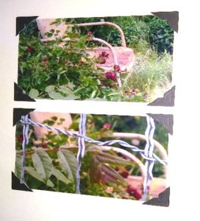This is one of my favorite pictures. It hangs in my bathroom, so I look at it every day. I took it on a trip to Jerome, AZ. The chair and roses on the top reminded me of my youth growing up in Virginia. My grandparents had lawn chairs like this one. Plus, my grandmother grew roses. Lots of roses. She had a beautiful rose garden. It was a lovely place to sit and smell the roses

But if you look closely at the bottom picture, you will see a fence. My grandparent’s rose garden had a fence around it as well. The big question: Is the fence there to keep people/animals/things inside the fence or to keep them out?

There are days when I want to keep everyone out. I want the fence to be high and closed in. I want to be alone with my thoughts, to just enjoy the beauty. I don’t want anyone to get too close. I might have to share.

Other days, I want out. I feel stifled. The fence is too tall, too restrictive. I want to be free. To create. To share with the world.

I build my fence daily. Don’t you?

A **fence** is a structure that encloses an area, typically outdoors, and is usually constructed from posts that are connected by boards, wire, rails, or netting.

The fence in this picture was probably meant to keep someone in. A child, elderly person, animals. We don’t know. We do know that we build fences of all kinds around our lives. Most of the time we call them walls, but a fence differs from a wall in not having a solid foundation along its whole length. A fence can be taken down or moved.

Fences are important. They separate property or give us boundaries. Fences keep things in specific areas or keeps things out of areas. Fences can be tall, short, wooden, wire, electric, invisible. Fences are a barrier.

Even though a fence does not have a solid foundation, we sometimes associate it with building a wall. In ***The Spirit and Art of Conflict Transformation: Creating a Culture of JustPeace*,**Thomas Porter writes: “We often create walls we then fight to maintain or walls we hide behind,…As Robert Frost says, ‘Something there is that doesn’t love a wall.” We know God does not like walls. Jesus died to breakdown the dividing walls of hostility (Eph. 2:14). Walls are a physical confession of sin. Walls do not make good neighbors. We need to ask ourselves what we are walling in and walling out. We also need to remember the most powerful walls are invisible, in our minds.”

And, Dudley Nichols said: “Fear is the highest fence.”

If fear is our highest fence, how high is your fence?

How high does it have to be to keep you safe?

What are you afraid of?

What in your life is keeping you behind the barriers you have built?

I don’t have an answer to those questions. It is up to each one of us to figure that out.

I do know that Christ came so we (God’s children) would not have to live behind barriers.

Eph. 2:13-18 NIV

But now in Christ Jesus you who once were far off have been brought near by the blood of Christ. For he is our peace; in his flesh he has made both into one and has **broken down the dividing wall, that is, the hostility** between us, abolishing the law with its commandments and ordinances, that he might create in himself one new humanity in place of the two, thus making peace, and might reconcile both to God in one body through the cross, thus putting to death that hostility through it. So he came and proclaimed peace to you who were far off and peace to those who were near, for through him both of us have access in one Spirit to the Father.

You cannot put a barrier around your life and say I will only be friendly with those who are like me; think like me, belong to the same political party as me, go to the same church, or be the same denomination or go to the same school. No!

If Christ brought us (everyone!) peace, by destroying the dividing wall of hostility, why do we continue to build walls for separation?

Why do we want to barricade ourselves from those who Christ died for?

We (God’s children) are in this world together. It doesn’t matter if we live in North America, South America, Africa, Europe, China, Russa, Ukraine. As Christians, our Lord and Savior came to bring us all peace. Christ died to reconciled us to God.

We must tear down the fences (and walls) that we build and learn to live as God’s beloved children. In Peace and filled with the Holy Spirit. Amen!



Sunrise Social Media

[**@sunrisephx**](https://www.facebook.com/sunrisephx/)[**#sunriseumcphx**](https://www.instagram.com/sunriseumcphx/)



[This Photo](http://commons.wikimedia.org/wiki/File:Facebook_Shiny_Icon.svg) by Unknown Author is licensed under [CC BY-SA](https://creativecommons.org/licenses/by-sa/3.0/)



[This Photo](https://radiouniversidad.uca.edu.ni/instagram-agrega-stickers-animados-historias/) by Unknown Author is licensed under [CC BY-SA](https://creativecommons.org/licenses/by-sa/3.0/)