 Sunrise UMC

**February**

**2022**



Hello Sunrise!

It’s February and we are in our second month of 2022. February is a bit of a place holder for us in the church; we’ve finished the busy Advent/Christmas season and are preparing for Lent and Easter and right in the middle of that is February. This month is “____ Sundays after Epiphany in the liturgical church year and it is the month that we hear sermons about Jesus’ life and ministry. I find that I get a bit stuck preaching about Jesus in this season because it is almost the same stories every year and what else can be said in a sermon about changing water into wine, Jesus’ first sermon, “fishing for people”, or the beatitudes?

Sometimes I feel like I am stuck in the Groundhog Day movie, where I am repeating the same day, the same season over and over. The reality is, I am and you are too. The joy and the difficulty of this season is its repetitiveness, it’s ordinariness, its holding pattern place in the Christian year. First, the difficulty; I don’t know about you but my personality has a tendency to crave that which is new, exciting, different, unusual. I am a 7 on the Enneagram (If you don’t know about this, ask me). This season is not new, exciting or different, it is the same every year. I struggle with finding the meaning in sameness, ritual, everydayness but I know that is where we often encounter God in deep and profound ways. Brother Lawrence, a monk who wrote the book, “***Practicing the Presence of God***” encouraged us to find God in the everyday; washing dishes, walking the dog, going to work, working in the garden, balancing the checkbook. Those are the places where we practice our time with God, so in the big seasons of life, the trials of life, the BIG DAYS we already have a relationship where we know and can trust and lean on God.

You see, that is the joy of this in between time if we can embrace it (I’m still working on it), it is the time to relax into God’s presence and be reminded through the stories of Jesus just who God is, in the flesh, and be encouraged in how we are to live out our faith. It is the season for slow steady growth.

So, before you roll your eyes, think to yourself “not this story again”, “not this place, again”, before you do a little huff puff and whine; let’s imagine what we can embrace in the ordinary, the ritual, the sameness, the repetition and Practice the Presence of God!

With you in the ordinariness of our days,

Rev. Donna

***Upcoming Sermon Series***

A Light to the Nations:

February 6:  5th Sunday after Epiphany, "Called and Sent" Luke 5:1-11

February 13:  6th Sunday after Epiphany, "Full and Empty", Luke 6:17-26

February 20:  7th Sunday after Epiphany, "Unlimited Love", Luke 6:27-38

February 27:  Transfiguration Sunday, "Listen to Him!", Luke 9:28-43a

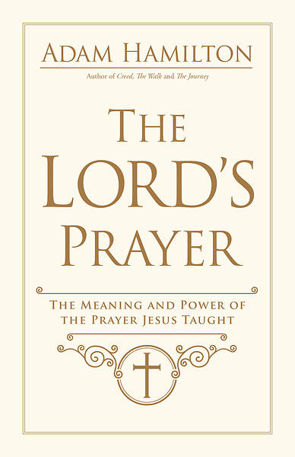**The Lord’s Prayer Lenten Study:**

**This study will begin March 6th following worship and will continue for 6 weeks.  Books are $14.00**

**The power and significance of the prayer Jesus taught.**  
Most Christians know the Lord’s Prayer by heart. We pray it often, at different times and in different settings. We remember it as the prayer that Jesus taught his disciples. But do we really understand and appreciate the meaning and power of its words, what we ask of God each time we pray it?  
When the disciples asked Jesus how to pray, Jesus gave them this prayer. He likely taught it to his followers often, not just one time. He never intended the Lord’s Prayer to be a museum piece, framed and placed on a mantel or in a display case. It was Jesus teaching God’s people, through his disciples, how to pray.  
In*The Lord’s Prayer: The Meaning and Power of the Prayer Jesus Taught*, pastor and bestselling author Adam Hamilton guides us to really know—and really pray—the Lord’s Prayer. He explores each of its rich lines and their meaning in the Bible, illuminating what we ask of God and what we ask of ourselves through its words. And he teaches us how to use it as a pattern for our own prayer life.



|  |  |  |  |
| --- | --- | --- | --- |
| |  |  |  | | --- | --- | --- | | |  |  | | --- | --- | | |  | | --- | |  | | | |

"Do It Anyway"

People are often unreasonable, irrational, and self centered.

Forgive them anyway.

If you are kind, people may accuse you of selfish, ulterior motives.

Be kind anyway.

If you are successful, you will win some unfaithful friends and some genuine enemies.

Succeed anyway.

If you are honest and sincere people may deceive you.

Be honest and sincere anyway.

What you spend years creating, others could destroy overnight.

Create anyway.

If you find serenity and happiness, some may be jealous.

Be happy anyway.

The good you do today, will often be forgotten.

Do good anyway.

Give the best you have, and it will never be enough. Give your best anyway.

In the final analysis, it is between you and God. It was never between you and them anyway. ~Mother Teresa

**Church News**

**Daily Prayer:**

[prayer.forwardmovement.org](http://prayer.forwardmovement.org/)

[dailyofficeexpress.org](http://dailyofficeexpress.org/)

[lectionary.library.vanderbilt.edu/daily.php?year=B](http://lectionary.library.vanderbilt.edu/daily.php?year=B)

Upperroombooks.com/neweverymorning/

If there have been any changes to your information; address, phone number, email address, please email the office at hello@sunrisephx.org and let them know of the changes. Thank you!

**Find Sunrise UMC on Social Media,**

**@[sunrisephx](https://www.facebook.com/sunrisephx/)** [**#sunriseumcphx**](https://www.instagram.com/sunriseumcphx/)



[This Photo](http://commons.wikimedia.org/wiki/File:Facebook_Shiny_Icon.svg) by Unknown Author is licensed under [CC BY-SA](https://creativecommons.org/licenses/by-sa/3.0/)



[This Photo](https://radiouniversidad.uca.edu.ni/instagram-agrega-stickers-animados-historias/) by Unknown Author is licensed under [CC BY-SA](https://creativecommons.org/licenses/by-sa/3.0/)

**Easy Ways to Give:**

**Shop at Fry’s and help Sunrise UMC. 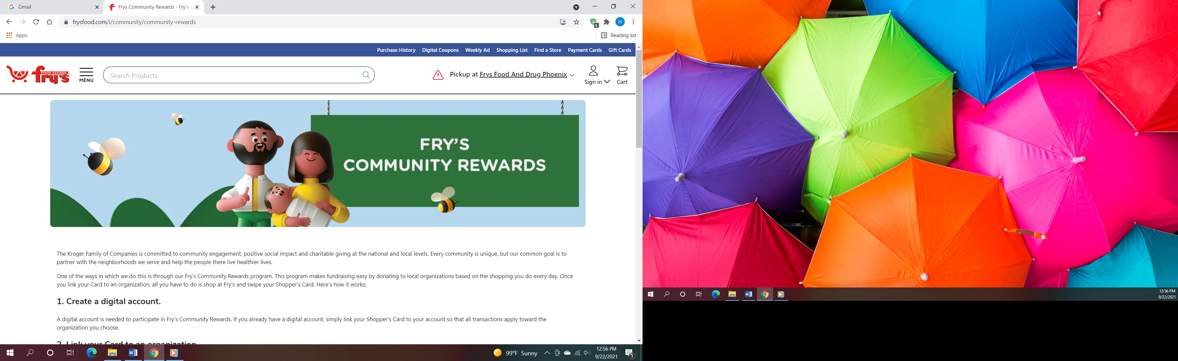Fry’s Community Rewards program**. This program makes fundraising easy by donating to local organizations based on the shopping you do every day. Once you link your Card to an organization, all you have to do is shop at Fry’s and swipe your Shopper’s Card. Need help signing up, please, let the office know.

**AmazonSmile:** Sign up for AmazonSmile, Enter the link below and it will automatically ask if you want to support Sunrise United Methodist Church. Say yes, and 0.5% of the price of eligible purchase will go to the church. Continue to shop and support the church. Just log in to AmazonSmile first.

[**https://smile.amazon.com/ch/86-0572433**](https://smile.amazon.com/ch/86-0572433)

** We also collect cans; plastic bottles**

**NEWS FROM OUR MINISTRIES**



[This Photo](http://www.picserver.org/t/trustee.html) by Unknown Author is licensed under [CC BY-SA](https://creativecommons.org/licenses/by-sa/3.0/)

**Trustees:**

Greetings Sunrise from your trustees!

Trustees meet the first Monday of the month at 7:00 PM.

**Recovery Worship Service:**

The Wednesday Recovery Services is on a brief hold as we strive to better serve the community.

**NEWS FROM OUR MINISTRIES**

Missions ~

Family Promise  
Our 2022 Family Promise weeks have been assigned.  Please mark your calendars for April 24-May 1 and October 24-30.

**New Prayer Shawl Ministry**  
Prayer shawls have been made for centuries. They are universal and embracing, and offer comfort while they enfold, and shelter. Sunrise's prayer shawl ministry will be for anyone who wants to share God's love and care by creating a prayer shawl.  If you have ever knitted or crocheted, please pray about being a part of this ministry.



[This Photo](http://sweetbeebuzzings.blogspot.com/2014/08/nordic-shawl.html) by Unknown Author is licensed under [CC BY-SA-NC](https://creativecommons.org/licenses/by-nc-sa/3.0/)

I received enough skeins of yarn from a friend of Billie's to allow any interested person a chance to try making a shawl.  Typically, knitting needles size 11 or 13 and crochet hooks size K-P can be used and I have those to share as well. Most shawls are between 26"-30" wide x 60" in length. I will have copies of basic instructions on how to cast on, knit, plural, and crochet as well as general information at the back of the sanctuary.

**Feeding the homeless**  
During Lent we will be cooking a meal at the House of Refuge Sunnyslope (HRS) is a Christian housing program serving the homeless, unemployed, and recently sober of Phoenix. They provide shelter, food, employment skills, and spiritual transformation through our programs for men, women, and single mothers with children. More information to follow.



[This Photo](https://commons.wikimedia.org/wiki/File:U.S._Army_Sgt._1st_Class_Rose_Artis,_left,_serves_mashed_potatoes_during_the_Feed_The_Homeless_Dinner_at_the_downtown_Convention_Center_in_El_Paso,_Texas,_Nov._28,_2013_131128-A-JV906-175.jpg) by Unknown Author is licensed under [CC BY-SA](https://creativecommons.org/licenses/by-sa/3.0/)

Missions ~

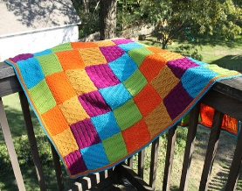 **“Blanket Drive”**. This Mission project is to collect toddler and children blankets and provide them to Phoenix Children’s Hospital. The blankets are given to children being treated at the Cancer Unit. The children do get very attached to “their security blanket” and the blanket goes home with them when they leave the hospital, or given to their parents.

**Ongoing Mission Projects**

Justa Center and Constitution Elementary School:



[This Photo](http://all-en-a-days-work.blogspot.com/2010/10/happy-birthday-doris.html) by Unknown Author is licensed under [CC BY-ND](https://creativecommons.org/licenses/by-nd/3.0/)

Joanna S. 4th

Karen G. 5th



Frank and Dana F. 1st

Allan and Janice F. Feb. 14th

**NEWS FROM OUR MINISTRIES**

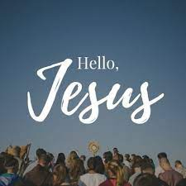

**Prayer Ministry ~**

Fullest Possible Joy

Jesus said:

I have loved you as the Father loved me.

Now remain in my love.

I have obeyed my father’s commands, and I remain in his love.

In the same way, if you obey my commands,

you will remain in my love.

I have told you these things so that you can have the same joy I have

and so that our joy will be the fullest possible joy. John 15:10-11

Each year I choose a theme to be a standard which I live by. This year I have chosen “Joyful Love”. I confess it is the first time I have chosen a theme that hasn’t been because I had a need or desire to mature in a specific area of spiritual growth (like patience). Maybe it is my age. Lol But I do feel a unique sense of Joy. A joy that I cannot describe other than to say it is a Joy that provides me strength. It is a Holy Joy. My desire is to experience the same Joy that our Christ has with our Father. I desire my joy in Christ to be the fullest possible Joy so I will be enabled to share it with others. This is accomplished by obeying Christ’s commands.

Love the Lord your God with all your heart and with all your soul and with all your mind. This is the first and greatest commandment. And the second is like it. Love your neighbor as yourself. Matthew 22:37-39

What does loving others as you love yourself actually look like in everyday life? I am confident that you can think of many examples. Some of the common threads in all the examples would be honesty, respect, creating an environment for unity and to be understood etc.

Sometimes I think it is silly to be commanded to love. Yet, sometimes we forget to love. However, as the scriptures states, it only takes our willingness to obey Christ’s commands so we will remain in His Love and to receive the fullest possible Joy. Intentionally sharing Joyful Love is another great way to love your neighbor as yourself.

Hello Jesus Feb. 2022

**NEWS FROM OUR conference**

**Lay Servant Ministry ~**

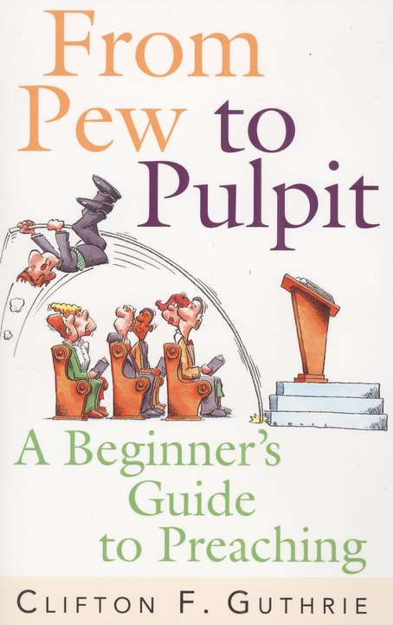

*Called to Preach*

March 7, 14, & 21

(In Person) 5:30- 9:00PM

Sunrise UMC 19234 N 7th Avenue, Phoenix, AZ

Rev. Donna Hughes – Instructor

Come join us in a REQUIRED class for those wanting to become a Certified Lay Speaker and for those wanting to learn more about public speaking and providing pulpit support to their pastor and others in our Conference. This is a class designed for those who have not completed formal preaching training and for others who are called to preach in a pastor’s absence.

Students will be asked to follow CDC Social Distancing, wearing masks – except when speaking at the podium!! Class attendees are VERY much encouraged to be vaccinated for everyone’s safety.

The class is $15. If you have to cancel or postpone you will get a credit for a future class in the West District. The book you need to purchase and read completely before class begins is – From Pew to Pulpit by Clifton Guthrie. It is available in print for $15.99 and by Kindle for $9.99. You can find them at Cokesbury or Amazon.

To register go to: <https://dscumc.org/lay-servant-ministries-training-sessions>

Life Together in the United Methodist Connection

(United Methodist Polity) February 11 & 18 (In Person) 9:30AM-2:30PM Lunch provided

Willowbrook UMC 19390 N 99th Ave, Sun City, AZ

Rev. Gary Kennedy & Laurie Lineberry - Instructors

Come join us in a REQUIRED class for those wanting to become a Certified Lay Speaker. This course gives participants an overview of the structure and organization of The United Methodist Church. Currently, masks are recommended, and students will be asked to follow CDC Social Distancing (updates will follow). The class is $15. If you have to cancel or postpone you will get a credit for a future class in the West District. The book you need to purchase and read completely before class begins is – Polity, Practice, and the Mission of The United Methodist Church by Thomas E. Frank. It is available in print and by Kindle. The class will finish with Holy Communion and Graduation. (you will need to commit to both sessions) (all times are Arizona time) To register go to: <https://dscumc.org/lay-servant-ministries-training-sessions>

**Leadership Webinars**

The West District is excited to join with the South and East Districts for a series of Leadership Webinars in 2022. The first is Saturday, February 5, 2022 at 11:00 AM to12:30 PM MST.

Since John Wesley began a movement which came to be known as the Methodist Church, connecting has been a value, a practice, and a part of the fabric of the organization. Through the years, The United Methodist Church has created a structure to keep the connection strong.

Our Leadership Seminars are designed to encourage a practical and intentional connectionalism. Our presenters will guide us through a process of discovery and practice as participants engage in conversation and activities which create the connection. We will be intentional about creating cross connections, not by creating structure, but by networking in more organic ways which reflect the context of the ministry and the unique giftedness of individuals.

In this webinar, we’ll watch and discuss a recorded video from Bishop Grant Hagiya on the why and how this value and practice of Connectionalism began in our Methodist movement. We’ll discuss why Connectionalism is important to the work of our church in making disciples and transforming the world, and about why we need the Connection now more than ever.

Registration information: <https://dscumc.org/blog/2021/12/21/district-leadership-webinars-in-2022/>.



Sunrise Social Media

[**@sunrisephx**](https://www.facebook.com/sunrisephx/)[**#sunriseumcphx**](https://www.instagram.com/sunriseumcphx/)



[This Photo](http://commons.wikimedia.org/wiki/File:Facebook_Shiny_Icon.svg) by Unknown Author is licensed under [CC BY-SA](https://creativecommons.org/licenses/by-sa/3.0/)



[This Photo](https://radiouniversidad.uca.edu.ni/instagram-agrega-stickers-animados-historias/) by Unknown Author is licensed under [CC BY-SA](https://creativecommons.org/licenses/by-sa/3.0/)